Radioactive Emission/Capture Examples

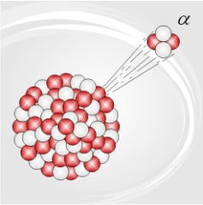
2 protons &
2 neutrons
http://commons.wikimedia.org/wiki/File:Alphadecay.jpg

Alpha Emission Example: ${}_{\text{92}}^{\text{238}}{}U→{}_{\text{90}}^{\text{234}}{}\text{Th}+{}_{2}^{4}{}\text{He}$
(A uranium atom with 92 protons and a mass of 238 amu emitted an alpha particle with 2 protons and a mass of 4 amu producing an atom of Thorium with 90 protons and a mass of 234 amu)

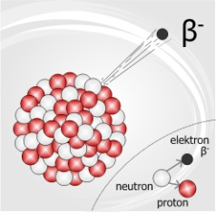
1 electron
http://commons.wikimedia.org/wiki/File:Betadecay.jpg

Beta Emission Example:
(A carbon atom with 6 protons and a mass of 14 amu emitted a beta particle with a loss of 1 electron with a mass of 0 producing an atom of nitrogen with 7 protons and a mass of 14 amu)

Positron Emission Example:
(A potassium atom with 19 protons and a mass of 38 amu emitted a positron (positive electron) changing a proton into a neutron producing an atom of Argon with 18 protons maintaining the same mass as a particle was neither added nor subtracted only changed forms.)

Electron Capture Example:
(A silver atom with 47 protons and a mass of 106 amu captured an electron to aid in changing a proton into a neutron producing an atom of palladium with 46 protons maintaining the same mass as a particle was neither added nor subtracted only changed forms.)

