Hydrological Cycle (Water Cycle): The water cycle concentrates on the continuous exchange of water between the atmosphere, oceans, and landmasses on Earth’s surface. It goes through the following stages: First the water goes through evaporation. The water is heated changing it from a liquid to a gaseous state (water vapor), so it may enter the atmosphere. Transpiration also aids in adding water vapor to the atmosphere. It is the evaporation of water from vegetation through tiny pores in their leaves. Next, the water is condensed a process by which water vapor is cooled back into a liquid: such as dew, frost, clouds, and fog. Finally, the condensed droplets will become large enough to fall out of the sky either as a solid or liquid in the stage known as precipitation. Once fallen, it may either soak in the ground becoming ground water or become surface runoff flowing into nearby streams, lakes, or rivers.

Hydrological Cycle: | 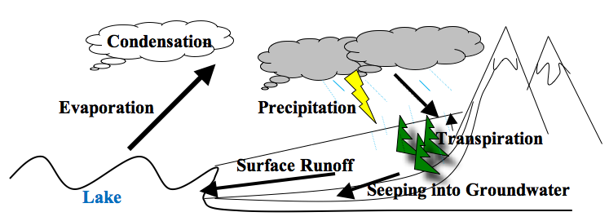
Water Pollution: Pollutants may enter water at a point source (directly into a body of water) or via a nonpoint source (indirectly through transport or environment change). Point sources include industrial plant and municipal sewage treatment plant discharges into water sources. Although, it is the nonpoint sources or indirect contamination of water that are most difficult to monitor, but can cause the greatest reduction in water quality over time such as: pesticides, fertilizers, petroleum products, mining waste, and animal waste.
Treatment of Water: To purify or restore water quality there are several options:
1) Flocculation/ sedimentation: process of removing inorganic contaminants by decreasing the
turbidity or increasing the clarity of the water by combining small floating particles into
larger particles (coagulate), so they will settle out of the water as sediment.
2) Filtration: process of removing inorganic and organic contaminants by passing water through
a material that sifts unwanted particles from the water removing them (ex. sediment filter)
3) Disinfection (chlorination/ ozonation): process of removing organic contaminants such as
dangerous microbes by adding a chemical to kill them typically chlorine/chlorine based
compound or ozone (O₃)
4) Ion Exchange (water softener): process of removing inorganic contaminants by exchanging
them with safer cationic and anionic ions, charged within plastic resin beads (removes
arsenic, chromium, excess fluoride, nitrates, radium, uranium, calcium, magnesium etc.)
5) Absorption: process of removing organic contaminants which affect the color, odor, and taste
of the water using activated carbon (slightly-positively charged carbon) to attract and filter
6) Reverse Osmosis: process of removing both inorganic and organic contaminants (such as
bacteria, spores, and viruses) by forcing the water using high pressure through multiple
membranes going against the osmotic pressure drawing the water back towards the solutes
7) Distillation: process of removing both organic and inorganic contaminants by separating
substances using their boiling points or reenacting the water cycle or ; water is heated,
evaporated into water vapor, then it is transported to a clean container and cooled/condensed
into a liquid form.

