Photovoltaic Cells - Diagrams

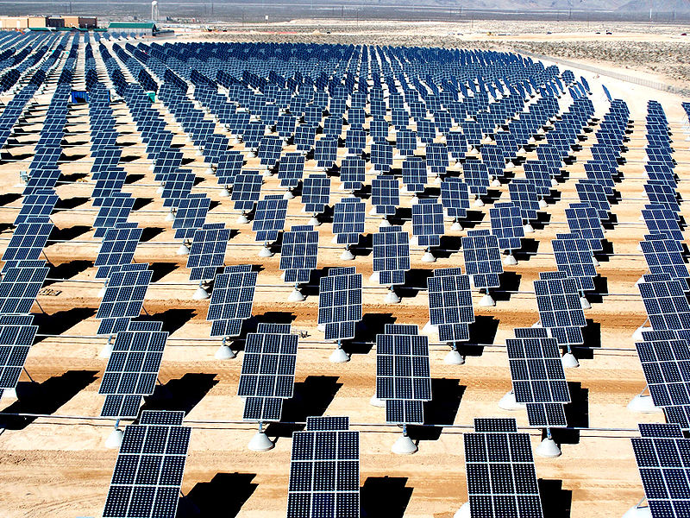
Photovoltaic array with many photovoltaic cells in each device.

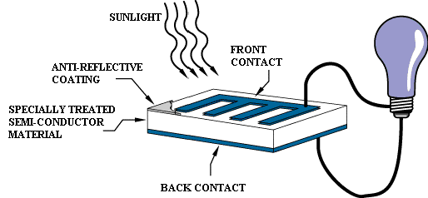
Photovoltaic cell showing in general how one operates.

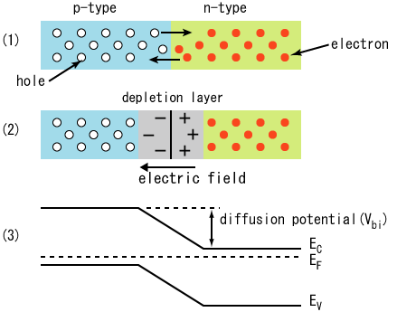
P-N junction inside the photovoltaic cell.
All images are from Wikimedia commons

