SPIRIT 2.0 Lesson:
Cell Me What?

==============================Lesson Header===============================
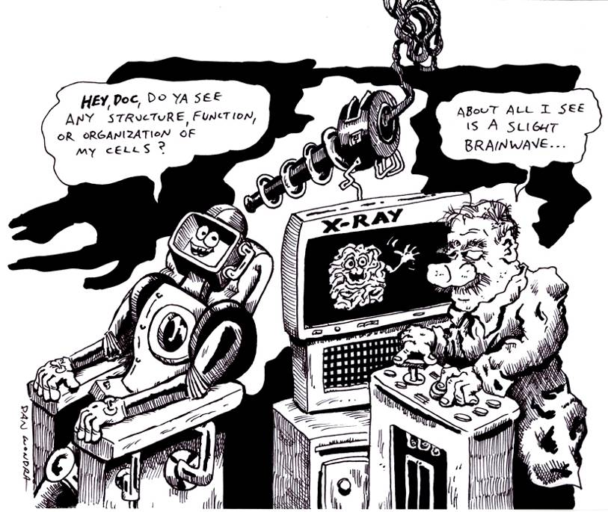
Lesson Title: Cell Me What?
Draft Date: July 17, 2008
1st Author (Writer): Jason Rhine
Topic: Organelles of eukaryotic cells
Grade Level: Middle or Secondary

Content (what is taught):
- Functions of eukaryotic (plant or animal) cellular organelles
- Characteristics of eukaryotic cellular organelles
- Relationship between differing organelles that facilitate cellular organization

Context (how it is taught):
- Students will investigate the organelles of eukaryotic cells including functions and responsibilities.
- Students will investigate the structure of the CEENBoT parts and functions.
- Students will create an analogy between the CEENBoT and a eukaryotic cell using three column notes and a graphical image (poster).

Activity Description:
In this lesson, students will discover the structure, function, and organization of organelles within the eukaryotic cell. At the same time, students will explore the structure, function, and organization of the CEENBoT. By comparing the functions within each item, students will obtain an appreciation of how the CEENBoT and the cell work, while acquiring a deeper understanding of the component parts. Students will use the analogy, “My Cell is like my CEENBoT because ________.” Students will take notes in a three-column format (Cell Part, Function/Job, CEENBoT Part) and will use these notes to represent graphically their findings. Finally, students will present an oral defense of the choices that they made to check for understanding. Students will have the opportunity to explain why they paired components from the CEENBoT to components of the cell.

Standards:
- Math—E1, E2, B1 | - Science—A1, A2, C1, C5 | - Technology—A1, A3, D3

Materials List:
- Classroom Robot | - Plant Cell Diagram | - Notebook Paper
- Animal Cell | - Poster Paper | - Whiteboard
- Diagram | - Markers/Colors | - Writing Materials

ASKING Questions (Cell Me What?)

Summary:
Students are asked how a robot and a cell are alike.

Outline:
- Breakdown the parts of the robot by function/job.
- Examine cell organelles for function/job.
- View diagrams of both the robot and cell.

Activity:
Place diagrams of both CEENBoT and a eukaryotic cell on the overhead, LCD projector, or board. Breakdown the parts of each and describe the functions of part.

Questions | Possible Answers
Why would we use an analogy when teaching? | We would use an analogy when teaching to apply something that we understand to something that we do not understand.
How are machines and cells alike? | Machines and cells are alike in movement, function, memory, and programmability.
How are machines and cells different? | Non-living vs. living, fragile vs. sturdy, and artificial vs. natural
If you had to describe a robot without using some key words like metal, plastic, circuit, board, or robot/machine, what would you say? | Answers will vary. This discussion is an exploratory activity where students should be allowed to express their creativity.
What can you observe about the parts of cell and the parts of the robot? | There are robot parts that do the same job as the cell parts. The cell and robot parts are not located in the same place, but do equally the same work.

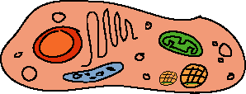

EXPLORING Concepts (Cell Me What?)

Summary:
Students are asked how a robot and a cell are alike.

Outline:
- Use a basic analogy to illustrate the compatibility of two separate objects.
- Allow students to brainstorm suggestions between the robot and eukaryotic cell.

Activity:
Demonstrate a basic analogy (e.g., a cell is like a school) by giving a partial list of comparisons. Give students a blank 3-column chart to fill out about a cell and the robot.

Cell Part | Function | School Part
Nucleus | Control center of the cell; regulates and controls internal functions and structures | The Principal
Nuclear Envelope | Membrane surrounding the nucleus; controls what enters and leaves the nucleus | The Main Office
Lysosomes | Areas that contain enzymes for the removal/destruction of worn out parts, waste or intruders within the cell | Custodial Staff
Mitochondria | “Powerhouse of the cell”. Site where chemical energy is created through cellular respiration and the breakdown of glucose. | School Boiler or Electrical Room

Student Worksheet: 3-Column_Chart.doc

INSTRUCTING Concepts (Cell Me What?)

Organelles of eukaryotic cells
Living things and machines have many similarities in function. The wheels on a robot are like an animal’s legs because both provide a means of movement. These similarities continue down to the cellular level. A robot has many parts that function like parts of a living cell.
The nucleus of a cell is like the robot’s central processing unit (CPU). Both are the “brains” of their respective entities. The CPU controls all the robot’s processes and the nucleus directs all cell activities.
The mitochondria of a cell are like the battery of the robot. They are related to power. The battery stores power for the robot to use and mitochondria creates an enzyme called ATP that transports chemical energy within the cell for the plant to use for metabolism.
Ribosomes make proteins, which perform specific functions that are encoded in each protein like metabolism, DNA replication, DNA repair, and numerous others. In robots the switches, voltage regulators, resistors and LED’s are like ribosomes. They have specific functions that are designed into their structure and they perform tasks related to the working of the robot.
The Golgi apparatus in a cell is like the sensors on a robot. The Golgi apparatus process and package proteins and other things synthesized by the cell. The sensors on a robot collect (package) information about the environment and prepare it to be sent on for other parts of the robot to use.
The lysosome in a cell is like the motors of the robot. A lysosome contains digestive enzymes to help break down (convert) food into energy that the cell can use. The motor of a robot takes electrical energy and converts it to mechanical energy that the robot can use to move.
The endoplasmic reticulum of a cell is like the wiring of a robot. The endoplasmic reticulum is often called the "intracellular highway" because it is for transporting all sorts of items around the cell. The robot’s wiring carries electricity and instructions around the robot to make it function.
A vacuole in a cell is like a capacitor in a robot. A vacuole is used for storage; vacuoles usually contain water or food. In the robot, a capacitor stores electricity.
If you are talking about plant cells, they have additional organelles that are similar to robots.
Plants have chloroplasts that use the sun’s energy to create food through photosynthesis and many robots will have solar panels on them to capture the sun’s rays to create energy for the robot to use. Excess energy is stored in the robot’s battery and many plants store food in tubers, rhizomes, or bulbs.
A plant cell has a rigid cell wall that supports the entire plant. Robots have a rigid frame that holds all its parts so it can function.
ORGANIZING Learning (Cell Me What?)

Summary:
Students will create a visual representation of their cell/robot analogy.

Outline:
- Exchange 3-column note chart with peers for feedback.
- Brainstorm different ways to represent visually the analogy.
- Create a visual representation.

Activity:
Students will use the notes from the 3-column chart to create a visual representation of their analogy.

Nucleus – Control Board
The Nucleus is the control center of the cell because it regulates and controls internal functions and structures. The Control Board is the CEENBoT’s brain and controls the robot’s movements.

UNDERSTANDING Learning (Cell Me What?)

Summary:
Students will compare the parts of the robot and the cell.

Outline:
- Formative assessment of eukaryotic cellular organelles
- Summative assessment of cells

Activity:
Formative Assessment
As students are engaged in learning activities ask yourself or your students these types of questions:
1. Were the students able to see similarities and differences in cells and robots?
2. Do students understand what the cell organelles do?
3. Do students understand the different parts of a robot and the function of each of these parts?

Summative Assessment
- Students will present their analogy to the class and will be assessed using a rubric.

Rubric: Cell_Robot_Rubric.doc

