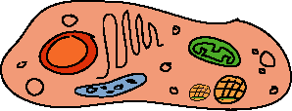
Cell Assessment

Students being tested:

- _______________________

- _______________________

Organelle | Organelle Identified Correctly | Function Described Correctly | Student Identifying Structure and Function
Nucleus | Yes or No | Yes or No
Mitochondria | Yes or No | Yes or No
Endoplasmic Reticulum | Yes or No | Yes or No
Golgi Bodies | Yes or No | Yes or No
Free Ribosome | Yes or No | Yes or No
Chloroplast | Yes or No | Yes or No

Students can answer the following writing prompts:
1. Describe the function of at least 5 cell organelles and how robots have functions that are
similar.

2. Describe the importance of membrane-bound organelles within eukaryotic cells.

3. Does the surface area-to-volume ratio of a cell matter? Defend your answer.

