SPIRIT Lesson:
Journey to the Center of a Cell
===============================Lesson Header==============================
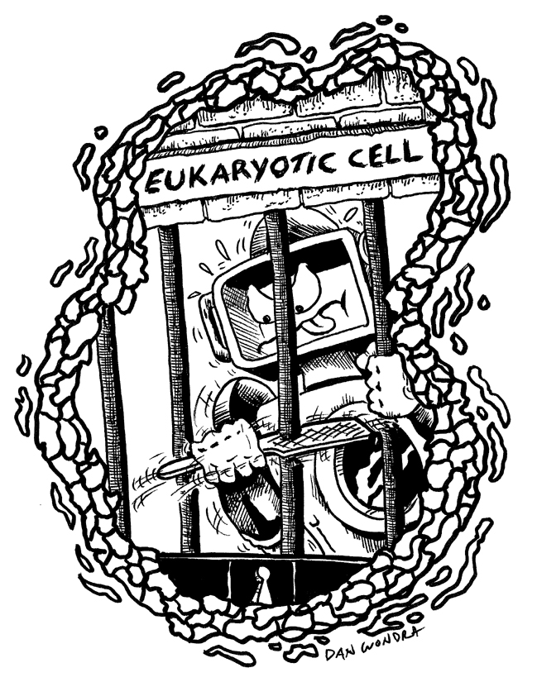
Lesson Title: Journey to the Center of a Cell
Draft Date: July 17, 2008
1st Author (Writer): Greg Schlegel
Biology Topic: Cell Structure and Function
Grade Level: 9th Grade Biology
Cartoon Illustration Idea: Robot within a eukaryotic cell with a confused look on his face and a question mark above its head.

Content (what is taught):
- Students will identify a eukaryotic cell.
- Students will identify the structure of different organelles located within a eukaryotic cell.
- Students will identify the function of different organelles located within a eukaryotic cell.
- Students will describe how the organelles function as a unit to support the life of the cell and the organism that they are contained in.
Context (how it is taught):
- Students will navigate the robot through previously created eukaryotic cell models.
- Students will identify the organelles and their functions as they encounter each within the cell model.
- Students will create a video tutorial using the robot and cell model.

Activity Description:
Students will use previously created cell models as well as information previously gathered to complete this lesson. Students will work in groups to do the research and to create the large-scale cell models. As a group, students will practice navigating the robot through the cell. As they encounter various organelles, students will have to identify the organelle and state its function. Once students have become well versed on this process, they will be required to make a video tutorial. This tutorial must be a high quality video that can be used as a teaching tool for younger students.

Standards:
- Math—C1
- Science—A1, A2, C1, C3
- Technology—A2, A3, B1, B4

Materials List:
- Classroom Robot (3-4 if possible) | - Cell Models (student created)
- Organelle Checklist | - Video Cameras (3-4 if possible)
- Computers for Video Editing | - Extra Batteries
- Video Editing Tutorial
ASKING Questions (Journey to the Center of a Cell)

Summary:
Students are asked to describe why cells are important to the lives of plants and animals.

Outline:
- Demonstrate the controls of the robot and show students its movement capabilities.
- Show students pictures of organelles and have students identify them.
- Ask students to identify the function of the organelles within the cell.
- Have students brainstorm ideas for making a fun, informative video.

Activity:
Demonstrate how the robot moves through the cell and encounters different organelles. As a class, identify specific organelles. Also, describe the purpose and the function of each organelle and relate it to the purpose and function of each part of a robot.

Questions | Possible Answers
How is a eukaryotic cell different from a prokaryotic cell? | Eukaryotic cells tend to be very complex whereas prokaryotic cells are very simple. Also, eukaryotic cells have membrane-bound organelles that must work together to support the life of the cell and the organism in which the cell is located.
Assuming that the organelles cannot change size, would it be easier for an organelle to move through a large cell or a small one? What does this tell us about the surface area to volume ratio in cells? | It would be easier to move through a large cell because a large cell has a large surface area to volume ratio, which allows particles to move more freely thus allowing the cell to function more efficiently.
Would it be possible for a cell or an organism to survive if their cells were missing any of these organelles? Explain why or why not. | A cell or organism could not survive if missing any of these parts. For instance, if mitochondria were not present, an organism would not produce the energy needed to survive.
Why is it important for membranes, such as the cell membrane, to be semi-permeable? | Many chemical reactions take place within cells. If membranes were not semi-permeable, reactants and products would not be able to move in and out of cells when necessary.
In your own words, describe an analogy that would explain why all the parts of a cell are important to the overall functioning of an organism. | A cell is kind of like a school. The principal is like the nucleus and is in control of everything that happens within that school. The teachers are like…?
How are the organelles of a cell like the parts of a robot? | Answers will vary. See instructional component.
EXPLORING Concepts (Journey to the Center of a Cell)

Summary:
Students practice moving a robot through the cells they created and identifying organelles located within those cells.

Outline:
- Students will set up their cell models on the floor, giving their cells a large surface area to volume ratio.
- Students will place a robot within the cell and navigate the robot throughout the cell.
- As students encounter organelles located within the cell, they will identify the organelle, its function, and how it might function like a part of the robot.
- After students have accurately identified the structure and function of the organelle and have related it to a part of the robot, the organelle can be marked off the checklist and they can continue moving through the cell.
- Once all students have had the opportunity to navigate through the large cell, they will decrease the surface area to volume ratio of the cell and go through the activity a second time.

Activity:
Each group of students will have a robot and the cell model they created. Students will set up their cell models to have a relatively large surface area to volume ratio. In addition, each student will receive a checklist that she/he must complete before she/he is finished with the activity. One group member will have an answer sheet in order to monitor other group members.

Once students have set up their cell models, they will put their robots inside of the cell, navigating their way through the cell. When students encounter specific organelles, they must correctly identify the organelle and the organelle’s function, and they must consider how a part of the robot might perform a similar function. After correctly identifying the structure and function of the cell and robot, they can continue moving the robot from organelle to organelle repeating the aforementioned procedure until they have completed the first column of their checklist.

After each student has navigated through the large cell, groups will decrease the surface area to volume ratio of their cell. Groups will go through the procedure listed above again, this time with the smaller cell. As before, they will practice identifying the structure and function of the organelles they encounter. As a group, students will have to discuss and answer the following questions:
- Through which cell was it easier to navigate? Explain which type of cells you would like to have in your body and why.
- Why do you think that it would have been easier to navigate through a prokaryotic cell?
- Which organelle would be the most important to a cell or organism? Defend your answer.

Worksheet: Sample_Checklist.doc

INSTRUCTING Concepts (Journey to the Center of a Cell)

Organelles of eukaryotic cells
Living things and machines have many similarities in function. The wheels on a robot are like an animal’s legs because both provide a means of movement. These similarities continue down to the cellular level. A robot has many parts that function like parts of a living cell.
The nucleus of a cell is like the robot’s central processing unit (CPU). Both are the “brains” of their respective entities. The CPU controls all the robot’s processes and the nucleus directs all cell activities.
The mitochondria of a cell are like the battery of the robot. They are related to power. The battery stores power for the robot to use and mitochondria creates an enzyme called ATP that transports chemical energy within the cell for the plant to use for metabolism.
Ribosomes make proteins, which perform specific functions that are encoded in each protein like metabolism, DNA replication, DNA repair, and numerous others. In robots the switches, voltage regulators, resistors, and LED’s are like ribosomes. They have specific functions that are designed into their structure and they perform tasks related to the working of the robot.
The Golgi apparatus in a cell is like the sensors on a robot. The Golgi apparatus process and package proteins and other things synthesized by the cell. The sensors on a robot collect (package) information about the environment and prepare it to be sent on for other parts of the robot to use.
The lysosome in a cell is like the motors of the robot. A lysosome contains digestive enzymes to help break down (convert) food into energy that the cell can use. The motor of a robot takes electrical energy and converts it to mechanical energy that the robot can use to move.
The endoplasmic reticulum of a cell is like the wiring of a robot. The endoplasmic reticulum is often called the "intracellular highway" because it is for transporting all sorts of items around the cell. The robot’s wiring carries electricity and instructions around the robot to make it function.
A vacuole in a cell is like a capacitor in a robot. A vacuole is used for storage; vacuoles usually contain water or food. In the robot, a capacitor stores electricity.
If you are talking about plant cells, they have additional organelles that are similar to robots.
Plants have chloroplasts that use the sun’s energy to create food through photosynthesis and many robots will have solar panels on them to capture the sun’s rays to create energy for the robot to use. Excess energy is stored in the robot’s battery and many plants store food in tubers, rhizomes, or bulbs.
A plant cell has a rigid cell wall that supports the entire plant. Robots have a rigid frame that holds all its parts so it can function.
ORGANIZING Learning (Journey to the Center of a Cell)

Summary:
Student groups will be assigned various organelles to research. Students will gather information on their given organelles and create tangible models. It will be necessary to make enough models of their organelles so that each group may have a copy.

Outline:
- Distinguish between prokaryotic and eukaryotic cells.
- Identify the form of various eukaryotic organelles.
- Describe the function of various eukaryotic organelles.
- Identify correlations between living cells and robots.
- Describe the surface area-to-volume ratio associated with all eukaryotic cells.

Activity:
The class will be divided into groups of 4-5 students. Each group will be assigned 2-3 organelles that they are responsible for teaching the rest of the class. Each group will be required to research these organelles to identify correctly their form and function. Students will be required to write a short summary of the function of their organelles and a summary of how the mechanical robot has parts that perform functions similar to the organelles. In addition, groups will be required to make large models of their organelles and will be required to make enough models to give one to each group. Using all of the model organelles that they have collected, groups then will be able to create their own large cell model.

Once students have researched and become experts on their organelles, they will present their findings to the rest of the class. Each group will present the information that they found on their cell organelles and the correlation between living cells and robots. Also, groups will present the models that they put together, clarifying how their structure supports the function of that organelle. Each student will design a chart in their biology notebook and will record the information presented by each of the groups.

The class will construct a large cell model so students can accurately visualize what the inside of a cell looks like. The class will practice moving the robot within the large cell model. As the robot encounters various organelles, students will identify the organelle and state its function. After practicing as a class, groups will separate and construct their own cell models. Each group will complete a checklist. The group will move the robot throughout the cell, will identify the organelles and their functions, and will relate the organelle functions to similar robotic functions. As the group performs this exercise, students will mark the specific organelles off their checklist until they have accurately identified each organelle. The students will complete this lesson with a cell that has a small surface area-to-volume ratio cell as well as with a cell that has a large surface area-to-volume ratio. One student will act as a moderator and will be responsible for assessing the correctness of the answers given by each student.
UNDERSTANDING Learning (Journey to the Center of a Cell)

Summary:
Students will assess each other while they practice moving their robots. They will be summatively assessed on a performance-based assessment.

Outline:
- Formative assessment of cell structure and function.
- Summative assessment of cell structure and function.

Activity:
Formative Assessment
As students are practicing with the robots, they will be assessed in the following ways:
1. Students will assess each other using their checklist of organelles.
2. The teacher will informally assess students based on observations made during student
practice time.
3. If necessary, the teacher will check overall student understanding by conducting an informal
review session before administering the performance-based assessment.

Summative Assessment
The students’ final grade will be based on their summative assessment. The teacher will conduct performance-based assessment for groups of two, however, the teacher will grade students individually based on the organelles they are asked to identify. At the end of the assessment, the teacher will provide two essay questions and students will answer the questions as a team. The teacher will administer the assessment by giving alternating questions to the students. Students will be graded using a checklist.

Worksheet: Cell_Assessment.doc

