SPIRIT 2.0 Lesson:
Function Junction

================================Lesson Plan===============================
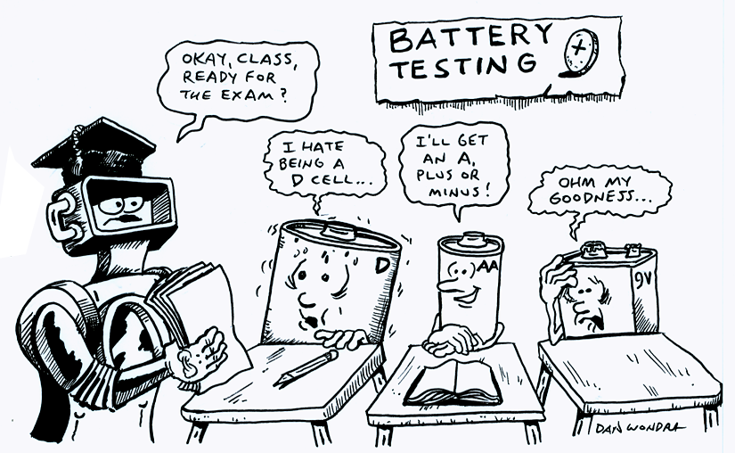
Lesson Title: Function Junction
Draft Date: July 15, 2008
1st Author (Writer): Carrie Nielsen
Technology Topic: Electronics and Circuit Boards
Grade Level: Middle School

Content (what is taught):
- Electrical Devices contain circuit boards.
- Components on the circuit boards perform a given function.
- Resistor color bands refer to the amount of resistance given in Ohms.

Context (how it is taught):
- Observations of internal components of electrical devices
- Online simulations of electrical components
- Creation of battery tester

Activity Description:
In this lesson, students will observe the internal workings of electrical devices and will identify correctly certain electrical components (resistors, diodes, LEDs, and capacitors). Students will then learn the purpose of resistors and the meaning of the color bands found on resistors. They will also learn how to create circuits in a virtual lab. Lastly, students will create a batter-tester.

Standards:
- Math—A1, A2, B1, D1
- Science—B3, E1, E2
- Technology—F1, F4

Materials List:
- Classroom Robot | - Electric Fan
- Classroom Computers | - Notebook
- Scavenger Hunt Worksheet | - Battery Tester Kit
- Soldering Irons/Solder | - 9V Batteries

ASKING Questions (Function Junction)

Summary:
Students are asked to identify internal and external components on a computer, robot, and fan.

Outline:
- Point to different parts of a computer and have students identify those parts.
- Demonstrate the robot to the class.
- Open the electric box on a fan (or other device) and show it to the students.

Activity:
Point to the different components of a computer (monitor, keyboard, mouse, etc.) and ask students to identify correctly the parts. Next, open the computer and have students look inside and identify parts. Finally, demonstrate some of the CEENBot capabilities and compare its components with the computer parts. If a fan or other device is available, take it apart and identify the parts.

Questions | Possible Answers
What do you see inside the computer/robot/fan? | Green boards, lots of wires, metal boxes, a fan
Can anyone correctly identify components found within the computer/robot/fan? | CD/DVD Drive, CPU, Memory Cards, battery, motors, wheels, screws, LEDs
Are there any components that are similar among the computer/robot/fan? | Wires, screws, circuit boards, lights
What can the (computer, robot, fan) do that the others cannot do? | The robot can move from one place to another; you can type documents on the computer; the fan can blow air on you.

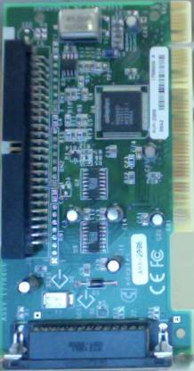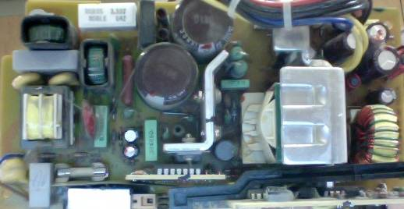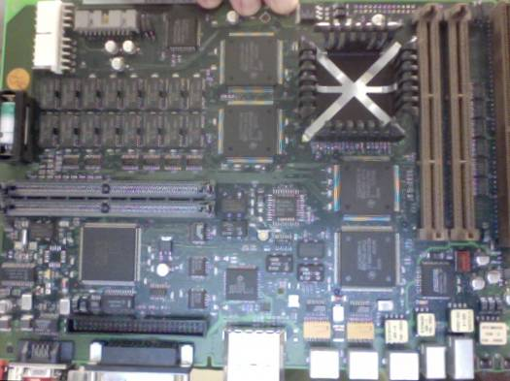

EXPLORING Concepts (Function Junction)

Summary:
Students will visually examine the internal components found on the inside of a computer, the components found on the CEENBot, and the electrical components found on a fan (or other device).

Outline:
- Show pictures/examples of the four components students will be looking for: resistors, diodes, LEDs, and capacitors.
- Open the case of a computer, have the CEENBot in the room, and open the electric compartment on a fan (or other device).
- Students will look for the four components and count how many of each component is found in each device.
- Students will turn on the computer and the CEENBot and observe/record their findings.
- Students will drive the CEENBot through an obstacle course observing/recording their findings.
- Students will share their results with the class.

Activity:
Using pictures and samples show students what some resistors, diodes, LEDs, and capacitors look like. Explain to students that they will be going on an Electrical Scavenger Hunt. Using the first worksheet, students will look at each of the three devices and try to locate correctly any or all of the four components. Students will record their findings on the worksheet. Students will then turn on the computer and the CEENBot and observe/record their findings as they perform different functions detailed on the second ‘Electrical Scavenger Hunt’ worksheet. Once all of the students are done, the class will gather and discuss their findings.

To provide formative assessments as students are exploring these concepts ask your students these questions:
- Are there any significant differences between the numbers of components found in each device? Why?
- Can you think of any other electrical devices that may look similar to the computer/robot/fan?
- What color are the LEDs when the CEENBot is driving forward? What happens if you turn? What happens when you apply the brakes or drive backwards?

Worksheet: S012_Electrical_Scavenger_Hunt1.doc and S012_Electrical_Scavenger_Hunt2.doc

INSTRUCTING Concepts (Function Junction)

Electric Current

Putting “Electric Current” in Recognizable terms: Electric current is the flow of electric charge from one location to another. This charge is usually an electron but can actually be any charge that is in motion.

Putting “Electric Current” in Conceptual terms: Having a closed circuit for the electric charges to flow along creates an electric current. If there is an open circuit, the energy will not flow and any device connected will not function. For instance, if you flip a light switch you close the circuit and charges are allowed to flow freely around the loop. Part of that loop is a thin wire that becomes hot from the energy passing through it and begins to glow causing light.

Putting “Electric Current” in Mathematical terms: Electric current does not flow without loss of energy. This loss of energy is called resistance. The direct current resistance of a material can be defined by the formula $R=\frac{l⋅p}{A}$ where R is the resistance, l is the length of the material in meters, A is the cross sectional area of the material in square meters, and p is specific to each material and is the electrical resistivity measured in Ohmmeters.
Resistance is an integral factor in the formula$I=\frac{V}{R}$ where I is the current in amperes (the amount of energy to flow past a point), V is volts (how quickly electrons flow through a material), and R the resistance of the material measured in Ohms.

Putting “Electric Current” in Process terms: Since no closed system is completely efficient, there is energy loss as the current flows through the circuit. The resistance in the material that the circuit is made of causes this loss. Resistance is defined as the difference between the potential amount of energy that can flow through a circuit and the actual amount of energy that flows through the circuit. Sometimes the amount of energy that flows through a circuit needs to be limited or controlled. This restriction can be accomplished by inserting a resistor in the circuit. A resistor is a device that limits the flow of electricity. That reduction in flow is measured in Ohms. Resistors have different strengths that are coded by colored bands. Each color means a different resistance level. Search the Internet to find what each color means.

Putting “Electric Current” in Applicable terms: Electric current or electricity is an essential part of our modern lives. We take for granted the use of electric current and the work that it provides us. The applications of electric current have become more widespread as technology becomes more prevalent in society.

Organizing Learning (Function Junction)

Summary:
Students will complete drawings of the CEENBot, the computer, and the fan (or other device) components.

Outline:
- Students will complete a Venn diagram of the three devices studied in the lesson.
- Students will draw pictures or create models of the electronic components of the CEENBot, the computer, and the fan (or other device).
- Students will specify in their drawings if and how any parts move.
- Students will specify in their drawing if any lights turn on and if so, which color.

Activity:
Students will first complete a Venn diagram detailing the similarities and differences they have discovered between the CEENBot, the computer, and the fan (or other device). Next, students will work in groups and create drawings or models of the electronic components of the three devices. Students will specify the parts that light up and what colors they are. They will also explain if and how any parts move. The teacher can display these drawings in the hallway outside of the classroom.
Students will then critique the other groups’ drawings/models to determine if they missed any electrical components. Using post-it notes in the areas of the missed components, each student will draw and describe the missing component.

Worksheet: S012_Venn_Diagram.doc

UNDERSTANDING Learning (Function Junction)

Summary:
Students will create a battery tester in the lab.

Outline:
- Students will be instructed on lab safety issues.
- Students will be instructed on how to assemble their battery testers.
- Students will assemble a battery tester and take it home.

Activity:
Summative Assessment
Students will complete the resistor worksheet and turn it in to the teacher before they start the lab project.

Performance Assessment
Students will complete a battery tester by soldering a resistor, LED, and battery leads to the circuit board. Students will pass if they are able to light up successfully their LED when a charged battery is attached.

Worksheet: S012_Understanding_Resistors.doc

Online Resource: Virtual Circuits Lab: http://www.mhhe.com/physsci/physical/giambattista/circuits/circuits.html

Assessment Extension/Challenge: Have students create a VELLEMAN Brain Game (Simon). This game uses 4 LEDs and 4 pushbuttons along with resistors and capacitors (see picture below). This can be ordered through www.elexp.com/kit_k112.htm

