SPIRIT 2.0 Lesson:
The UPS Experiment

===============================Lesson Plan===============================
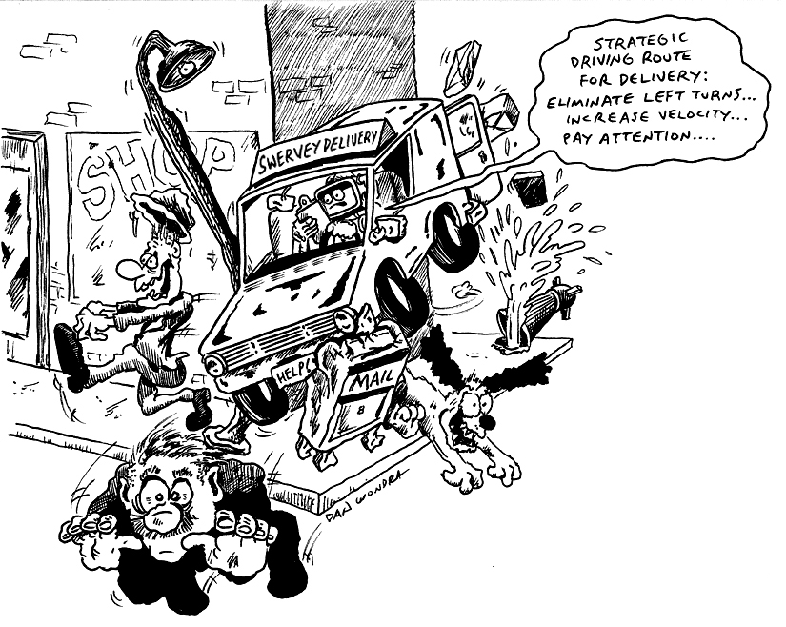
Lesson Title: The UPS Experiment
Draft Date: July 17, 2007
1st Author (Writer): Lisa Tingelhoff
Science Topic: Inquiry; Speed; Measurement
Grade Level: 7-8

Content (what is taught):
- Measurement of distance with metric measurements
- Calculation of speed and velocity
- Inquiry and problem solving skills; experimental design
Context (how it is taught):
- Students will design an experiment to support UPS strategic driving routes.
- Students will construct and measure a delivery route.
- The classroom robot will travel various delivery routes.
- Students will calculate speed and/or velocity of each trial.
- Students will collect and analyze data and use it to defend a position.

Activity Description:
The activity will begin by discussing the UPS initiative to eliminate most left turns in the delivery routes. In cooperative groups of 3-4 members, students will then be asked to design an experiment that supports the initiative using the CEENBot. Upon concluding the experiment, each group will present their experimental design and data to the class using a multimedia format such as PowerPoint or iMovie. Finally, the class will discuss each design’s successes and limitations and will determine if the initiative was proven.

Standards:
- Math—D1, D2
- Science—A1, B1
- Technology—A3, B1

Materials List (per group):
- CEENBot, Engineering notebook
- Masking tape, Stopwatch, Meter stick
- Digital camera (optional), Digital video camera (optional)
- Computer and projector access (optional)
ASKING Questions (The UPS Experiment)

Summary:
Can you design an experiment that supports the UPS initiative to eliminate most left hand turns from their delivery routes?

Outline:
- Discuss the UPS initiative.
- Determine factors/variables that affect the determination of a travel route.
- Determine factors/variables that would affect or that would be affected by the implementation of the UPS initiative.
- Design an experiment that would support the initiative based on the factors/variables that would affect or that would be affected by the initiative.

Activity:
Design an experiment that supports the elimination of most left hand turns for UPS delivery routes.

Questions | Possible Answers
What factors do you use to determine your route to school, store, or any other destination? | Factors include shortest travel distance, avoiding traffic lights, avoiding the interstate, and avoiding any additional stops along the route
UPS has developed an initiative to eliminate most left hand turns. What are the factors that would affect or that would be affected by this initiative? | Factors that would affect or be affected by this initiative include whether it is possible to avoid the left hand turn, mileage, gas consumption, time, CO2 emissions, and driver safety
Can you design an experiment that supports (proves) the UPS initiative? | Answers will vary.
What did you do to account for variables in your experimental design? | Included mandatory wait time if a left turn is made on route and mandatory wait time if driver has to stop on the opposite side of the street to make a delivery.

ROBO-UPS

EXPLORING Concepts (The UPS Experiment)

Summary:
Students explore experimental design and data collection to calculate speed and velocity using the CEENBot as the vehicle.

Outline:
- Students design and construct a delivery route.
- Students determine ways to account for variables such as traffic lights and same side delivery in their route simulations.
- The robot will simulate the travel of a variety of routes ensuring delivery of all packages along route (e.g., shortest distance, no left turns, one left turn, same side delivery, etc.).

Activity:
1. Collaborative groups will design a route for a given amount of deliveries. The route can be constructed using the grid on a tile floor as roads and wood blocks as delivery stops.
2. Once the route is designed, the groups will return to the notebook to construct data tables that will be used to collect information/data such as distance, time and direction traveled gathered during their experiment.
3. The group will also devise ways to account for variables such as traffic lights and opposite side delivery in their simulations.
4. Groups will then use the CEENbot to simulate trials making deliveries using a variety of routes such as shortest distance, no left turns, etc.
5. Once the simulations have been completed and data has been recorded, students will make calculations for speed and velocity.

Resources:
http://multichannelmerchant.com/opsandfulfillment/advisor/fuel_conserve/
http://www.usatoday.com/money/industries/energy/2008-04-30-fuel-costs-companies_N.htm
UPS has deliveries for house 1, 4, 6, and 8. What is the fewest number of left turns that can be made?
1
2
3
4
5
6
7
8
9

INSTRUCTING Concepts (The UPS Experiment)

Distance = rate * time
Putting “Distance = rate * time” in Recognizable terms: Distance = Rate * Time is a formula that is prevalent in algebraic settings. The formula is a linear equation with the rate serving as slope.
Putting “Distance = rate * time” in Conceptual terms: Distance = Rate * time is a formula that shows the relationship between three variables distance, rate, and time. If two variables are known, the third can be calculated. The formula is linear and an example of direct variation.
Putting “Distance = rate * time” in Mathematical terms: The formula give distance as either a function of rate or time with the other serving as a constant of variation. What this means is if the rate is held constant the distance will increase as the time increases (distance as a function of time) or if the time is held constant the distance will increase as the rate increases (distance is a function of rate).
Putting “Distance = rate * time” in Process terms: Thus if you know the rate and the time of the object you can calculate the distance. If you know the distance traveled and you know either the rate or time, you can calculate the other variable. The ordered pairs (rate, distance) or (time, distance) are infinite and if graphed will form a straight line.
This modeling situation can be used by students to make predictions about future events and is a concrete way of developing a linear equation that students can apply in other settings.
Putting “Distance = rate * time” in Applicable terms: The formula models the real world. It can be applied anytime that an object is in motion at a constant rate or for a constant time. If you drive a robot faster, it will go farther in the same amount of time or if you maintain a constant speed the robot will go farther in a longer time. To create a situation that models the real world, drive the robot at a constant speed for a determinable length of time and measure both the speed and time. The distance will be equal to the rate driven times the length of time driven.

ORGANIZING Learning (The UPS Experiment)

Summary:
Students use data tables to record route distance traveled, time, direction traveled, and calculations for speed. Students use graphical representations such as a bar or line graph to display visually the results.

Outline:
- Collect data as the CEENbot travels each route.
- Vary the route to meet certain criteria.
- Collect data that includes distance traveled, time, and direction traveled.
- Calculate the speed for each route.
- Graph data such as variations in speed, distance traveled, and time.

Activity:
Data collected will relate to changes in the delivery route. Variations of the delivery route will change the distance traveled and travel time necessary to make the same deliveries. Students will record such changes on a data chart (running several trials for each delivery route). Variables such as traffic light wait time and opposite side deliveries should remain constant for each trial for easy comparison. For instance, if a left turn is to be made, a specific wait time should be incorporated. Once all data has been collected, students will calculate the speed for each route. Using the data table, students will construct a graphical representation such as a bar or line graph to show their results.

Worksheet: UPS_Delivery_Routes.doc

Possible Extension: Use Google Earth to find a driving route for the robot to travel. Students can look up their neighborhood or the school’s neighborhood, which can be mapped out on the floor.

UNDERSTANDING Learning (The UPS Experiment)

Summary:
Collaborative groups will use a multimedia presentation to communicate data and analysis of their experiment.

Outline:
- Formative assessment of metric measurements
- Formative assessment of formula for speed
- Formative assessment of use of data tables and graphs
- Summative assessment of experimental design

Activity:
Formative Assessment
As students are engaged in learning activities ask yourself or your students these types of questions:
1. What is the measurement of this portion of the route?
2. What is the formula for speed? How did you calculate speed for this trial?
3. How would you construct your data table? (Prior to suggesting data table headings.)
4. What type of graph would best demonstrate your data? What type of graph will best support your findings?

Summative Assessment
As a culmination for this activity, collaborative groups will develop a multimedia presentation of their findings using PowerPoint or iMovie.

Multimedia presentations should include:
1. A briefing of the experimental design used for the simulation.
2. Data chart and graphical representation of the data collected during the simulation.
3. Analysis of the data—what does it mean?
4. Specific research information about the impact it has had on UPS operations.
4. What are the real-world applications of your findings? Who else might benefit?
If using PowerPoint, students could use digital pictures to enhance their presentation as well as importing graphs and tables.

If using iMovie, students could use digital video to enhance their presentation with audio and video footage of their actual experiment.

