Spirit 2.0 Lesson:
What’s the rub? It’s All About Friction!

===============================Lesson Plan================================
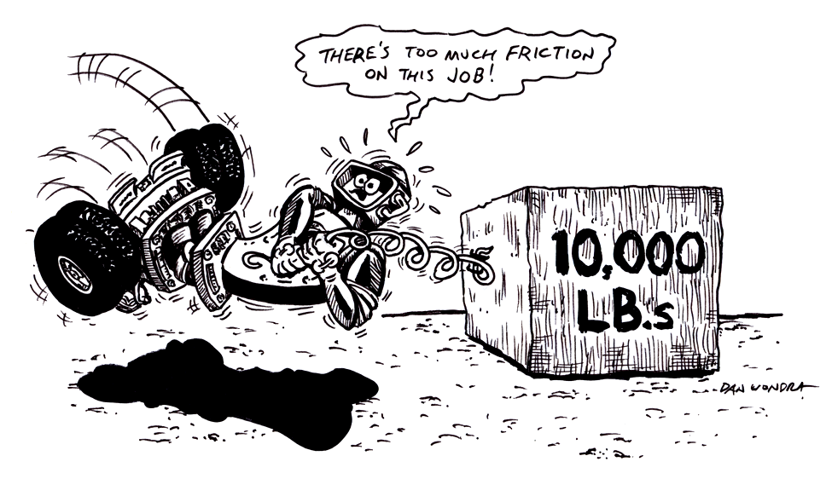
Lesson Title: What’s the Rub? It’s All About Friction!
Draft Date: July 16, 2008
1st Author (Writer): Mike Perry
Physics Topics: Friction, Formulas and Technology
Grade Level: Secondary

Content (what is taught):
- Friction Formula
- Scientific Method

Context (how it is taught):
- Scientific investigation of static and kinetic friction using a spring scale or force probe
- Collection and analysis of data
- Synthesize information in a lab report with a purpose, hypothesis, variables, materials, procedure, data, calculations, graph, and conclusion.

Activity Description:
In this lesson, students will explore friction by having a robot pull a block with a spring scale or force probe. Students will have the robot pull the block over a variety of surfaces, which will allow them to understand the coefficient of static and kinetic friction and what factors will affect friction. Students will collect data and produce a lab report of an experiment.

Standards:
Math—A1, A2, B1, B2, B3, D1, D2
Science—A1, A2, B1, B3, E1, E2
Technology—B1, B4, C4, D3, F1

Materials List:
- Classroom Robot
- Spring Scales
- Blocks of Wood
- Notebook
ASKING Questions (What’s the Rub? It’s All About Friction!)

Summary:
Students are asked to recall and synthesize previous information while developing an understanding of the concept of moving friction.

Outline:
- Recall and synthesize previous learned information on friction.
- Students will brainstorm different surfaces and put them in order from sticky to slippery.

Activity:
Have students recall previous learned information about friction. If possible, set up scenarios or situations for students to visualize (website listed below). Give students a list of common surfaces used in physics (Velcro, metal, glass, etc.). As a class, arrange the surfaces from the stickiest to the most slippery.

Questions | Possible Answers
What does it mean when a robot is moving at a constant speed? | At a constant speed, the net force on the block is zero. This implies that the force of friction and the force pulling the block are equal. If we can measure the force, we can calculate the coefficient of kinetic friction for the block.
What is friction? | The force that opposes motion.
Does weight change friction? | It should. In the formula F_{f}=μF_{n} the normal force is mass multiplied by the force of gravity or mg.
How does the force produced by friction change with acceleration, at constant speed or at rest? | There is a different friction for objects at rest (called static). The force for motion should remain the same but with this particular set up we can only calculate force for motion if it is at a constant speed.

Resource:
http://www.regentsprep.org/Regents/physics/phys01/friction/default.htm

wood

EXPLORING Concepts (What’s the Rub? It’s All About Friction!)

Summary:
Students explore the physical theories that there is no net force at constant speed, friction is a force that opposes motion, weight will change friction, and surface will change friction force.

Outline:
- Students will use the CEENBoT to pull a spring scale that is pulling a block of wood over several surfaces.
- Students will observe changes in friction.

Activity:
1. Pre lab: Discussion of concepts
2. Lab: See Below
3. Post Lab: Review of the lab and discussion of what was learned.

Students will break into assigned groups of three. Each group will gather equipment and set up their lab station. Several groups will start out with a CEENBoT to pull a block at a constant speed. The groups that are waiting to use a CEENBot may build a device out of random parts and may use this device to pull a block at a constant speed. The students will drag the block 3 times, each at a constant speed and will then calculate the average. The force in which the block is dragged is equal to the frictional force if the block is not speeding up or slowing down. If this value can be measured, and the normal force can be calculated, then we can use the formula F_{f}=μF_{n} to solve for the coefficient of friction. The teams will calculate the value for several surfaces. During one run, the block will be dragged over sandpaper, another run over silk, and another run across the table. Each group will calculate the values for the coefficient of kinetic friction. The values will be compared to a list of accepted values. If any values are off by 10% or more students will include an explanation of what happened.
wood

INSTRUCTING Concepts (What’s the Rub? It’s All About Friction!)

Friction
Putting “Friction” in Recognizable terms: Friction is a force between two objects that tends to “damp out” or oppose motion. It always acts in complete opposition to another force applied to an object. There are two main types of friction. Static friction is the frictional force opposing putting an object at rest into motion. Kinetic friction is the frictional force which tends to slow an object in motion. Usually static friction is higher than kinetic friction meaning it takes a greater force to put an object into motion than it does to maintain motion. Cases where kinetic friction is higher than static friction can occur with the use of lubricants which create a drag force that increases with velocity.
Putting “Friction” in Conceptual terms: Friction opposes the force required to start or maintain an object in motion. It is dependent on the surfaces that are in direct contact. Friction is created by the rubbing or dragging of the surfaces across each other. Friction can be increased or decreased by modifying the surfaces.
Putting “Friction” in Mathematical terms: The coefficient of friction must be calculated for any surface because different surfaces provide different amounts of friction. The coefficient of friction, µ, can be found by taking the force of friction, F_{f}, divided by the normal force, F_{n}, written as: µ = F_{f} / F_{n}. When the force to start an object in motion is used, the “static” coefficient is found. If the force to keep an object in motion is used, the “kinetic” coefficient is found. The normal force is the force component of the surface, perpendicular to the surface, acting on the object. If the surface and applied forces are horizontal, the normal force will be equal and opposite to the force of gravity, which is the weight of the object. If the surface and applied forces are NOT horizontal you must resolve the forces perpendicular to the surface.
Putting “Friction” in Process terms: Friction is the force that allows us to move. Without friction there would be no force to act in opposition to our desired motion. Thus friction is the force that fulfills Newton’s 3rd law - for every action there is an opposite and equal reaction. We cannot move in a desired direction unless friction works against us in the opposite direction. Friction is desirable and necessary for motion as we understand it and yet we are always trying to reduce friction in many instances because it requires less energy to move an object. At other times we want to increase friction to keep an object at rest.
Putting “Friction” in Applicable terms: Friction is the force that allows us to walk, climb, drive, throw, or put any object in motion. Without friction we couldn’t move objects. Friction is both desirable and undesirable depending on if you want an object to move or stay at rest. Higher friction requires more energy input. Lower friction requires less energy input.
ORGANIZING Learning (What’s the Rub? It’s All About Friction!)

Summary:
Students will produce lab reports. All reports must be typed and document not only the design process, but also the science steps. Students will produce a lab report with purpose, hypothesis, variables, materials, procedure, data, calculations, graph, and conclusion.

Outline:
- Collect data as the block slides across different surfaces (mass, distance, speed, force).
- Vary the surface across which the block slides.
- Calculate the coefficient of friction.

Activity:
The teams will calculate the coefficient of friction for several surfaces. During one run, the block will be dragged over sandpaper, another run over silk, and another run across the table. Each group must turn in a lab report with calculated values for the coefficient of kinetic friction. These calculated values will be compared to a list of accepted values. Any values off by 10% or more must be accompanied with an explanation of what happened. All reports must be typed and document the design process and the science steps. Students will produce a lab report with purpose, hypothesis, variables, materials, procedure, data, calculations, graph, and conclusion.

Resources:
Table of Friction Coefficients:
http://encarta.msn.com/media_461544499/table_of_friction_coefficients.html

Worksheet: Lab Report

UNDERSTANDING Learning (What’s the Rub? It’s All About Friction!)

Summary:
Students will be assessed on their response to a writing prompt.

Outline:
- Formative assessment friction.
- Summative assessment of friction.

Formative Assessment
As students are engaged in learning activities, ask yourself or your students these types of questions:
1. Were the students able to understand what friction is and how it effects the motion of an
object?
2. Can students explain why different objects have different coefficients of frictions?
3. Can students explain how different weights affect friction?

Summative Assessment
Students can answer the following writing prompts:
- Explain what friction is and how it helps and hinders us in the world.
- How do different surfaces and weights affect the friction?

