SPIRIT 2.0 Lesson:
Don’t sit under the apple tree…You Might Become Famous!

===============================Lesson Header ==============================
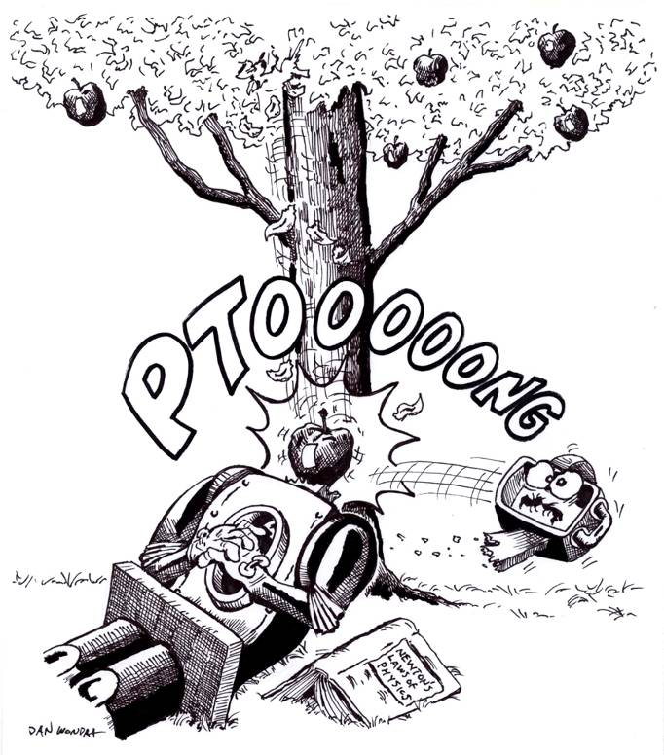
Lesson Title: Don’t Sit Under the Apple Tree…You Might Become Famous
Draft Date: June 18, 2008
1st Author (Writer): Andy Smith
Algebra Topic: Formulas,
with a special emphasis on s = d/t
Grade Level: Middle Elementary

Outline of Lesson

Content (what is taught):
Historical background on Isaac Newton
Review of basic concepts like speed, friction, and gravity.
Understanding Newton’s Laws and conditions placed upon them.
Application of the mathematical formulas s = d/t, a =F/m, momentum =m times velocity
Application of Newton’s Laws to “real life” situations.
Context (how it is taught):
- The CEENBoT will be used to try and duplicate each of Newton’s three laws of motion followed by a discussion of how each of those laws apply.
- After each law is taught, students will work on example problems, real life situations

Activity Description:
In this activity students will use the CEENBoT to more deeply understand Newton’s Three Laws of Motion. Students will first come to an understanding of the concept of each law through observations followed by measurement and calculations. Once laws are understood students will look at ways that they can apply Newton’s laws to everyday situations.

Standards:
Science D1, D2, E1, E2 Math D1, D2, E1, E2
Technology A3, D1, D3, E2

Materials List:
Classroom Robot Stopwatch
Calculators Ramps, small blocks
Data notebook (grid lines) Meter sticks
Masking tape
ASKING Questions (Don’t Sit Under the Apple Tree)

Summary: Let’s question Newton’s laws. Why don’t they seem to work? (i.e. Once in motion why doesn’t the robot keep going down the ramp?)

Outline:
- Demonstrate a robot climbing a ramp and then going down a ramp
- Show robot stopping at bottom of ramp
- Ask students what they understand about motion
- Determine variables and measurements, make calculations

Activity:
Demonstrate how the robot climbs a ramp. Increase the ramp angle and show how the robot begins to struggle as it climbs the ramp.

Questions | Possible Answers
- Why didn’t the robot keep going according to Newton’s first law? | Newton’s law will hold true in a vacuum without gravity. Here on earth the forces of friction and gravity make the robot stop.
- Can we figure the amount of acceleration the CEENBoT has? How do you figure acceleration? | Acceleration is the rate of change of velocity. The formula Force = acceleration*mass could be used if we know force and mass.
- How can the motion of the robot be measured? | The motion of the robot can be measured in terms of distance and time. The formula d = rt could be used in the form r = d / t to find the rate of motion, that is the speed.
- What important pieces of data could be collected to help understand Newton’s laws? | Speed and direction for velocity, the mass of the robot could be calculated.

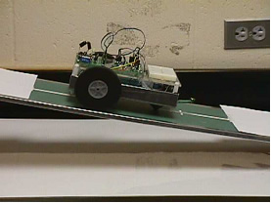
EXPLORING Concepts (Don’t Sit Under the Apple Tree)

Summary: After an introduction to Newton’s laws, students will use the CEENBoT to see if these laws really work.

Outline:
- The robot travels up the ramp and then down the other side
- Students notice that without power the robot stops
- The robot travels a level straight course starting at rest and ending at full speed
- The robot crashes into different types of block walls at different velocities

Activity:
Working with a classroom robot, students setup ramps to explore how far the robot travels down the ramp when set at different angles. Students should notice that the robot will stop once the power is turned off. Trying a different surface (less friction) student will not see much difference. Students will realize that not all objects in motion will stay in motion. Students will try a small ball rolling down the ramp. It will soon roll to a stop. How does Newton’s first law apply?
Students then observe the CEENBoT starting from a stopped position and gradually moving faster. What does this say about Newton’s second law? What is acting on the CEENBoT and what do you observe happening to it? Once students figure out that its accelerating can we figure out its rate of accelerating? If we add a trailer with weights (more mass) to the back of the CEENBoT how will that effect the acceleration?
Finally, students will test crash the CEENBoT into a wall of blocks at different speeds with some walls made of Styrofoam and some made of wooden blocks. Ask students what’s happening at the point of contact? How does Newton’s third law apply in this situation?
For a formative assessment ask yourself did students generate questions after each activity in relation to Newton’s laws? Did they write them down before asking them? How did they react when they realized conditions have to be put on the laws that they won’t work under all conditions.

Newton’s 1st Law of Motion

Putting “Newton’s 1st Law of Motion” in Recognizable terms: Newton’s 1st Law of Motion states that an object at rest tends to stay at rest and an object in motion tends to stay in motion unless acted on by an unbalanced force. This means that an object that is moving will continue to move unless something (a force) acts to change that motion and an object that is at rest will stay at rest unless something (a force) acts to change it.

Putting “Newton’s 1st Law of Motion” in Conceptual terms: Newton’s 1st law basically says that an object will continue doing what it is doing if nothing else changes. It is often called the law of inertia. Inertia means the resistance an object has to a change in its state of motion.

Putting “Newton’s 1st Law of Motion” in Mathematical terms: Newton’s 1st law has mathematical implications concerning the forces that are acting on the object. Since an object in motion wants to remain in motion it will take a force applied in the opposite direction to slow the motion. An object at rest wants to stay at rest so it will take a force to start the object moving.

Putting “Newton’s 1st Law of Motion” in Process terms: Thus, because of Newton’s 1st law of motion, we know that it takes a larger force to change the motion of an object than to just maintain the motion. The implication is that it takes more energy input to change the motion of an object.

Putting “Newton’s 1st Law of Motion” in Applicable terms: Newton’s first law is possibly easiest explained by these two cases. 1) A moving object will continue its motion is evident when you hit the brakes in your car. Your body’s tendency is to continue forward at the same speed and direction as it had before the brakes were applied. Your body will continue to move with a constant velocity unless your seatbelt creates a force that restrains your movement. 2) An object at rest will remain at rest is evident when you attempt to move a heavy object. To get the object moving you will have to apply a force to the object that is greater than the sum of all frictional and resistance forces. This creates a non-zero net force or what can be referred to as an unbalanced force. An unbalanced force causes acceleration and the object will change its velocity.

INSTRUCTING Concepts (Don’t Sit Under the Apple Tree)

Newton’s 2nd Law of Motion
Putting “Newton’s 2nd Law of Motion” in Recognizable terms: Newton’s 2nd Law of Motion states that the acceleration of an object is produced by a net force in the same direction as the acceleration, is directly proportional to the magnitude of the net force, and inversely proportional to the mass of the object. This means that the acceleration (a) of an object is dependant on a force applied to the object and the mass of the object.
Putting “Newton’s 2nd Law of Motion” in Conceptual terms: Newton’s 2nd law basically says the net force (unbalanced) (F_{net}) is equal to the mass (m) times the acceleration (a) and as a result the object will accelerate in the same direction as the (unbalanced) net force.
Putting “Newton’s 2nd Law of Motion” in Mathematical terms: Using the formula that can be derived from Newton’s 2nd law, a = F/m or F = m * a, you are able to calculate acceleration of an object given the unbalanced force applied to the object and the mass of the object. Realize the 2nd law includes the 1st law as a special case, for when the net force is zero, the acceleration will be zero, and so an object in motion stays in motion or if at rest stays at rest. The 2nd law also includes how the object's velocity changes as a result of an unbalanced force applied and the mass of the object.
Putting “Newton’s 2nd Law of Motion” in Process terms: Thus, because of Newton’s 2nd law of motion, the acceleration of an object is a quantifiable concept. We are able to use this Law of Motion to make predictions about the acceleration of an object given the net force and mass. The implications here are four fold: 1) if the net force increases and the mass stays the same the acceleration increases, 2) if the net force decreases and the mass stays the same the acceleration decreases, 3) if the net force remains constant and the mass decreases the acceleration increases, and 4) if the net force remains constant and the mass increases the acceleration decreases. It is also possible to show that if mass and force increase or decrease by the same factor, the acceleration will have no change as illustrated below.
Putting “Newton’s 2nd Law of Motion” in Applicable terms: Newton’s 2nd law is easily explained by looking at the free fall of 2 different objects with no air resistance. If one object is 1000 times more massive, it will have 1000 times more force acting on it due to gravity. If an object has a mass of m and a force of gravity of W (Weight), then the heavier object will have a mass of 1000*m and a force of gravity of 1000*W. The acceleration of both objects will be the acceleration of gravity, g, since by Newton's 2nd Law, a = F/m, in this case g = W/m = (1000*W)/(1000*m). This shows that, with no air resistance, all objects no matter the mass will accelerate at the same rate when acted on by gravity. This is illustrated by Galileo's famous experiment where he dropped a small metal ball and large cannon ball from the Leaning Tower of Pisa. Both balls accelerated at the same rate and hit the ground at the same time.

INSTRUCTING Concepts (Don’t Sit Under the Apple Tree)
Newton’s 3rd Law of Motion
Putting “Newton’s 3rd Law of Motion” in Recognizable terms: Newton’s 3rd Law of Motion states that for every action there is an equal and opposite reaction. This means that for every force on an object there is equal force acting in the opposite direction. Forces always come in pairs, which are forces equal in magnitude and opposite in direction.
Putting “Newton’s 3rd Law of Motion” in Conceptual terms: Newton’s 3rd law basically says that there are no forces that don’t have an opposite. If you sit in a chair, you push down on the chair and the chair pushes up on you. If you run through the air, you push on the air and the air pushes back on you. If you drive a car, the wheels push backwards on the road and the road pushes forward on the car. It is the road pushing forward on the car that makes the car move.
Putting “Newton’s 3rd Law of Motion” in Mathematical terms: Newton’s 3rd Law of Motion applies mathematically when you are looking at the forces that are acting individually on an object. The forces acting on an object affect the motion of the object. When looking at forces and motion, you must choose the force in the equal and opposite force pair that acts on the object.
Putting “Newton’s 3rd Law of Motion” in Process terms: Thus, because of Newton’s 3rd law of motion, we are able to move or remain stationary in our universe. The force that you exert to move creates a force in the opposite direction, and it is this opposite force that really moves you in the desired direction. If we are at rest, the balanced forces acting on us keep us in one place.
Putting “Newton’s 3rd Law of Motion” in Applicable terms: Newton’s 3rd law is easily explained as the concept that allows birds to fly, people to walk, cars to drive on the road, etc. It is the force of the air on the bird wing, the ground on your foot, or the road on the tires that cause motion. Without the opposing force whether it is the air, the ground, or the road it would be impossible to move.
ORGANIZING Learning (Don’t Sit Under the Apple Tree)

Summary: Students use data tables to record the type of object, distance, time, direction, and ramp surface. Students will calculate the rate of motion (speed) and velocity.

Outline:
- Collect data as the robot and other objects travel down a ramp, distance traveled and time.
- Time CEENBoT over measured increments of a straight-line course to determine change in velocity, recording data
- Calculate the momentum of different objects, CEENBoT, different types of balls, objects
- Graph data such velocity vs. time to understand acceleration of CEENBoT

Activity:
Observe objects rolling down ramps. Measure distance they travel and determine forces that are getting in the way and making the objects stop. Next, time and note direction of CEENBoT as it travels a straight course to determine velocity. From this, students can determine acceleration using the formula f = ma (force equals mass times acceleration).
From the calculations of velocity and knowing the mass of the objects, students can calculate the momentum of different objects.

Worksheet: Apple Tree Calculations

UNDERSTANDING Learning (Don’t Sit Under The Apple Tree)

Summary: Students write essays about the CEENBoT and how it helped them understand Newton’s laws of motion.

Outline:
- Formative assessment of speed and velocity
- Summative assessment of f = mass x acceleration, understanding acceleration
- Summative assessment of tables and graphs, and momentum

Activity:

Formative Assessment
As students are engaged in learning activities ask yourself or your students these types of questions:
1. Were the students able to apply the formula for speed and figure velocity?
2. Can students explain the meaning of acceleration given force and mass?
3. Can students knowing the mass and velocity of an object apply the momentum formula?

Summative Assessment
Students will complete the following essay questions about Newton’s laws:
- Write a story involving the motion of the classroom robot applying Newton’s three laws. (i.e. CEENBoT in space would keep traveling once in motion).
- Create a data table showing the accelerating of a classroom robot with different forces applied at a constant mass.
- Create a table showing changes in momentum using the CEENBoT with constant mass and changes in velocity.

