SPIRIT 2.0 Lesson:
Robot Waves
==============================Lesson Header===============================
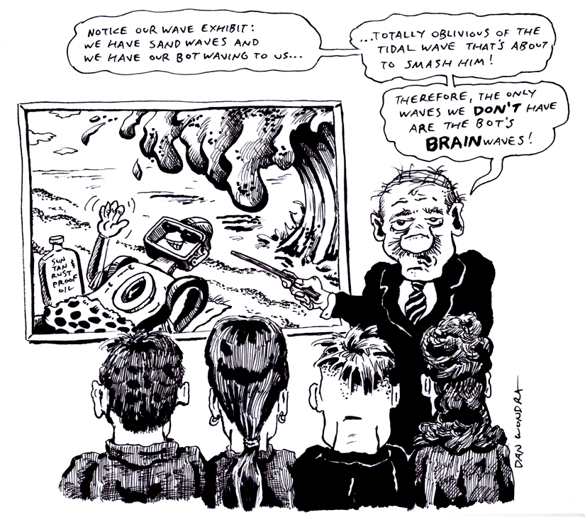
Lesson Title: Robot Waves
Draft Date: July 17, 2008
1st Author (Writer): Roger Lescelius
Science Topic: Waves
Grade Levels: Middle
Content (what is taught):
- The concept of a wave as a pattern of repetitive motions in the environment around us
- Demonstration, measurement, and description of waves of different kinds in different media
- Vocabulary describing waves and wave motion
Context (how it is taught):
- The classroom robot deposits a trickle of sand from a funnel as it moves in two patterns: a compressive wave (fast and slowly in a straight line), and a transverse wave (side to side at constant speed). This activity produces waves of sand on the floor that can be easily measured.
- Students will measure and record amplitude and wavelength. For transverse waves, students measure the amplitude peak-to-peak (side to side) and for compression waves the students will measure the amplitude peak-to-peak, the width of the track of sand (from narrow to wide), or the difference in height of the sand layer (from low to high).
- Students will produce compression and transverse waves with a Slinky. The teacher will demonstrate and contrast travelling waves and standing waves. Students will demonstrate and report on reflections of waves. These activities produce waves that are functions of distance and time, which are much more difficult to measure but will give a deeper understanding of waves.
- Students will demonstrate and explore producing transverse waves with a jump rope, illustrating horizontal polarization, vertical polarization, speed of propagation, reflections from a fixed end, reflections from an open end, harmonic modes in standing waves, etc.

Activity Description:
A funnel will be attached to the CEENBoT, the opening taped shut, and will be filled with sand or rice. The tape will be removed so rice can trickle out. The teacher will drive the CEENBoT in a wavy line and then will drive it back in a straight line varying speed: Fast, Slow, Fast, Slow. The teacher will ask the students, what pattern is the robot making? Next, the teacher and students will demonstrate compression waves and transverse waves using a slinky and jump rope.
Standards:
Math—B1, B3, C1, C3, C4, D1, D2 Science—A1, A2, B1, B3, F5, G1, G2
Technology—A1, A2, A3, B1, B2, C1, C4, D1, F1, F4
Materials List:
- Classroom Robot | - Data Sheet | - Notebook | - Jump Rope (3 each)
- Funnel with sand | - Slinky (10 each) | - Graph paper | - Meter Sticks
ASKING Questions (Robot Waves)

Summary:
Students will learn about waves as repetitive patterns in the environment around us.

Outline:
- Generate a compression wave pattern and transverse wave pattern in sand using the robot
- Explain the concepts of amplitude and wavelength.
- Ask students the question: Where do we see waves in our environment? Show the picture of the robot laying down a pattern of sand and ask students the question: What pattern is the robot making? Show pictures of water waves on a lake or ocean, wind moving the grass, flocks of birds, video of a caterpillar. Show a picture of a Slinky with compression waves and/or transverse waves on it.
- Ask students the question: Where do we hear waves? Explain that we hear waves in our ears that are pressure waves of air molecules. (This could lead to a lesson on hearing: wavelength versus pitch.) Play some music, or a tape of natural sounds.
- Ask students the question: How do we see waves? Explain that we see waves with our eyes. Light can be described as waves of electromagnetic energy. (This could lead to a lesson on vision: wavelength versus color.) Show a picture of a painting, or a natural scene.
- What kinds of waves cannot we see or hear? Explain to students that the waves we cannot see or hear are X-Rays, Gamma Rays, Infrared (heat), microwaves, and radio waves. Show a picture of a rainbow and/or a spectrum chart.

Activity:
Groups of students will demonstrate waves with synchronous motions of their hands, “The Wave”. Students will move their hands from right to left to demonstrate compression waves and will move their hands up and down to demonstrate transverse waves.

Questions | Possible Answers
How can we demonstrate a compression wave? | Move our hands back and forth in the direction the wave is travelling.
How can we demonstrate a transverse wave? | Move our hands up and down, or side to side.
Are there other kinds of waves? | Yes, waves can have circular polarization or elliptical polarization.
How can the wave motion of the robot be measured? | The sand trail after the robot records the wave the robot produced.
What important pieces of data could be collected to help understand the observed motion? | Measuring amplitude and wavelength of the sand trail. Measuring the speed of the robot. Measuring the time per cycle (period) or the frequency.

Online Resource Search: Physics Classroom Waves

EXPLORING Concepts (Robot Waves)

Summary:
Students drive the CEENBoT making different kinds of waves. Students play with a Slinky and use a jump rope to investigate and demonstrate waves. Students draw waves, and measure wavelength and amplitude. Students can video their demonstrations of waves.

Outline:
- Students vary the speed of the robot slow-fast-slow-fast about one cycle per second.
- Students vary the direction of the robot right-left-right-left about one cycle per second.
- Students measure the sand patterns due to the robot speed changes and direction changes.
- The wavelength, amplitude, and speed of propagation (robot speed) can be found.
- Changes in wave shape can be observed.

Activity:
Students familiarize themselves with wave motion, wave measurements, and different kinds of waves while working with the CEENBoT, the Slinky, and with the jump rope.
To provide formative assessments as students are exploring these concepts, ask yourself and/or your students these questions:
- Did students notice advanced concepts such as wave shape, reflections, refraction, interference, standing waves, speed of propagation, or harmonics? How successful were they at measuring wave length and amplitude?
- How did students measure or calculate the wavelength?
- Did students try to measure amplitude?

Waves
Putting “Waves” in Recognizable terms: A wave is a disturbance that travels (propagates) through time and space and transfers energy. They take on many forms that are recognizable to the naked eye like tidal waves, ripples in a pond, or the ear like sound waves. These types of waves are called mechanical waves and they travel through a medium (solid, liquid, or gas). Visible light such as the color red is an electromagnetic wave that is recognizable as well, but many of the electromagnetic waves are not visible. These invisible waves such as radio waves, microwaves, infrared, ultraviolet, x-rays, and gamma rays do not require a mechanical medium and can travel through a vacuum such as the space between stars.
Putting “Waves” in Conceptual terms: Waves are a vibration that travels in a direction away from the wave source. If the vibrations form repetitive patterns they are known as periodic, but if not they are known as non-periodic waves. Two types of periodic waves are transverse and longitudinal (compression). Transverse waves have particle displacement (vibration) perpendicular to the direction of wave travel (so the wave vibrates the particles up and down vertically, while it moves forward or horizontally) and for some transverse vibrations can produce a sine shaped wave. Longitudinal (compression) waves have particle displacement (vibration) parallel to the direction of travel (so the particles vibrate horizontally along with the wave as it travels forward, such as in a sound wave.
Putting “Waves” in Mathematical terms: Periodic waves have several characteristics that can be measured including: amplitude, wavelength, period, and frequency. The amplitude and wavelength are measured at different locations for a transverse or longitudinal wave (See diagram). The amplitude measures the distance the medium particles move from the rest position and is an indication of the amount of energy a wave carries. On a transverse wave, amplitude is measured from either the crest to rest position or trough to rest position, but on a longitudinal wave, the length of the compression is measured. The wavelength “λ” (lambda) measures the distance between two equivalent wave points with similar motions such as from one crest to another crest. The period “T” of a wave is the time required for one full wavelength to pass a certain point or the time for one complete oscillation of a single point. The frequency “f” of a wave is the reciprocal of the period (f = 1/T) and represents the number of wavelengths (oscillations) that pass in one unit of time or cycles per one second (# of waves/1 second). The unit of frequency is 1 hertz (Hz) = 1 cycle / second. If one wavelength of a wave passes by in 0.25 seconds or ¼ of a second then 4 waves can pass by in one second. The speed of a wave can be calculated using the formulas Speed = frequency * wavelength (s=f*λ) or using the reciprocal of frequency Speed = wavelength/period (s = λ/T).
Putting “Waves” in Process terms: All waves can exhibit reflection, refraction, and interference. Standing waves are a prime example of reflection and destructive interference. Unlike traveling waves, a standing wave is confined such as on a guitar string. If vibrated at the right frequency the wave will reflect back upon itself creating points in the wave that appear to stand still due to destructive interference. (see diagram). Transverse waves can exhibit polarization as well. They are able to move in two-dimensions such as if a string was anchored on one end and you moved a string side to side (one-direction), then moved the string up and down (another direction), now move the string counter clock wise forming a left-handed helix (two-dimensions). Electromagnetic waves or light are capable of moving in two-dimensions or having polarization.
Putting “Waves” in Applicable terms: Waves are all around us in the world. They give us light, sound, produce mechanical energy (tidal waves), heat our foods (microwaves), and numerous other applications. An entire branch of physics is devoted to the study of waves and their applications and uses.

Attachments:
I_Sci_25_Waves_I_Diagrams.doc
ORGANIZING Learning (Robot Waves)

Summary:
Students use data tables that record the average robot speed (total distance/total time), frequency (number of cycles per second), and distance per cycle (wavelength) to calculate the rate of motion (speed of propagation) of their classroom robot.

Outline:
- Collect data as the robot lays down a sand trail.
- Vary the speed (for compression waves).
- Vary the direction (for transverse waves).
- Data includes distance, time, amplitude, wavelength, and frequency.
- Calculations could include speed of propagation (given wavelength and frequency).
- Graph data such as wave shape.

Activity:
Students make wave patterns with the robot measuring the speed of the robot with a stopwatch. Students measure amplitude and wavelength and compare their measurement (or estimate) of frequency versus their calculated frequency.

Worksheet: Robot Waves Worksheet

Extension:
Charts can be developed for the many kinds of waves:
Sound Waves: Thunder, Music, Sirens, Sonic Boom, Bird Song, Speech, Industrial Noise
Water Waves: Surf, Boat Wakes, White Caps, Ripples
Light Waves: Red, Orange, Yellow, Green, Blue, Indigo, Violet. White is the sum of all of these. Black is the absence of light.
Electromagnetic Waves: Light, Ultra-violet, X-rays, Gamma Rays, Infra-red (heat), Microwaves
Radio Waves
Seismic Waves: Earthquakes, Tremors, Vibrations

UNDERSTANDING Learning (Robot Waves)

Summary:
Students write essays about the various kinds of waves and the speed-frequency-wavelength formula. Students describe how this formula can be used to investigate and calculate the speed of propagation.

Outline:
- Formative assessment of wave phenomena: frequency, wavelength, and speed
- Summative assessment of wave motion and kinds of waves
- Summative assessment of tables and graphs
- Description of waves: as patterns of repetitive motions in the environment around us

Activity:
Formative Assessment
As students are engaged in learning activities ask yourself or your students these types of questions:
1. Can students apply the formula Speed = Frequency * Wavelength and solve for speed?
2. Can students explain the meaning of speed of propagation? Speed of sound? Speed of light?
3. Can students explain waves as patterns of repetitive motions in the environment?

Summative Assessment
Students will complete the following essay questions about the Speed = Frequency * Wavelength formula:
- Write a story involving the motion of a classroom robot where the speed of the robot can be calculated using the Speed = Frequency * Wavelength formula.
- Create a video demonstrating various types of wave motions.
- Describe waves in terms of amplitude, wavelength, frequency, waveform, and speed of propagation.

Students could answer these quiz questions as follows:
- The classroom robot travels across the floor at a constant forward rate of forward speed moving side to side at approximately one cycle per second, trailing a trickle of sand: What kind of wave is the robot making? (Transverse) What is the approximate frequency? (One cycle per second. One Hertz). What is the approximate wavelength (answer will vary according to the speed of the robot, but the units should be in inches, feet, centimeters, or meters)?
- Sketch a compression wave on a Slinky. Sketch a transverse wave on a Slinky. Sketch a transverse wave on a jump rope.
- Describe the difference between a traveling wave and a standing wave. [A traveling wave moves with time (from right to left). A standing wave (or vibration) stays in place.]
- What is the approximate speed of sound in air? (1100 ft/sec or 700 miles per hour)
- What is the approximate speed of light? (300,000,000 meters per second)
- What is the formula relating wave propagation speed to frequency and wavelength? (Speed=Frequency*Wavelength)

