SPIRIT 2.0 Lesson:
Planetary Terrain

==============================Lesson Header ==============================
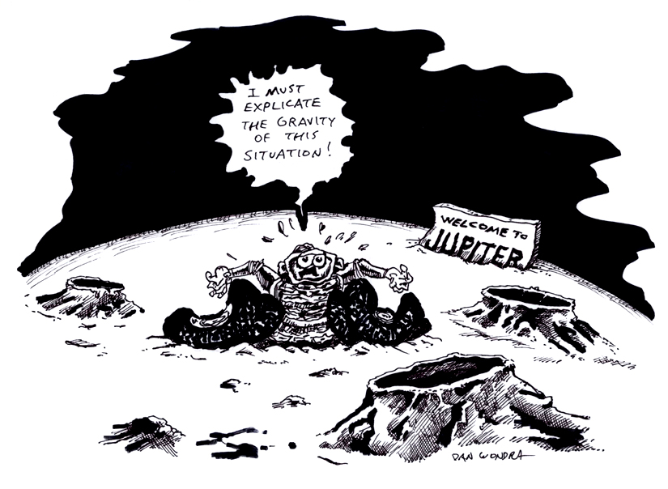
Lesson Title: Planetary Terrain
Draft Date: July 17, 2008
1st Author (Writer): Scott Tingelhoff
Science Topic: Astronomy
Grade Level: Middle School

Content (what is taught):
- Characteristics of the eight planets
- Ways to research different information
- Demonstration of friction with different materials
- Practice taking notes and writing down information from speakers
Context (how it is taught):
- Students will research information on their planet.
- Students will present their information to the class.
- Students will fill in a chart for the other planets.
- Students will re-create their terrain of their planet.

Activity Description:
In this lesson, students will be placed in groups and choose a planet to research. Students will be given a guideline with specific information that will be required for their presentation. During each student’s presentation, other students will have a guided practice sheet to follow and will fill out the sheet with specific information about all planets. There will be 8 groups total in each class, one for each planet. During the presentations, students will use material to re-create a similar terrain and show how it relates to the actual planet. Students will use the CEENBot to maneuver through the terrain.

Standards:
- Math—A1
- Science—A1, A2, B1, D1, D2, D3, E1, E2, F5
- Technology—A1, A3, B1, B4, C1, D2, F4

Materials List:

- Classroom Robot
- Study Guide
- Styrofoam
- Sand Paper
- Wood
- Box Fan
- Paper

ASKING Questions (Planetary Terrain)

Summary:
Students are asked what their (real) planet would look like.

Outline:
- Students will receive guidelines for researching their planet.
- Student will research information on their planet.
- Students will receive blank outline to fill in.
- Students will determine what information to include in their presentation.

Activity:
What are the different characteristics of your planet?

Questions | Possible Answers
Is your planet hot or cold? | Answers will vary depending on the planet.
What is the climate like on your planet? | Answers will vary depending on the planet.
Is there anything that you planet is known for? | Answers will vary depending on the planet.
Has your planet had any visitors? | Answers will vary depending on the planet.
How does your re-created terrain relate to the real terrain of your planet? | Answers will vary depending on the planet.
What is the distance of your planet from the sun and its revolution? How many moons orbit your planet? | Answers will vary depending on the planet.

Online Resources Search:
Websites: Geology of Planet Mercury
Images: Planet Surfaces
EXPLORING Concepts (Planetary Terrain)

Summary:
Students determine how the terrain on their planet looks and the features that set it apart from other planets.

Outline:
- Students will use resources to find information.
- Students will determine what the terrain on their planets look like.
- Students will compare their planet terrain to material in the classroom.
- Students determine the features of their planet that could be discovered with a robot.

Activity:
Place students into eight groups (one for each planet) and give each group a planet along with a guideline sheet. The guideline sheet will outline the specific information that the students need to include in their presentation. Student presentations will be conducted as a group with a visual aid, most likely PowerPoint. Along with the presentation, students will use material to re-create terrain from their planet. They will use the CEENBot to drive over the terrain and will discuss how the terrain is related to the planet. The students will also discuss how the robot can be used to further discover objects or material from their planet.

During each presentation, each student will have a blank guided practice sheet for each planet along with important information as categories. These categories will be specific topics that each group must discuss during their presentations. It will be the job of the audience to follow along and fill in the blank boxes as the student presents his/her planet. Students presenting will follow this guideline but may also choose to include other interesting information about their planet.

Worksheet: Planet Facts

Online Resource Search:
Video: Mars Rover
Websites: Planet Information
Solar System Characteristics

Classification of Celestial Bodies in the Planetary System
There are 4 major classifications of celestial bodies in the solar system: Jovian, Terrestrial, Dwarf planets (Planetodal), and Asteroidal. These classifications are listed in order from largest to smallest. Jovian bodies are gas giants. Terrestrial bodies are rocky worlds larger than 1000 km in diameter. Planetodal bodies are rocky with a size between 250 and 1000 km in diameter. Asteroidal bodies are rocky and are smaller than 250 km in diameter. These bodies have several variations in their physical, chemical, and motion characteristics.
Physical
Physical characteristics of celestial bodies include measurements such as distance to the Sun, radius, gravity, mass, density, volume, rotational period, revolution period, tilt of axis, and max/min temperatures. It also includes the quantity of atmosphere gases and moons. These characteristics often help in determination of the classification of the body. Similar classifications have similar characteristics.
Chemical
Each celestial body has its own unique chemical makeup of various elements. The chemical composition of a body has been determined in three ways. First, through direct observation from rovers or spacecrafts sent to many of the planets. The next two ways use indirect methods such as: 1) using the observation of the “wobble” created by the body 2) using observations of color spectrum viewed by a radio telescope. A wobble is the slight movement side to side of a star as a celestial body is revolving around changing the gravitational pull on the star as it moves. The amount of movement indicates the mass and volume of the body, which can be used to calculate its density. Also, element’s emit a certain color spectrum with specific bands of color present and others absent. Viewing the spectrum given off by a celestial body along with comparison of the density with known bodies, scientists can speculate on the composition of these unknown bodies because of the similarities to known bodies explored by rovers.
Planetary Motion
Mathematically, the planets can be modeled by Kepler’s Laws of Planetary Motion. There are 3 distinct laws that Kepler discovered. The first law states that each planet orbits the Sun in an elliptical orbit with the Sun at one of the foci of the ellipse. The second law, called the law of equal areas, states that a line which connects a planet and the Sun will sweep out equal areas during equal intervals of time no matter the position of the planet in its orbit. The third law states that the square of the time a planet takes to orbit the Sun is directly proportional to the cube of the semi-major axis (the distance from the center of the ellipse to the ellipse along the major axis or average distance) of the planet’s orbit. Mathematically this law can be represented by the formula $\frac{P_{\text{planet}}^{2}}{a_{\text{planet}}^{3}}=\frac{P_{\text{earth}}^{2}}{a_{\text{earth}}^{3}}$, where “a” is the semi-major axis and “P” is the orbital time of the planet.

For explanatory diagrams see attached file:
I_Sci_017_Solar_System_I_Diagrams.doc

ORGANIZING Learning (Planetary Terrain)

Summary:
Students will use different study tools to organize their learning.

Outline:
- Students will collect data about their planet.
- Students will find the information that is important for presentation.
- Student will determine who will present which part of the group’s presentation.
- Students will compare terrain to classroom material.

Activity:
Students will use an interactive science notebook in which they will record notes as they research their planet. Guide students in what information they must include but give them the opportunity to include any other information that they find during their research. Give each student a worksheet for each planet that lists all of the relevant categories. Students will fill in all the blanks on the worksheet during other group presentations.

On the back of the planet worksheet, an additional section will be included where students can describe the planet’s terrain. In this space, students will need to write about the terrain of the planets that were presented. If there is information that students do not receive from a group’s presentation, then they will need to fill in the blank areas on their own. Students will be graded on this worksheet and the worksheet will be handed back to use as a study tool for the test.

Worksheet: Planet Facts

UNDERSTANDING Learning (Planetary Terrain)

Summary:
Students will complete a variety of assessments.

Outline:
- Formative assessment of the planets
- Summative assessment of the planets

Formative Assessment
As students are engaged in learning activities ask yourself or your students these types of questions:
1. Were the students able to see similarities and differences in the planets?
2. Can students see how the robot could be used in the planetary environment?
3. Do students understand the difficulty with planetary exploration?

Summative Assessment
- Each student will be responsible to fill in the blanks on their guided practice worksheet for each planet. This worksheet will be graded as a homework assignment. Once students get the assignment back, the class will go over the answers to make sure that everyone has the correct answers so that they can use the worksheet to study for the test.
- Students will give group presentations over what they learned about their planet and how the robot can be used on their planet. Each group will receive a rubric that will include grading on the facts that were presented, their presentation skills, and on how well they worked as a team. Also, students will be graded individually.

Students can answer the following writing prompt:

Students will write an individual reflection that is a 1-2 page paper on how their research/activity can relate to STEM topics. The students will be asked how the research is integrated into these topics and how it could be further implemented in the future. Students can also include information about possible exploration that can be done using the robot.

