SPIRIT 2.0 Lesson:
You Drive Me Crazy!

==============================Lesson Header===============================
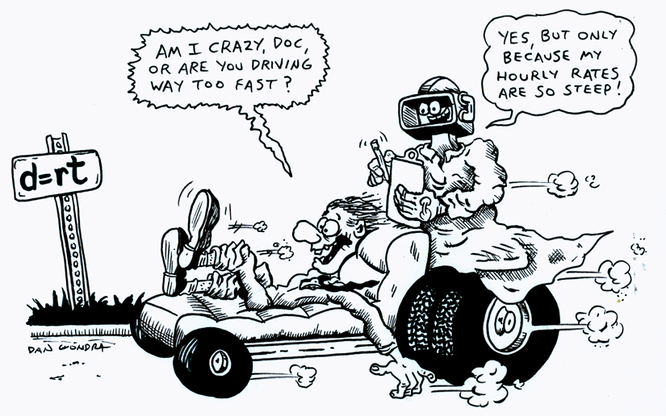
Lesson Title: You Drive Me Crazy
Draft Date: July 17, 2008
1st Author (Writer): Jennifer Pitzl
Physics Topic: Technology vs. Non-technology with emphasis on d=s/t
Grade Level: High School

Content (what is taught):
- Application of the Physics formula s=d/t
- Measurement and creation of data tables and graphs
- Demonstration of speed and acceleration of different objects
Context (how it is taught):
- The class will complete the “walk the walk” lab with themselves and then with the robot.
- Students will calculate speed and acceleration on the computer using Logger Pro.
- The class will discuss the limitations of technology and will produce ideas on how it can be improved.

Activity Description:
The students will use the motion detector, logger pro software, computers, robots and each other to analyze the motion of a student/robot moving across the room. The students will predict, test, and sketch a distance vs. time graph for both the student and the robot. Students will then analyze the difference between the two experiments and predict how to make the robots more efficient.

Standards:
Math—A2, D1
Science—A1, A2, B1, E2
Technology—F1, A4

Materials List:
- Classroom Robot
- Data Sheet
- Graph paper
- Computer
- Motion Detector
- Vernier LabPro and Logger Pro Software
ASKING Questions (You Drive Me Crazy)

Summary:
Students will guess whether it is easier for them to match the graphs by walking or for the robot to match the graphs by driving, and why. Students will try to match velocity and acceleration graphs by “walking” the graph themselves or by having the robot “drive” the graph.

Outline:
- Demonstrate the motion of the robot and a human.
- Ask students about expected outcomes.
- Determine variables.
- Match velocity graphs by having students ‘walk’ them and by having robots ‘drive’ them.

Activity:
Compare and contrast the movement of the student and robot.

Questions | Possible Answers
When the graph is moving at an increasing angle, what direction does the object need to be moving? | As the angle of the graph is increased, the object will need to travel forward to match the graph.
How can the speed be determined? | The speed can be found by taking the data and using the s=d/t formula. The graph can also be used by looking at the points and calculating.
What type of motion is occurring when the slope of a distance vs. time graph is zero? | There is no motion occurring, the object must be still.
What is the difference between the motions of the human vs. the motion of the robot? | The motion of the robot, the speed, is more difficult to change, which makes it more difficult, if not impossible to match the graph.

Students will set up the lab according to the preliminary directions. Students will then walk forward and backwards and at different speeds to try to match the presented graph. Students will then complete the analysis questions.

Working with a classroom robot, students will try to match the same graphs. Students may need to set up ramps to explore how the robot travels up and down different ramps. Students should notice that the speed of the robot will become less as the ramp angle is increased.

Students will begin to consider the data that should be collected about the ramp and the motion of the robot. Students may start measuring some of the data items such as the angle or slope of the ramp, along with the data collected with the motion detector.


To provide formative assessments as students are exploring these concepts ask yourself or your students these questions:
- How did changing the angle of the ramp affect the speed?
- Why was the velocity vs. time graph more difficult to match?

EXPLORING Concepts (You Drive Me Crazy)

Summary:
Students conduct several experiments to replicate graph patterns with humans and robots.

Outline:
- Define motion in terms of velocity.
- Apply the formula v = d/t.

Part I Preliminary Experiments
- Connect the Motion Detector to Dig sonic 1 of the Universal Lab Interface.
- Prepare the computer for data collection by opening “Exp 01b” from the Physics with Computers Experiment files of Logger Pro. One graph will appear on the screen. The vertical axis has distance scaled from 0 to 5 meters. The horizontal axis has time scaled from 0 to 10 seconds.
- Using Logger Pro, produce a graph of your motion when you walk away from the detector with constant velocity. To do this, stand about 1 m from the Motion Detector and have your lab partner click. Walk slowly away from the Motion Detector when you hear it begin to click.
- Try to match the shape of the distance vs. time graphs that you sketched in the Preliminary Questions section by walking in front of the Motion Detector.
Part II Distance vs. Time Graph Matching
- Prepare the computer for data collection by opening “Exp 01B” from the Physics with Computers experiment files of Logger Pro. The distance vs. time graph shown will appear.
- Describe how you would walk to produce this target graph.
- To test your prediction, choose a starting position and stand at that point. Start data collection by clicking. When you hear the Motion Detector begin to click, walk in such a way that the graph of your motion matches the target graph on the computer screen.
- If you were not successful, repeat the process until your motion closely matches the graph on the screen. If a printer is attached, print the graph with your best attempt.
- Prepare the computer for data collection by opening “Exp 01C” from the Physics with Computers experiment files of Logger Pro and repeat Steps 8 – 10, using a new target graph.
- Answer the Analysis questions for Part II before proceeding to Part III.
Part III Velocity vs. Time Graph Matching
- Prepare the computer for data collection by opening “Exp 01D” from the Physics with Computers experiment files of Logger Pro. You will see the following velocity vs. time graph.
- Describe how you would walk to produce this target graph.
- To test your prediction, choose a starting position and stand at that point. Start Logger Pro by clicking. When you hear the Motion Detector begin to click, walk in such a way that the graph of your motion matches the target graph on the screen. It will be more difficult to match the velocity graph than it was for the distance graph.
Prepare the computer for data collection by opening “Exp 01E” from the Physics with Computers experiment files of Logger Pro.
INSTRUCTING Concepts (You Drive Me Crazy)

Distance = rate * time
Putting “Distance = rate * time” in Recognizable terms: Distance = Rate * Time is a formula that is prevalent in algebraic settings. The formula is a linear equation with the rate serving as slope.

Putting “Distance = rate * time” in Conceptual terms: Distance = Rate * time is a formula that shows the relationship between three variables distance, rate, and time. If two are known the third can be calculated. The formula is linear and an example of direct variation.

Putting “Distance = rate * time” in Mathematical terms: The formula gives distance as either a function of rate or time with the other serving as a constant of variation. What this means is if the rate is held constant the distance will increase as the time increases (distance as a function of time) or if the time is held constant the distance will increase as the rate increases (distance as a function of rate).

Putting “Distance = rate * time” in Process terms: Thus, if you know the rate and the time of the object you can calculate the distance. If you know the distance traveled, and either the rate or time you can calculate the unknown variable. The ordered pairs (rate, distance) or (time, distance) are infinite and if graphed will form a straight line.

Note: This modeling situation can be used by students to make predictions about future events and is a concrete way of developing a linear equation that students can apply in other settings.

Putting “Distance = rate * time” in Applicable terms: The formula models the real world. It can apply anytime that an object is in motion at a constant rate or for a constant time. If you drive a robot faster it will go farther in the same amount of time or if you maintain a constant speed the robot will go farther in a longer time. To create a situation that models the real world, drive the robot at a constant speed for a determinable length of time and measure both the speed and time. The distance will be equal to the rate driven times the length of time driven.
ORGANIZING Learning (You Drive Me Crazy)

Summary:
Students use data tables that record distance, time, and ramp angle (if used) to calculate the speed of themselves and their classroom robot.

Outline:
- Collect both data from the robot and themselves.
- Data may include height, distance, and time.
- Calculations may include speed and acceleration.
- Graph data such as speed and acceleration.

Activity:
Students collect data about the motion of themselves and the classroom robot as it moves forward and backwards in sight of the motion detector. Students will vary the angle of the ramp to see if there is a change in speed. Students collect data using a data table in Logger Pro or a spreadsheet program.

Students use the data to calculate the velocity of motion using the formula s=d/t where d is the distance, s is the speed of motion, and t is the time. Students will then do an analysis of the data and predictions that could improve the motion of the robot.

Worksheet: Graph Match

UNDERSTANDING Learning (You Drive Me Crazy)

Summary:
Students will complete a lab write-up about the speed formula and about how to improve the robots ability to move.

Outline:
- Formative assessment of s=d/t speed
- Summative assessment of a=v/t
- Summative assessment of tables and graphs

Formative Assessment
As students are engaged in learning activities, ask yourself or your students these types of questions:
1. Were the students able to apply the s=d/t formula and solve for speed?
2. Can students explain the meaning of speed?
3. Can students explain the difference between speed and acceleration?

Summative Assessment
Part I Distance vs. Time Graph Matching (Complete Sentences)
- Describe how you walked for each of the graphs that you matched.
- Explain the significance of the slope of a distance vs. time graph. Include a discussion of positive and negative slope.
- What type of motion is occurring when the slope of a distance vs. time graph is zero?
- What type of motion is occurring when the slope of a distance vs. time graph is constant?
- What type of motion is occurring when the slope of a distance vs. time graph is changing? Test your answer to this question using the Motion Detector.
Part II Velocity vs. Time Graph Matching (Complete Sentences)
- Describe how you walked for each of the graphs that you matched.
- Using the velocity vs. time graphs, sketch the distance vs. time graph for each of the graphs that you matched. In Logger Pro, switch to a distance vs. time graph to check your answer. Do this by clicking on the y-axis label and unchecking velocity; then check Distance. Click to see the distance graph.
- What does the area under a velocity vs. time graph represent? Test your answer to this question using the Motion Detector.
- What type of motion is occurring when the slope of a velocity vs. time graph is zero?
- What type of motion is occurring when the slope of a velocity vs. time graph is not zero? Test your answer using the Motion Detector.
Part III Human vs. Robot (Short Essays)
- What was the difference in the graph matching between the robot and the human?
- What changes could be made to either the robot or the human to improve the data collection?
- Did you use any ramps to try to match the graphs with the robot? If so, did it make a difference and why?

