Graph Match

Directions: Match the following graphs using the robot first and then a student. Use a different colored pen or marker to draw in the paths. Compare the results.

Example:

Robot | Student
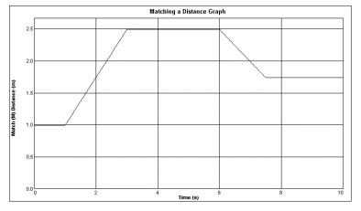
Comparison:

Velocity Graph
Robot | Student
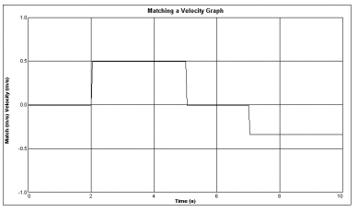
Comparison:

Distance Graph
Robot | Student
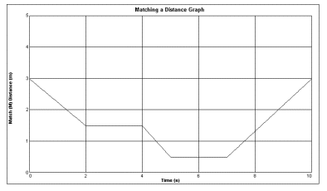
Comparison:

