SPIRIT 2.0 Lesson:
You’re Related to ME? (Electricity and Magnetism)

==============================Lesson Header===============================
Lesson Title: You’re Related to ME?
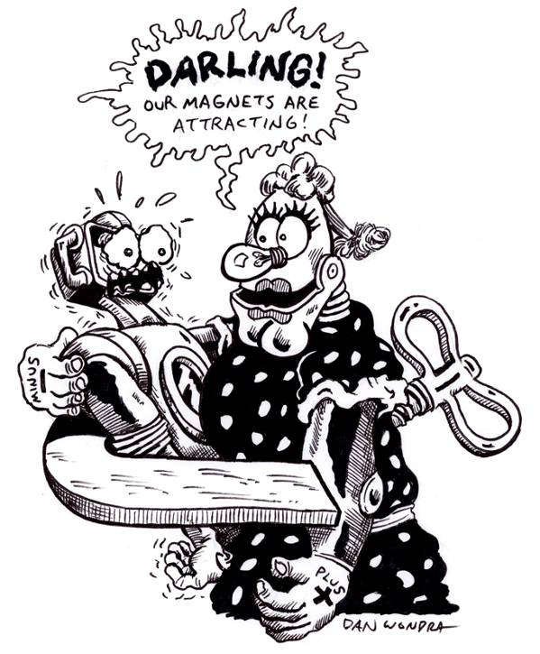
Draft Date: July 17, 2008
1st Author (Writer): Rachel Benson
Science Topic: Magnetism and Electricity
Grade Level: Middle

Content (what is taught):
- What electromagnets are and how they work, compared with a bar magnet
- Basic understanding of a stepper motor (found in some robots) and how this relates to an electromagnet
- Creating graphs of data and recording data and observations in notebooks
Context (how it is taught):
- Students will create an electromagnet.
- Students will measure and compare the strength of the electromagnet vs. the bar magnet; students graph results.
- Students will view and compare diagrams of common electromagnets and a stepper motor.
- Students will act out a simplified version of a stepper motor as a class.

Activity Description:
In this lesson, students will investigate what an electromagnet is and from where it gets its strength. Students will observe how electromagnets are used in daily life; often found in many different settings and contraptions. Students will demonstrate a basic understanding of a CEENBot’s stepper motor, which uses an electromagnet to function. Using the robot will help students experience how electromagnets can be found all around them.

Standards:
Math—A1 Science—E1 Technology—B3, F5, D3

Materials List:
- Classroom robot | (One set per pair of students)
- Poster board | - 1 m bell wire or magnet wire
- Student notebooks | - iron nail
- Diagrams of electromagnets used in daily life | - D cell battery
- Diagrams of robot’s stepper motor | - Bar magnet
- Non-digital clock | - Graph paper
- One square each of red and black | - Paper clips

ASKING Questions (You’re Related to ME?)

Summary:
To activate prior knowledge, ask students what they know about electromagnets and how electromagnets compare with bar magnets. Students will find the answers to these questions as they experiment with creating and revising the electromagnet.

Outline:
- Observe diagram of how electromagnets are made.
- Ask students to construct an electromagnet using 1m bell wire or magnet wire, iron nail and D cell battery.
- Compare electromagnet and bar magnet’s strength by seeing how many paperclips each will pick up.
- Experiment ways to increase the electromagnet’s strength.
- Graph the results.

Activity:
Students will create an electromagnet, compare it with the bar magnet, and revise it to increase its strength. Students will graph the strength of the two types of magnets based on the number of paper clips that each type picks up.

Questions | Possible Answers
What are electromagnets? | An electromagnet is made when a coil of wire is put around a ferromagnetic material (such as iron) and is attached to an electrical current. It produces a strong magnetic field, and this magnet can be turned on and off.
How do they compare with bar magnets? | A bar magnet’s magnetic field cannot be shut off. Since the electromagnet’s magnetic field depends on the electrical circuit, it can be shut off when the circuit is opened. Bar magnets and electromagnets are also made from different materials.
Why are electromagnets profitable? | Electromagnets are profitable because they can have a very strong magnetic field. They can also be shut off, which allows for more versatility.
How does an electromagnet get its strength? | An electromagnet’s strength comes from the strong magnetic field that results from current flowing through wire, formed into a coil around a metal, which also becomes magnetized as a result.
How can you make electromagnets even stronger? | When the number of coils of wire is increased around the screw, the strength of the magnetic field also increases.

Online Resource Search:
Hyperphysics magnets and electromagnets
EXPLORING Concepts (You’re Related to ME?)

Summary:
Students will view diagrams of common devices that use electromagnets in order to see how electromagnets are used in daily life.

Outline:
- Observe a diagram of an electromagnet in an alarm bell.
- Observe a diagram of an electromagnet in other common devices such as a telephone or a magnet that picks up crushed cars.
- Observe a diagram of an electromagnet used in a CEENBot’s stepper motor.
- Compare the similarities and differences of the electromagnets in a Venn diagram.

Activity:
After the students understand how an electromagnet is formed and from where it gets its strength, they will observe diagrams to see how electromagnets are used in many common devices.
Alarm Bell: When current flows through the wire coil, a magnetic field is created. This magnetic field attracts a strip of iron on a spring, which is also connected to a ringer, which strikes the bell. At the same time, the strip of iron breaks the circuit, which makes the spring return to its original position after striking the bell.
Stepper Motor: When current flows through the stepper motor, it flows only to specific points around a circle of electromagnets. Inside of this circle is a bar magnet, which is attracted to the specific points that are magnetized. The specific points are given electricity in such a way that the magnet in the middle will continue to make continuous, rapid revolutions, in line with the specific points to which it is attracted. In this way, the revolving bar magnet will cause the motor to have a revolving motion, which provides energy for other operations, such as the turning of wheels on the CEENBot. The teacher can use a clock to illustrate the concept of the bar magnet in the middle turning at specific intervals.

Students will compare the similarities and differences of how these electromagnets are used in a Venn diagram.
Similarities: All use an electromagnet in which a magnetic field is created by electric current running through a spiraled wire. The magnetic field produced by the electromagnet is then used to attract another component to perform a different function.
Differences: The alarm bell uses an electromagnet in which current flows completely through it. The stepper motor has only certain points in the electromagnet in which the current flows at any given moment.

Worksheet: Venn Diagram

INSTRUCTING Concepts (You’re Related to ME?)

Magnetism

Putting “Magnetism” in Recognizable terms: Magnetism is the product of attractive and repulsive forces by a material (usually cobalt, nickel, or iron). Attractive and repulsive forces (magnetism) can also be generated by electrical currents or electrically charged particles.

Putting “Magnetism” in Conceptual terms: Magnetism is created by the opposite poles of the magnet, commonly called the north and south poles. If you have two magnets, opposite poles will attract and the same poles will repel. Around each magnet is a magnetic field the size and strength of which is determined by the strength of the magnet. Magnetic fields attract and repel like magnets.

Putting “Magnetism” in Process terms: Magnetism is a force that is used to benefit humans. Magnets and the fields generated by them are integral components of all electronic devices, medical applications, and use and may be used to reduce friction. Some monorail trains, as an example, use repulsive magnetism to lift the train from the surface of the rail. As clean energy and efficiency become more important in the future, magnetism will play an increasingly more important role in technological development.

Putting “Magnetism” in Applicable terms: The simplest application of magnetism is the common compass as it orients itself to earth’s magnetic field allowing the user to find magnetic north. Magnetism is used to create electricity and is a staple in much of the technology we use every day.

ORGANIZING Learning (You’re Related to ME?)

Summary:
Students graph the strength of electromagnets compared to bar magnets by measuring the number of paper clips that each type of magnet will pick up. Students use a Venn diagram to compare two uses of electromagnets used in common devices.

Outline:
- Create an electromagnet and measure number of paper clips that it can pick up.
- Measure the number of paper clips that the bar magnet can pick up.
- Increase electromagnet’s strength by increasing the number of coils; measure the number of paper clips that can be picked up now.
- Graph results on a bar graph to determine which magnet is stronger.
- Observe diagrams of electromagnets and their uses in common devices.
- Write observations in a notebook.
- Use a Venn diagram to compare these uses of electromagnets.

Activity:
After creating an electromagnet, the students will measure its strength by the number of paper clips it can pick up. Students will attempt to increase the electromagnet’s strength by increasing the number of coils of wire around the iron screw. Students will also measure the strength of a bar magnet by determining the number of paper clips it can pick up. All results will be graphed on a bar graph, including the number of paper clips picked up by the original electromagnet, the revised electromagnet, and the bar magnet.

Worksheets: Electromagnet Venn Diagram and Magnet Graph

UNDERSTANDING Learning (You’re Related to ME?)

Summary:
Students will create a poster of four key ideas related to electromagnets, and one (or more) idea of something they could alter or invent to use an electromagnet. Students will also show a basic understanding of a stepper motor by acting it out as a class.

Outline:
- Formative assessment of a basic understanding of how a stepper motor works
- Formative assessment of how an electromagnet is made and how it works
- Summative assessment of how an electromagnet is made, where it gets its strength, why it is useful, how they are used in common devices, and how they are different than bar magnets
- Summative assessment of bar graph and Venn diagram

Activity:
Formative Assessment
As students are engaged in learning activities ask yourself or your students these types of questions:
1. Were the students able to create an electromagnet and increase its strength?
2. Can students explain how an electromagnet works?
3. Can students explain how a stepper motor works?

As a class, the students will act out the basic components of a stepper motor. All of the students will stand in a circle, facing inward. One student will be chosen to stand in the middle of the circle. Each student will be given one square each of red and black paper. Two students will have electricity flowing through them at once. These students will hold up red squares of paper. When no electricity is flowing through a student, he or she will hold up a black square of paper. The person in the middle will always turn toward the students with red paper. As the electricity flows around the circle, the person in the middle will rotate. The object will be to see how fast the students in the circle can make the student in the middle rotate. This will be done by making the electricity “flow” around the circle as fast as possible!

Summative Assessment
Students will create a poster of five key ideas related to an electromagnet, responding to the following questions: How is it made? Why it is useful? How it is used in common devices? How is it different then a bar magnet? Students will also include one (or more) ideas of something they could alter or invent that would use an electromagnet. Students will present their ideas to the class.

