SPIRIT 2.0 Lesson:
A ‘CEEN’ic Galaxy Quest! (Speed)

============================= Lesson Plan =============================
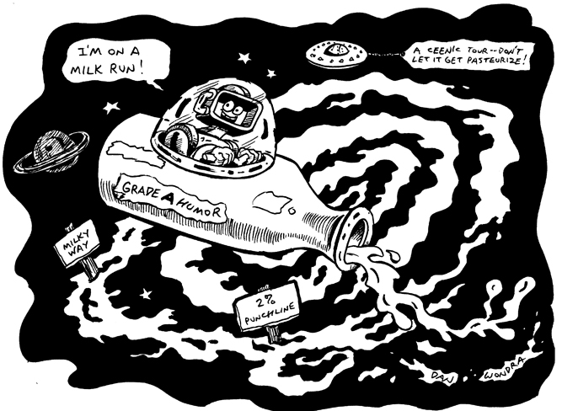
Lesson Title: A CEENic Galaxy Quest!
Draft Date: December 31, 2008
Author (Writer): Derrick A. Nero
Topic: Speed, emphasis on astronomical speed requirements.
Grade Level: Middle

Outline of Lesson

Content (what is taught):
- Speed
Context (how it is taught):
- Students research the distances between objects in the Milky Way.
- Students calculate the mean speed of a CEENBot.

Activity Description:
In this lesson, students research the distances between objects in the Milky Way galaxy in terms of various units (e.g., light year, astronomical unit (AU), kilometer, and mile). Students will compare objects’ distances in relation to the mean diameter of our solar system. Then, students will calculate the mean speed of a CEENBot through a series of speed trials.
Students will calculate the time that would be necessary for a CEENBot to travel from one object in the Milky Way to another object in the galaxy.


Standards:

Science: A1, A2, B2, D3 Math: A1, B3, C4, D1, D2
Technology: A3, C2

Materials List:
Astronomical database
Measuring tape, 50-100m
Stopwatch, digital
Colored masking tape
Engineering notebook

ASKING Questions (A ‘CEEN’ic Galaxy Quest!)

Summary: Students are asked to determine the speed of various objects.

Outline:
- Present video of various objects traveling over a distance.
- Facilitate an inquiry of the speeds traveled.

Activity:
The teacher will present video of various objects traveling over a distance to the students. Students will hypothesize the speed traveled by the objects.

Questions | Possible Answers
- What units of measurement would be most useful to report? | Various. Depending on the country (i.e., U.S. Customary when in the United States and Metric everywhere else).
- What resources would be useful to find the speed of the objects? | Various. Measuring tape, stopwatch, reference point, radar gun, etc.
- What is the importance of the ability to obtain high speeds? | Various. Travel long distances in less time.
EXPLORING Concepts (A ‘CEEN’ic Galaxy Quest!)

Summary: Students explore how to calculate speed.

Outline:
- Students will explore conducting speed trials.
- Students will apply calculating trip duration based on speed.

Activity:
Students will conduct speed trials by determining a distance to travel and timing various objects traveling the determined distance. Students will time “objects” traveling the determined distance using stopwatches. The time necessary for each object to travel the determined distance will be recorded (see sample table below). Then, students will calculate the speed (speed = distance / time) of each object.

Worksheet: Object Speed Tables

To provide a formative assessment as students are exploring conducting speed trials, ask yourself or your students these questions:
- Did students assign a student(s) to confirm the distance? Time? Speed?
- Did students primarily use U.S. Customary or Metric measurement units?
- Did students compare the quantities of the speed results between U.S. Customary and Metric?
Students will use the mean CEENBot speed to calculate the CEENBot’s trip duration to Mars. Students will then use the mean CEENBot speed to calculate the CEENBot’s trip duration to a chosen object in the Milky Way galaxy.
To provide formative assessments as students are exploring the application of calculating trip duration ask yourself or your students these questions:
- Did students primarily use U.S. Customary or Metric measurement units?
- Did students convert quantities to scientific notation?
- Did students use proportions to find unknown values?
- Did students calculate trip duration using light years after trip durations were initially calculated?

Astronomical Measurement

Putting “Astronomical Measurement” in Recognizable terms: Astronomical measurement is the process of measuring great distances present in space. The most common units used are the mile, kilometer, light year, astronomical unit, and parsec. Astronomical measurements are critical for our understanding of the universe. The sheer size of the universe’s expanse makes using common units impossible. For this reason the light year, astronomical unit, and parsec were created to quantify these large expanses.

Putting “Astronomical Measurement” in Conceptual terms: Each of the five common units used to measured space were defined and developed differently. The mile (mi) is much older than any of the other units and was developed with several versions. Currently, the survey mile is used for astronomical measurement as it is equal exactly to 5280 feet. The basis of the kilometer (km) is the meter, which in 1983, was defined as the length travelled by light in vacuum during 1 / 299,792,458 of a second. A kilometer is equal to 1000 meters. Finally, the development of the light year (ly) came. It is really a measurement of distance, but is based on the length a light ray can travel in space in one year. An astronomical unit (AU) is the approximate mean distance between the Earth and the Sun. The AU is considered an approximation because the Earth travels in an elliptical pattern around the Sun, yet it measures the radius of an assumed circular orbit. Nonetheless, it is a helpful comparison for other objects in space. The parsec (pc) is defined as the distance from the Earth at which stellar parallax is 1 second of arc. Originally the method of calculating the parsec involved trigonometry, but currently the parsec is based off other astronomical units and equals approximately 3.26 light years or about 206,265 astronomical units.

Putting “Astronomical Measurement” in Mathematical terms: The five main astronomical units can be readily converted one to another. All that is needed is to know the conversion factor. Then, a mathematical method known as dimensional analysis or unit analysis will aid in making the conversion. (see attached chart and diagram)
Astronomical measurements are often necessary to determine how long or how fast an object in space travels. The distance (astronomical measurement) will equal the rate traveled multiplied by time (d = rt). Note when using the formula d = rt it is important that the units be in agreement. For instance, if the distance is in light years, the rate must be in light years per time.

Putting “Astronomical measurement” in Applicable terms: Astronomical measurements are used for determining the distance between objects in space as well as for developing ideas of space travel. A daunting tasking knowing the formula d=rt indicates transport in space must either be extremely fast or very time consuming to reach any of the vast distances. Using current technology it takes over 3 days to travel the approximate 384,000 km (less than .003% of an AU) to the moon. This example makes it evident that current technology (rocket engines) will not suffice for long-term space travel. Some examples of theoretical space travel are: 1) generational ships, 2) traveling in suspended animation, 3) frozen embryos, 4) faster than light travel, and 5) wormholes in space. These ideas are theoretical and may never exist, but serve as launching boards that scientists can use to developing ideas for traveling in the large expanses of space.

Related I’s: Dimensional Analysis

Attachments:
I_Sci_014_Astronomical_Measurement_I_Diagrams.doc
ORGANIZING Learning (A ‘CEEN’ic Galaxy Quest!)

Summary: Students use a data table to record the speed of an object and the time required to travel to another object in the Milky Way galaxy.

Outline:
- Research and record distances between objects in the Milky Way and Earth.
- Compute the time required to travel to another object in the Milky Way galaxy.

Activity:
Students research the distances between objects in the Milky Way and Earth using the assigned astronomical database (i.e., textbook, reference book, software, and/or online). Students complete a “Distances and Durations to Other Places in the Milky Way” organizer (see table below). Students compute “Duration” (time required to travel to another location) by dividing “Destination” by “Speed”.

Distances and Durations to Other Places in the Milky Way Organizer

Object | Speed | Destination  (distance from Earth) | Duration
Student
Ball, rolled
Ball, thrown
CEENBot

Worksheet: Distance and Duration Tables

UNDERSTANDING Learning (A ‘CEEN’ic Galaxy Quest!)

Summary: Students create a “travel package” for customers traveling the Milky Way galaxy.

Outline:
- Formative assessment of the use of units of measurements and speed.
- Summative assessment of application of units of measurements and speed.

Activity:
Students will research sample “travel packages” provided by cruise lines, airlines, and rail systems to develop a baseline of common criteria presented such as destination, duration, amenities, cost, etc. In addition, students will compare presentation media and design layout.

Formative Assessment
As students are engaged in learning activities ask yourself or your students these types of questions:
- Can students explain the relationship between the mode of travel, duration, and destination?
- Can students explain the cost differences between the modes of travel such as fuel cost, maintenance, etc.?

Summative Assessment
Students will form small groups (three to four students) to create a “travel package” for customers traveling the Milky Way galaxy.
- Travel packages must present
  - Destination
  - Duration
  - Mode of travel (innovations made to the CEENBot)
  - Amenities
  - Cost
- Travel packages must present respective object in the Milky Way
  - Interesting facts
  - “What to do” during travel

