SPIRIT 2.0 Lesson:
FRICTION THIS

==============================Lesson Header===========================
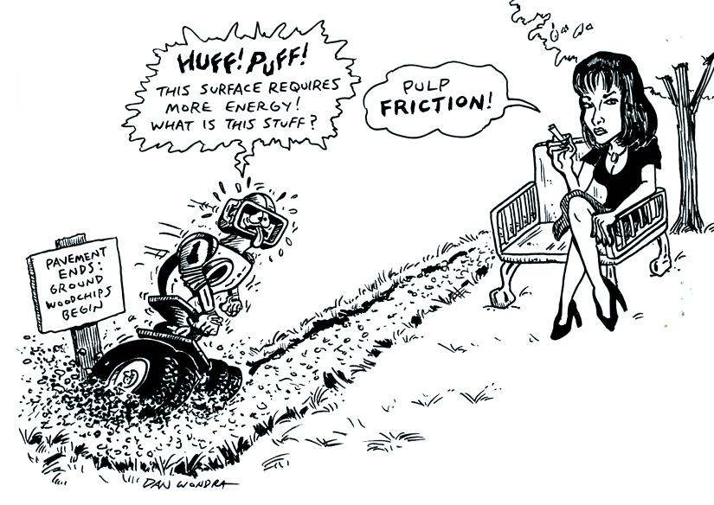
Lesson Title: Friction This
Draft Date: April 2009
1st Author (Writer): Susan De Roy
Math Topic: Use of formula d=rt
Grade Level: Upper Elementary

Content (what is taught):
- Type of road surface and how it effects force needed to move the CeenBot
- Higher friction requires more energy input
- Lower friction requires less energy input

Context (how it is taught):
- The classroom robots will be driven along a surface of different materials
- The distance and times are measured, recorded, and compared
- Speed is calculated and data is graphed

Activity Description:
Students will use various materials to cover a given distance to drive a CeenBot over. They will investigate the impact different materials have on creating friction between the road and tires of the robot. They will use the time and the distance traveled to compute the rate of motion for each type of material used. Students will try to determine the most efficient* material for the road. (* maximum speed and minimum friction)

Standards:
Math – D2, A3 Science - A1, A2 Technology - C1

Materials List:
Various “road materials”
- Different grades of sandpaper, Wax paper, Smooth metal
- Small pebbles, 12 inch tiles
- Rough cut wood board (wide enough for robot)
Data Sheets, Graph Paper
Stopwatches, Measuring Tools

ASKING Questions (Friction This)

Summary: Students will predict what effect different road surfaces might have on the speed of a robot traveling a given distance.

Outline:
- Ask students to predict the effect different road surfaces have on speed.
- Ask students to predict if different surfaces have anything to do with “friction”.
- Set up a road in the hallway, outside, or other open area.
- Change the surface by adding various materials for the robot to drive over.

Activity:
- After covering the concept of friction in science, discuss friction if real life and how it effects our daily life. Create a real life situation by testing road surfaces and the speed of the robot on various types of roads.

QUESTIONS | POSSIBLE ANSWERS
- Does the type of road you drive on effect the speed of the vehicle? | Bumpy roads will make you slow down. Slick roads will make you go faster. Straight and curvy roads would effect the speed of a vehicle.
- How can you determine the speed of a vehicle on a road? | Measure how far the vehicle travels and then divide that number by the amount of time it took to travel it.
- How can the motion of a robot be measured? (Formula r = d/t) | By using distance and time again. The motion of the robot would be measured by taking the distance and dividing it by the time.
- Does increased speed reflect more or less friction? | The faster something moves, the less friction it has. Friction slows things down so they would take longer to go the same distance as something with less friction.

EXPLORING Concepts: (Friction This)

Summary: Students will explore the speed of the robot on various surfaces.

Outline:
- The road is measured to a given length
- Students start by measuring time and distance on a straight road
- Students cover the same distance with various materials on the road and record time and distance again
- Changes in friction can be assessed by difference in times

Activity:
Working in small groups, students will set up various road conditions. They will drive the robot over the different surfaces recording the time and distance traveled each time (see sample data table below). Students explore what surfaces create the fastest times and which slow the robot down. Students then discuss how weather might effect road conditions. Students then try adding water to some of the road surfaces and again record times. You might try using vegetable oil or crushed ice on surfaces as well.
Students should start to see patterns of how characteristics of materials effect time needed for the robot to travel a given distance. The data collected will be used to evaluate student participation and understanding of activity.

Road Surface | Time | Distance | Rank surfaces from fastest to slowest
INSTRUCTING Concepts (Friction This)

Distance = Rate * Time

Putting “Distance = rate * time” in Recognizable terms: Distance = Rate * Time is a formula that is prevalent in algebraic settings. The formula is a linear equation with the rate serving as slope.

Putting “Distance = rate * time” in Conceptual terms: Distance = Rate * time is a formula that shows the relationship between three variables distance, rate, and time. If two are known the third can be calculated. The formula is linear and an example of direct variation.

Putting “Distance = rate * time” in Mathematical terms: The formula give distance as either a function of rate or time with the other serving as a constant of variation. What this means is if the rate is held constant the distance will increase as the time increases (distance as a function of time) or is the time is held constant the distance will increase as the rate increases (distance is a function of rate).

Putting “Distance = rate * time” in Process terms: Thus if you know the rate and the time of the object you can calculate the distance. If you know the distance traveled and either the rate or time you can calculate the one. The ordered pairs (rate, distance) or (time, distance) are infinite and if graphed will form a straight line.

Of note, is that this modeling situation can be used by students to make predictions about future events and is a concrete way of developing a linear equation that students can apply in other settings.

Putting “Distance = rate * time” in Applicable terms: The formula models the real world. It can apply anytime that an object is in motion at a constant rate or for a constant time. If you drive a robot faster it will go farther in the same amount of time or if you maintain a constant speed the robot will go farther in a longer time. To create a situation that models the real world, drive the robot at a constant speed for a determinable length of time and measure both the speed and time. The distance will be equal to the rate driven times the length of time driven.
ORGANIZING learning (Friction This)

Summary: Students will use data tables to record the type of road surface; distance the robot travels, and the time. Students will use this information to calculate the rate of motion or speed of the robot.

Outline:
- Drive the robot over a straight road.
- Change the road surface with various types of materials.
- Record distance, time to travel, surface materials, and added “weather conditions” if any
- Calculate speed for each type of road created and tested

Activity:
Students all drive the robot over the unaltered blacktop for a given distance determined by teacher to use as their baseline data. They mark the beginning and end of the distance traveled then record data on table. Students then change the road surface using materials provided and again drive the robot over the road and record results. Students should use three or more surfaces for data collecting. Students may then try adding “weather conditions” to the road surface, such as water or crushed ice and compare resulting data to see if frictions is effected by weather conditions. Example of a student handout is attached at end of this lesson.
Students then use the data to calculate the rate of motion or speed using the formula d = rt where d equals the distance traveled, r is the rate of motion of the robot, and t is the time. Students will then create line graph to plot the data*. They will compare speeds to road surfaces and weather conditions by graphing dry road surface data in blue, wet road surface data in green, and icy road surface data in red (*the x-axis being the time in seconds and y-axis being road surface).

Worksheet: FrictionThisWS.doc

UNDERSTANDING Learning (Friction This)

Summary: Students create a data chart using the distance-rate-time formula and plot it.
Students will create a poster/collage using pictures of various types of transportation that is effected by friction and road conditions. They can use drawings and magazines or Internet pictures. Students will also brainstorm how friction might be increased or decreased on roads.

Outline:

Formative assessment of the math formulas taught (d = rt and r=d/t)

Formative assessment of the data charts created by students

Summative assessment of the poster created to show friction and ideas how to change it

Activity:

Formative Assessment
As students are engaged in the lesson, ask these or similar questions:

Were students able to collect accurate data?

Were the measurements reasonable?

Did the data vary between different surfaces?

Were students able to plot different data on a chart?

Were students able to transfer skills to a set of given, unrelated data provided by the teacher?

Summative Assessment

Unit Review and Evaluation:

Students will create and present a poster using pictures and drawings showing friction between various types of transportation and road conditions.

Students will use post-it notes to give feedback to students on their ideas.

Students will also brainstorm how friction can be increased or decreased.

A teacher-created assessment to give students the chance to apply speed formulas

Students will write the answer to one of the following essay questions about the activities and applications:

What are some situations/road conditions that you might want to increase friction between the tire and road of the robot?

What are some road surfaces and conditions that might make driving more dangerous? Use your data chart to support you ideas.

What pieces of information are needed to calculate speed? Give an example.

