SPIRIT 2.0 Lesson:
Robotic Muscles

===========================Lesson Header=========================

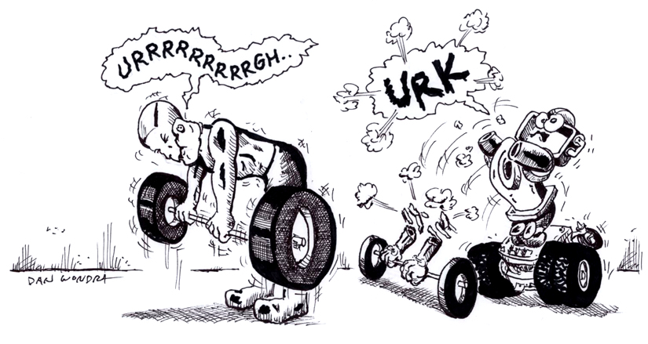
Lesson Title: Robotic Muscles
Draft Date: April 2, 2009
1st Author (Writer): Robert Jensen
Topic: Work, Pulleys
Grade Level: 4-6

Content (what is taught): Using a pulley to lighten the load for a robot.

Context (how it is taught): Students will use the CEENBot to pull a load. After trying a certain amount of weight we will add one pulley, then more to see how the load is easier to pull.

Activity Description: Using the CEENBot to pull weight with pulleys.

Standards: (At least one standard each for Math, Science, and Technology - use standards provided)
- Math – E1, E2, E3
- Science – A1, A2, B3, B2
- Technology - C2, C3, C4, D1, D2

Materials List:
- CEENBot
- Pulleys
- Rope
- Multiple sizes of weights
- Scale

ASKING Questions (Robotic Muscles)

Summary: Students will be shown the robot and some weights. They will be given the challenge of getting the robot to move all the weights.

Outline:
Question | Answer
Predict how much weight we can get our robot to pull. | Various Answers
What can we do to get this robot to pull more weight? | Add pulleys
What will happen if we add more pulleys to the robot’s load? | Make it easier to pull, more weight can be added.

Activity:

Have students lift the weights and see how much they can lift. What do they need to do to be able to lift more and more weight?

EXPLORING Concepts (Robotic Muscles)

Summary:
Simple machines will be presented and explored. The goal is to see how these basic ideas increase our ability to manipulate our surroundings.

Outline:
- Present simple machines and provide examples (possibly on the robot or in the world.)
- Have students talk about how a simple machine can help a robot increase its ability to do work
- Decide on a method to use a simple machine (pulley) that the robot can use.

Activity: The six simple machines are the lever, inclined plane, wheel and axle, screw, wedge, and pulley. Talk about how the simple machines can be used to increase efficiency of work and allow us to do more than we could do otherwise. Analyze the robot and see if any simple machines are present on the robot (wheel and axle, screws…) and look at the world for examples of these machines. Talk about the robot lifting weight and which simple machine would be most useful. The pulley is the obvious choice here. Teachers might have to guide students to the pulley to show how it could be applied. Provide examples of the simple machines for students to manipulate while this decision is being processed to get hands on experience.
Screwdriver
Inclined Plane
Screw
Lever
Pulley

Work

Putting “Work” in Recognizable terms: If one person lifts a 3 newton object 4 meters and another lifts a 2 newton object 6 meters, did they perform the same amount of work? The answer is yes, because work involves both the force applied to move or displace an object and the distance of the movement.
(Note: W = F x d = 3 x 4 = 2 x 6 =12)

Putting “Work” in Conceptual terms: Work is viewed in two types of situations when an object’s speed is changed or most commonly when an object’s position changes. If a child is swinging, work is performed when an adult pushes the child forward along with the swing. This increases the child/swing’s speed forward. Work is also performed when someone pulls against the bow on an arrow; an applied force goes against the elastic force of the bow string, lifts a bowling ball up from the ground; an applied force goes against the force of weight of the bowling ball, or slides a couch across the floor; an applied force goes against the force of friction of the floor to couch. In all these instances, a force was applied to move an object some distance against an opposing force.

Putting “Work” in Mathematical terms: Work can be mathematically computed by the formula W = F * d where “W” is the work done, “d” is the displacement of the object, and “F” is the force applied to the object. Note that to use this formula the force and displacement have to be in the same direction. Work is measured in joules (J) or the number of newton’s multiplied by meters. Force can be calculated as well using Newton's 2nd Law formula, F = mass*acceleration, provided the acceleration is constant.
If an object has a force acting at angle to the displacement, like a little girl pulling a wagon at an upward angle, then the formula W = F * d * cos θ is used where the angle between the force and displacement is θ. Since the wagon moves horizontally, only the horizontal component of the force does work.

Putting “Work” in Process terms: Thus, work is a measurement of the amount of energy that is transferred to an object by a force in the direction of the displacement. It is possible to exert a force and that does not do work. There are two key instances: 1) If a force is applied but no displacement occurs, then no work is performed. If a person pushes and pushes on a stuck car and it does not move then no work was performed.
2) When the force is applied at a 90 angle to the displacement, then no work is performed. For instance in circular motion the centripetal force does no work because it is perpendicular to the velocity of the object, or if a person carries a book horizontally across the room while applying a vertical force against the book, no work is performed. However, if the force is applied in opposition to the displacement this is considered negative work because the cosine of an angle is negative for angles from 90to 180.

Putting “Work” in Applicable terms: Work applies anywhere that a force in the direction of the displacement moves an object or when speed changes. It happens when stairs are climbed, objects are picked up, or merry-go-rounds are slowed down/sped up.

Other Related “I” pieces: Force, Vectors, Power, Hooke’s Law

ORGANIZING Learning (Robotic Muscles)

Summary:
Students will use a worksheet to keep track of work that the robot does with and without pulleys.

Outline:

Students will use the robot to “lift” weight and calculate the work being done in each situation. Pulleys will be added to each trial. The experiment run again to see how much work is done. Repeat until students have added at least 3 pulleys. Students should be filling out information on the worksheet to keep track of the amount of weight each robot can lift compared to a certain number or pulleys and calculating the maximum work done in each trial.

Activity:
- Ask: How can a pulley be used to lighten the load? Take all answers and predictions.
- Use the CEENBot and begin adding weight until the robot will no longer pull it.
- Record how much weight was pulled.
- Add 1 pulley and repeat the weight pulling
- Add 2 pulleys and repeat.
- Add 3 pulleys and repeat.
- Be sure and fill out worksheet as we work through.

Worksheet: Pulley Data Sheet

UNDERSTANDING Learning (Robotic Muscles)

Summary:
Assessment will take place throughout the lesson with a variety of assessment types. By the end of the lesson students will need to demonstrate a knowledge of pulleys as a simple machine in order for us to move on.

Activity:
Formative Assessment
As students are working ask these or similar questions:
- Do students understand how simple machines function and are useful?
- Can students find examples of simple machines present on the robot and in the world?
- Do students understand how the pulley system will work and increase the work done by the robot?
- Can students find the work done by the robot?

Summative Assessment

Students can answer the following writing prompt:
1) Define work and cite several different examples where work is done.
2) Describe why we can do more work with the aid of pulleys than without.
3) List the simple machines and where you would find an example of them in the world. How might
these simple machines be helpful to a robot?

