SPIRIT 2.0 Lesson:
The Raw of Newton’s 3rd Law

============================= Lesson Plan =============================

Lesson Title: The Raw of Newton’s 3rd Law
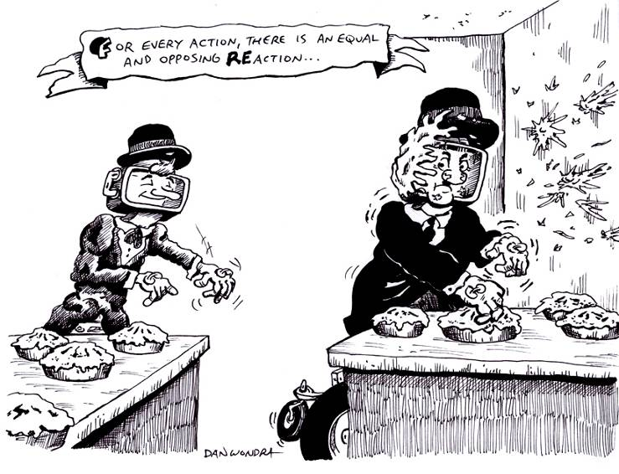
Draft Date: April 27, 2009
1st Author (Writer): Sara Bowen
Science Topic: Newton’s 3rd Law of Motion
Grade Level: Middle School

Content (what is taught):
- When one object exerts a force on a second object, the second object exerts a force back on the first object
- Action and reaction forces are always equal and opposite and they always happen in pairs

Context (how it is taught):
- Students will learn about Newton’s 3rd Law of Motion and discuss everyday occurrences when this law happens.
- Students will learn how Newton’s 3rd Law of Motion affects the CEENBot when it is stationary and when it is moving.
- Students will explore with a partner the different ways Newton’s 3rd Law of Motion occurs when using the CEENBot and will then place them in a eight segment pie chart.
Activity Description:
Students will learn what Newton’s 3rd Law of Motion is and understand what it means. Together the class will discuss different occurrences that fit this Law of Motion. Students will begin to discuss general ways this law affects the CEENBot. Students will pair up with a partner to explore different ways Newton’s 3rd Law occurs when the CEENBot is used the way that they use it. The students will place those examples in a cluster word web to share with the class.

Standards:

Math – B1, C1, E1, E2

Science – A1, A2, B1, B2, B3

Technology – A1, A3, A4, B2, B3, B4, C1, C2, C4, E2, F4

Materials List:
CEENBots Cluster Word Web 8 part Pie Chart
Pen/Pencil/or Marker Whiteboard
Asking Questions: The Raw of Newton’s 3rd Law

Summary: Discuss, define, and understand Newton’s 3rd Law of Motion

Outline:
Students will be taught about the definition of Newton’s 3rd Law of Motion and discuss different situations in which this law exists.
- Two marbles colliding
- A frog jumping from a lily pad
- Hitting a baseball with a bat
- A bowling ball striking pins

Activity: Discuss the following with the students

Questions | Answers
What is Newton’s 3rd Law of Motion? | It is often times referred to as the action/reaction law. It states that for every action, there is an equal and opposite reaction.
What does this mean? | This means that for every force on an object there is and equal force acting in the opposite direction. Forces always come in pairs.
Are there any forces that don’t have an opposite? | No, not according to Newton’s 3rd Law of Motion. This concept says that every force acting on an object has an opposite that needs to be accounted for.
What are some examples of this concept that you see everyday? | Birds being able to fly, people walking, cars driving on the road, etc.
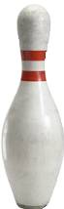

Exploring Concepts: The Raw of Newton’s 3rd Law

Summary: Students will experiment and discuss the ways that Newton’s 3rd Law affects the CEENBot.

Outline:
- Students will examine the CEENBot and brainstorm ways the 3rd Law of Motion affects it while moving and standing still
- Students will determine and describe ways in which Newton’s 3rd Law affects the CEENBot when it is stationary and when it is moving and share those ideas with a partner

Activity:
Ideally, students will be in groups where each group has access to a robot. Groups should be given time to move the robot about room to explore and experiment with possible opposing forces that can be observed or created. As students are engaged in this activity, move from group to group and observe what is occurring. Continually remind students that forces come in pairs so for each force that they can identify, Newton says that there should be an opposing force. Be sure that students are thinking about all possible forces: gravity, friction, walls pushing, etc. It is OK for students to locate applications of Newton’s 3rd law anywhere in the room, not just robotic applications.

Online Resource:
http://teachertech.rice.edu/Participants/louviere/Newton/law3.html
http://www.grc.nasa.gov/WWW/K-12/airplane/newton.html
http://hyperphysics.phy-astr.gsu.edu/hbase/truckc.html#c1

Instructing Concepts: The Raw of Newton’s 3rd Law

Newton’s 3rd Law of Motion
Putting “Newton’s 3rd Law of Motion” in Recognizable terms: Newton’s 3rd Law of Motion states that for every action, there is an equal and opposite reaction. This means that for every force on an object there is an equal force acting in the opposite direction. Forces always come in pairs, which are forces equal in magnitude and opposite in direction.

Putting “Newton’s 3rd Law of Motion” in Conceptual terms: Newton’s 3rd law basically says that there are no forces that don’t have an opposite. If you sit in a chair, gravity pulls you down and the chair pushes you up. If you run through the air, you push on the air and the air pushes back on you. If you drive a car, the wheels push backwards on the road and the road pushes forward on the car.

Putting “Newton’s 3rd Law of Motion” in Mathematical terms: Newton’s 3rd Law of Motion applies mathematically when you are looking at the forces that are acting individually on an object. This concept says that every force acting on an object has an opposite that needs to be accounted for, so when creating force diagrams for specific situations it is necessary to balance every force acting on the object.

Putting “Newton’s 3rd Law of Motion” in Process terms: Thus, because of Newton’s 3rd law of motion, we are able to move or remain stationary in our universe. The force that we exert when me we move is always balanced in the opposite direction therefore allowing us to move in the desired direction. If we are at rest the balanced force in the opposite directions keeps us in one place. The implication here is we are bound by this concept and it must be a major consideration of scientists, engineers, and designers.

Putting “Newton’s 3rd Law of Motion” in Applicable terms: Newton’s 3rd law is easily explained as the concept that allows birds to fly, people to walk, cars to drive on the road, etc. Without the opposing force (whether it is the air, the ground, or the road as in the cases listed) it would be impossible to move.

Organizing Learning: The Raw Of Newton’s 3rd Law

Summary: Students will brainstorm ideas on how Newton’s 3rd Law of Motion affects the CEENBot and will fill out an 8-section pie chart with their partner.

Outline:
- Students will fill out an 8-section pie chart with their partner of ideas that they came up with regarding their CEENBot and applications of Newton’s 3rd Law.
- Students will extend their knowledge of Newton’s 3rd law into the world.
- Students will discuss their ideas as a class and put those ideas on the whiteboard for everyone to see.

Activity:
Start by having students join a partner and brainstorm ideas on how Newton’s 3rd Law of Motion affects the CEENBot. Have the students fill out an 8-section pie chart with their partner. The top 4 sections should be ideas that they came up with when the CEENBot is stationary; the bottom 4 sections should be possibilities of how Newton’s 3rd Law of Motion might affect a moving CEENBot. Next, give students another pie chart and have them think about the implications of Newton’s 3rd Law in the larger world. Again, half of the chart can be dedicated to static situations and the other half to dynamic situations. Finally, bring the whole class together and discuss those ideas and write them on the board.

Worksheet: N3LPieWS.doc

Understanding Learning: The Raw of Newton’s 3rd Law

Summary: Students will tell how Newton’s 3rd Law of Motion affects the world around them.

Outline:
- Formative assessment of Newton’s 3rd Law.
- Summative assessment of Newton’s 3rd Law.

Activity:

Formative Assessment
As students are engaged in the lesson ask these or similar questions:
- Are students able to locate opposing forces?
- Do students understand that forces will always come in opposing pairs?
- Could students state another name for Newton’s 3rd Law?

Summative Assessment
Students can answer one of the follow writing prompts:
- Explain how a hammer pounding a nail into a board describes Newton’s 3rd Law of Motion.
- Why do action and reaction forces always occur in pairs?
- Describe a real world situation where Newton’s 3rd law is present and explain the forces at
work.

Using the cluster word web, put one example in each circle that shows proof of Newton’s 3rd
Law of Motion in our classroom

Worksheet: N3LClusterWeb.doc

