SPIRIT 2.0 Lesson:
What Does Time Have to do With It?

==========================Lesson Header ==========================

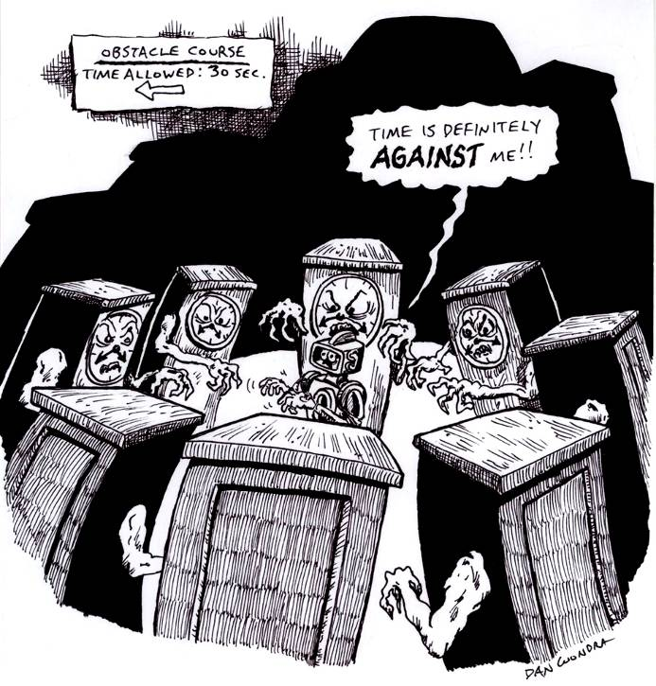
Lesson Title: Elapsed Time
Draft Date: May 1, 2009
1st Author (Writer): Cj Perry
Math Topic: Measurement
Grade Level: Upper Elementary

Content (what is taught):
- Elapsed Time
- Data Gathering & Interpretation
- Graphing
- Teamwork

Context (how it is taught):
- Heterogeneous teams will work over several days to run an obstacle course.
- Students will use a standard (non-digital) timer to keep track of each of their times on the course. The expectation is that they will watch the time elapse and apply this learning to elapsed time problems in math.
- Students should keep track of elapsed time for each teammates’ run as well as the elapsed time for their entire team.
- Students will record their predictions, times, and learning in their science or math notebooks.
- The teacher will collect and evaluate the journals after each team is done with their work.
- Data can be graphed to show change over time.
Activity Description:
Teams will run a predetermined course within the classroom or nearby hallway. Then they will take turns running the robot through the course, timing and recording their teammates’ runs
.
Standards:
Math: A1, A2, A3, D1, D2, E1, E2, E3
Science: A1, A2, E1, E2
Technology: A1, A3, A4, B1, B2, B4, C4, D2, D3, E2, F3, F4

Materials List:

Classroom Robot
Graph paper
Notebook
Data Sheet Standard Stopwatch and/or classroom clock

Asking Questions What Does Time Have to do With It?

Summary: Students are asked how they keep track of time as an obstacle course is run. How does time elapse?

Outline:
- Demonstrate how to run the course
- Demonstrate how to use the standard timer or classroom clock to time a run
- Students should predict the amount of time they will run the course and the amount of time it will take for their team to run the course
- Have students practice and ask questions
- Compare results with other teams and discuss with class
- Conclusion writing
- Teacher should collect notebooks after lesson to evaluate student learning

Activity:

Questions | Answers
How fast can we run the course? | See elapsed times
How can teammates help each other on the course? | Encouragement, guide through course, observing other teams and learning from their efforts
What data can we gather? | Personal and team times, change with practice
How does the difficulty of the course affect results? | Experiment with ramps, longer/shorter courses, etc. to see how times change
What happens if a run is interrupted? Do we stop the watch, or do we continue? | Debate with class—I would collect data both ways and discuss how interruptions in work affect the time we have to finish things
How does this apply to what we know about elapsed time? | Pull in learning about measuring time and elapsed time from other lessons from texts, student questions, etc.
START
FINISH
Exploring Concepts What Does Time Have to do With It?

Summary: Students explore how they can improve their time racing a robot through an obstacle course.

Outline:
- Heterogeneous teams will work over several days to run an obstacle course.
- Students will use a standard (non-digital) timer to keep track of each of their times on the course. The expectation is that they will watch the time elapse and apply this learning to elapsed time problems in math.
- Students should keep track of elapsed time for each teammate’s run as well as the elapsed time for their entire team.
- Students will record their predictions, times, and learning in their science or math notebooks.
- The teacher will collect the journals after each team is done with their work and evaluate the journals.
- Data can be graphed to show change over time.

Activity:
Students will take turns running the course. They will take turns running the stopwatch and recording the data. They will all need to copy the data and their thoughts into their notebooks.
Teams will try to improve their times as they practice.

To provide formative assessments as students are exploring these concepts ask yourself or your students these questions:
- What helps you go faster?
- What slows you down?
- How does time elapse as you run the course?
- How much time does it take for your team to all run the course?
- How much time does it take for a person to set up and start?
- How do interruptions in your work affect your overall time?
- How did this experiment help us better understand elapsed time?

Images show students creating an obstacle course for the robot to travel through.
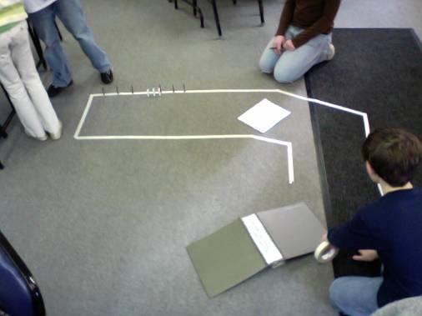
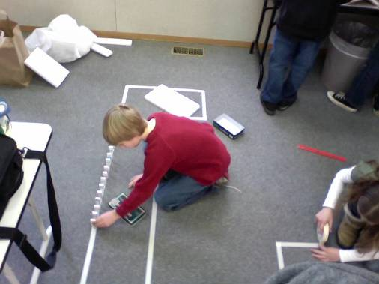
Measurement

Putting “Measurement” in Recognizable terms: Measurement is the process of assessing the magnitude of an object’s physical characteristics such as weight, length, volume, air pressure, etc. Measurement will always be an estimate because of the difficulty of finding the exact value of a measurement. No matter how precise the instrument, nor how careful the operator, there will always be measurement error due to a failing in establishing exactness.

Putting “Measurement” in Conceptual terms: Measurement is the act of quantifying a magnitude that relates to an object. This can be achieved through the use of instruments. For instance, to measure length you would use a ruler or meter stick. For mass you would use a balance. When a person estimates a quantity there is always measurement error due to human sensory limitations and instrument sensitivity limitations. Ideally, the person measuring will minimize the error as much a possible by working carefully and using calibrated instruments. Typically, the more precise the instrument used, the lower the measurement error.

Putting “Measurement” in Mathematical terms: The measurement of an object can be estimated to one smaller division than your instrument is marked. For instance, if you are measuring length and the meter stick is divided up into millimeters, you can estimate to tenths of a millimeter. Thus an object could be measured to be 857.2 mm long with this meter stick. The 857 would be the closest division to the length of the object and the .2 would be a closer estimate. In summary, the more precise the intervals are marked on the instrument the smaller the measurement error.
Percentage error is a calculated when the accepted value of a measurement is known and is used in comparison to an experimental value.

Putting “Measurement” in Process terms: Thus, measurement is about estimating the magnitude of an object and at the same time reducing the error associated with that estimate. A measurement should have three parts: 1) the measurement, 2) the margin error, and 3) the confidence that your measurement will fall within the margin of error. For instance, if you measure the weight of an object to be 5.43 kg with a margin of error of .01 kg with 95% confidence, you mean that 95% of the time the weight you measured will be within .01 kg. Basically, measurement is about making the best possible approximation.

Putting “Measurement” in Applicable terms: Measurement applies in everything we do. All jobs require accurate measurements for success to be attained. If measurements are done inaccurately or carelessly, the board a carpenter cuts might not fit, the rocket NASA designs might not fly, or the brakes on your car might not stop you. The old carpenter’s adage comes to mind, “measure twice and cut once”. This means you should be as sure of your measurements as you possibly can because industry as well as your life or someone else’s might depend on it.
Organizing Learning What Does Time Have to do With It?

Summary: Students use data tables that record their personal and team times as they explore how time elapses as they run the course.

Outline:
- Demonstrate how to run the course
- Demonstrate how to use the standard timer or classroom clock to time a run
- Students should predict the amount of time they will run the course and the amount of time it will take for their team to run the course
- Ensure that students know that they will need to time their team’s entire time on the course, not just add each person’s run time. We need to know how long everything takes, including set up and interruptions.
- Have students practice and ask questions
- Compare results with other teams and discuss with class
- Conclusion writing
- Teacher should collect notebooks after lesson to evaluate student learning

Sample chart for student notebooks:
Team Member Name | Trial 1 | Trial 2 | Trial 3
Overall time

Activity:
Students will take turns running the course. They will take turns running the stopwatch and recording the data. They will all need to copy the data and their thoughts into their notebooks.
Over several days students will record their individual times and team times and make notes on how the time elapses. They can use charts and graphs to show their data. They should be given time to work with other teams to discuss what they are learning and to compare data.

Understanding Learning What Does Time Have to do With It?

Summary: Students can share their raw data each day and then present their charts/graphs to the class when the experiment is done.

Outline:
- Formative assessment with journals, notes, and small and whole group discussions
- Summative assessment of data in charts and/or graphs
- Summative assessment of group discussion in class
- Summative assessment using standardized tests that include elapsed time

Activity:
Formative Assessment
As students are engaged in the lesson ask these or similar questions:
- Were the students able to predict how long they would take to run the course?
- Were they able to improve team times?
- Did the team times change each day as students became more aware of time elapsing?
- Were the students able to improve times?
- Did the students keep their data accurate and neat?
- Did the students continue to ask questions as they worked?

Summative Assessment
Students will participate in small group and class discussions about what they learned. They should be able to present and explain their data in charts or graphs.

Possible Formative/Summative Questions
- Lenny started his run at 10:15 and reached the finish line at 10:17. How long did it take him to go through the course?
- Lenny was done with his run at 10:17 and M’Lea was ready to start at 10:25. How much time elapsed between Lenny’s run and M’Lea’s?
- Team Alpha took 21 minutes to get all five of their teammates through the obstacle course. Team Bravo was done in 18 minutes and Team Charlie was done in 22 minutes. Who took the longest amount of time? Who was done the fastest?
- If there were five minutes between Team Alpha’s and Team Bravo’s runs and between Team Bravo’s and Team Charlie’s runs, how much total time did it take for all three teams to get finished?
- There are only fifteen minutes left in math class. If we have ten more students that have to go through the obstacle course and they will each need at least two minutes each to do the course, will all the students have time to finish the course? Why or why not?

