SPIRIT 2.0 Lesson:
It’s alive! Or is it?

==============================Lesson Header===========================
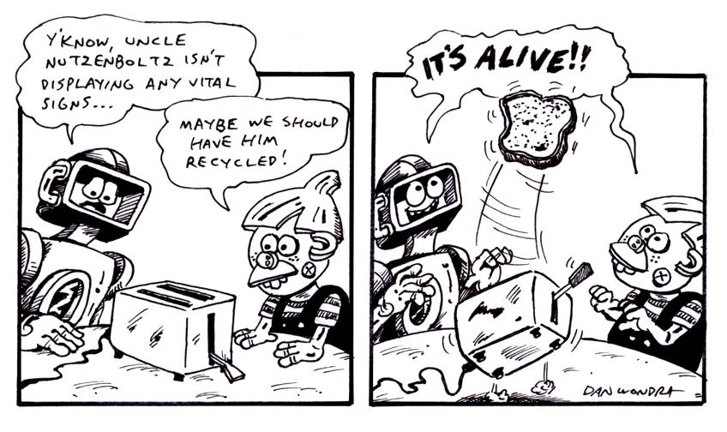
Lesson Title: It’s alive! Or is it?
Draft Date: 2/20/09
1st Author (Writer): David Porter
Science Topic: Characteristics of Life
Grade Level: Elementary

Content (what is taught): Characteristics of animal life.

Context (how it is taught): The CEENBoT is used to clarify the differences between living and non-living things

Activity Description: Students are first asked about the differences between living and non-living things. Then the CEENBoT is brought in and does some “living” things (moving, taking in energy, doing things on its own). The differences between things which are alive and not alive are then further explored.

Standards:
- Science – C1, C2, C3, C5
- Technology - A3, C1

Materials List:
- CEENBoT operable in remote control mode and bump-bot mode.
- Chalkboard/white board
- Magazines with pictures of living and non-living things
- Scissors
- Glue
- Poster board

ASKING Questions (It’s alive! Or is it?)

Summary: How can you tell if something is living? Students will explore the characteristics of living things and decide whether something is alive.

Outline:

List the 6 characteristics of life

Living things are made of cells

Living things obtain and use energy

Living things grow and develop

Living things reproduce

Living things respond to their environment

Living things adapt to their environment

Make a list of living and non-living things

Activity: Discuss and list the characteristics of life. Make a list of living and non-living things. Alternately, a KWL chart can be used to have students list what they already Know about living things, what they Want to know, and after the lesson what they Learned.

Questions | Possible Answers
What are some characteristics of living things? | They are made up of cells, they obtain and use energy, they grow and develop, they reproduce, they respond to their environment, and they adapt to their environment
What is living in our classroom? What is non-living and why? | All the people are living, a class pet, etc. The desks and chairs are non-living because they don’t have any of the characteristics of living things.

Worksheet: KWL.doc

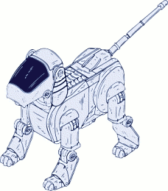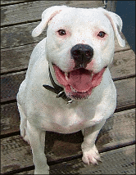

EXPLORING Concepts (It’s alive! Or is it?)

Summary: The CEENBoT will perform life-like behaviors for the students to observe. Students will find similarities and differences in the robot and living things. Students will fill in a Venn Diagram to show their understanding.

Outline:

Pose the question, “Is the CEENBoT alive?”

Have the CEENBoT demonstrate activities that meet some of the students’ prior definitions of life (moving and responding to the environment).

Students will fill in a Venn Diagram and create a definition of life

Activity: Pose the question, “Is the CEENBoT alive?” Announce a new form of animal life has been found—followed by the CEENBoT moving among the class. Ask students to list some of the characteristics of life that the robot displays (i.e. it moves, if it bumps into something it turns around). Ask students to list the characteristics of life that the robot does not display. In groups, have students fill in a Venn Diagram of the similarities and differences.

Worksheet: VennDiagram.doc

Which of these things is not like the others?
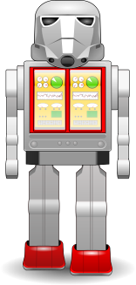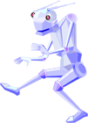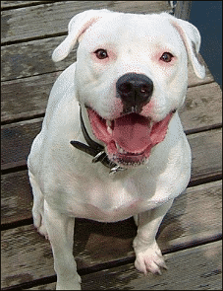

INSTRUCTING Concepts (It’s alive! Or is it?)

Living vs. Nonliving

Characteristics of living things

Living things have certain characteristics (biological processes) in common that make them classified as living. If those biological processes are no longer functioning or are not present the object is classified as nonliving (inanimate)

Living things are carbon and water based organisms that have these characteristics:
- Living things undergo metabolism, which is the breaking down of organic matter for two purposes: the gaining of energy and the building of cellular structures.
- Living things maintain homeostasis, which is the maintaining of its internal environment in a somewhat constant condition.
- Living things respond to stimuli or something outside them causes a reaction.
- Living things reproduce or cause new organisms to be formed.
- Living things have the capacity to grow.
- Living things adapt to their environment.
- Living things have inheritable genetic information.

These are the minimum requirements. More complex organisms can communicate, build communities, and modify or change their environment.

Nonliving things either are inanimate or the biological processes outlined above have ceased to function (they have died). Some nonliving things exhibit some of the characteristics above but not all of them. The statement about life being carbon and water based is from our experience of what is alive. It may be possible for life to exist somewhere in the universe that is not carbon/water based. If it does it would look very different from what we commonly think of as alive. If something like this is discovered our understanding of life will have to be modified.

ORGANIZING Learning (It’s alive! Or is it?)

Summary: Students will create a graphic representation of living and non-living things.

Outline:
- Have students go to: http://www.firstschoolyears.com/science/resources/games/ourselves/living/living.htm and complete the sorting activity.
- Watch a video on robotic animals being created/controlled at: http://jumpcut.com/view/?id=CCAF9A30899711DC85D3000423CF3686
- Provide magazines, newspapers, and pictures for students to create a display of living and non-living things.

Activity: The online sorting activity at http://www.firstschoolyears.com/science/resources/games/ourselves/living/living.htm can be done as a class or individually. Watch the video at http://jumpcut.com/view/?id=CCAF9A30899711DC85D3000423CF3686 as a class and then have students discuss it in small groups. Next have each student create a graphic representation of living and non-living things. Students can present their project to the rest of the class.

Worksheet: Rubric.doc

UNDERSTANDING Learning (It’s alive! Or is it?)

Summary: Students will be assessed on their understanding of living and non-living things.

Outline:
- Formative assessment of living and non-living things
- Summative assessment of living and non-living things

Activity: Throughout the lesson, students will be assessed on their understanding of living and non-living things. Listen to students as they talk about the characteristics that define life. Students will complete a grade-level appropriate summative assessment.

Formative Assessment
As students are engaged in the lesson ask these or similar questions:
- Were students able to make statements about what makes something living?
- Were students able to adapt their understanding of living things so that it does not fit the robot?
- Were students able to fill in the Venn Diagram of the characteristics of living and non-living things?

Summative Assessment

First have a large group discussion of what constitutes a living and non-living thing. Discuss how the definition of living changed after interacting with the robot. Then have students do one of the following assessments:

Primary Students: Use drawings and/or writing to show/give examples of animal life and why a CEENBoT does not belong in that category.

Intermediate Level Students: Respond to this scenario: A scientist built a robot that is able to build more robots. Is this a new form of life? Why or why not?

Students can answer the following writing prompt:
1) The teacher presents and object to students. Describe why you think the object is living or nonliving.
2) Name three things that a living thing will have that a nonliving thing will not.

