SPIRIT 2.0 Lesson:
How Far From Here to There?
============================Lesson Header ============================
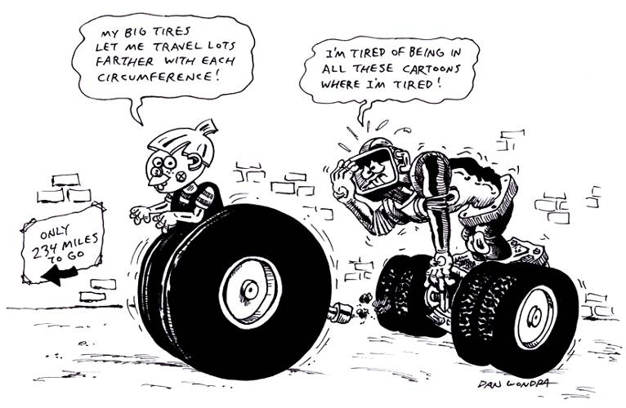
Lesson Title: How Far From Here to There?
Draft Date: February 15, 2009
1st Author (Writer): Susan De Roy
Math Topic: Measuring, Estimation
Grade Level: Upper Elementary

Content (what is taught):
- Finding length using a tape measure and the circumference of a wheel
- Estimation
Context (how it is taught):
- Students learn to calculate the circumference of a circle. (pi x diameter).
- Students will learn to define diameter, circumference, pi, and estimation.
- Students will measure a hallway using the number of rotations of a CEENBoT wheel.
- Students will measure the same hallway using a standard tape measure.

Activity Description:
After being introduced to the required math vocabulary, students will practice calculating the circumference of various circles. Students will then be put into teams of four and will be asked to demonstrate how to find the circumference of a circle and apply that knowledge to finding the circumference of various wheels on toy cars. Next they will take the CEENBoT and calculate the circumference of the larger wheel.
After calculating the circumference of the wheel, students will take the CEENBoT into the hallway. Two members of the team will mark a starting point with tape near one wall and drive the robot to the opposite end. They will mark their stopping point with tape and record the number of rotations on the wheel counter. The other two members of the team will measure from tape to tape using a tape measure. They will record the number of times they used the measuring tape in its entirety plus any partial use. The two pairs will then switch tasks and drive the CEENBoT back to the original location. Both pairs will again record their results. Returning to the classroom they will use calculators to calculate the distance by multiplying the number of rotations of wheel by the circumference and by multipling the number of times they used the measuring tape times the length of the tape used. Then add any partial length of the tape measure.

Standards:
Math: D2 Science: E1, E2 Technology: F1

Materials:
Classroom Robot, Paper, pencil, Masking tape, Measuring tapes marked to the inch, Calculator

ASKING Questions (How Far from Here to There?)

Summary: Students will explore different ways to measure the length of a given distance on the floor.

Outline
- Use masking tape to mark off different distances on the floor
- Ask students to think of different ways to measure the length of the distance marked off on the floor.
- Have groups of students estimate the length of the marked off distance and then measure it two different ways.
- Discuss the results and compare the estimations to the actual measurements.

Activity:
Ask students the questions below. Split students into groups of 2 or 3 and have them estimate the length of the distance marked off on the floor. Each group should measure the distance two different ways. As a large group, discuss the results and compare the estimations with the actual measurements.

Questions | Possible Answers
How can we determine the length of a room or hallway? | We can use measuring devices like tape measures or yard sticks. We can use a string and then measure the string.
How could you use a round object such as wheel to measure the room or hallway? | We can find the distance around the wheel (circumference) and drive it along the wall counting the number of times the wheel goes around.
Do we know how to find circumference of a round object? | We can use the formula pi x diameter to find the circumference.
Can we use that information to determine length of something that goes in a straight line like a hallway or room? | Yes, if we can count the number of times a round object rotates between the start and end of the room we can take that number times the circumference.

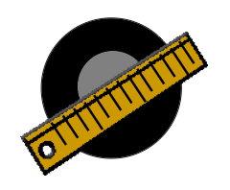
EXPLORING Concepts (How Far From Here to There?)

Summary:
Students will use the wheels on various sized toy cars and trucks to calculate circumference. They will use their calculations to measure short lines taped on the floor. Students will drive the robot down a hall and measure the same distance with a tape measure.

Outline:
- Groups of students will measure various sized wheels on toy cars and trucks and will calculate the circumference.
- Students will estimate distances taped on the floor.
- Students will use their toy car or truck to drive the distance and count how many wheel rotations occur.
- Students will calculate the circumference of the large wheel on the CEENBoT.
- Students will mark a starting point at one end of the hallway and drive the robot down the hall to an ending point taped on the floor. Students should attempt to count the wheel rotations (if a sensor is not already attached) to make an estimation of the distance.
- Students will measure the distance with a tape measure.
- Teams will calculate and compare results between wheel and tape measure.

Activity:
Put students into teams of four. Each group will have 2 toy cars or trucks to work with during the activity. Students should work together to fill in the worksheet making sure to answer each question. The team will report their results to the class at the end of the activity.

Ask students the following questions during discussion:

1. Did the students use the correct formula when finding the circumference?
2. Did the students have a way to show one complete rotation of the wheel?
3. Was there any difference between the measurement found by using the wheel and the measurement found using a tape measurement?

Worksheet: HowFarFromHereWS.doc
INSTRUCTING Concepts (How Far From Here to There?)

Measurement
Putting “Measurement” in Recognizable terms: Measurement is the process of estimating the magnitude some characteristics of an object such as weight, length, volume, air pressure, etc. Measurement will always be an estimate because we are never capable of finding exactly what an object measures. No matter how careful or precise we try to be there will always be measurement errors that are created by the precision of the instrument used.
Putting “Measurement” in Conceptual terms: Measurement is the act of quantifying a magnitude that relates to an object. You can achieve this through the use of instruments. For instance, to measure length you would use a ruler or meter stick. For weight you would use some type of scale. When we are estimating a quantity there is always measurement error. Ideally, the person measuring will minimize the error as much a possible by working carefully and using precision instruments. Typically, the more precise the instrument used the lower the measurement error.
Putting “Measurement” in Mathematical terms: The measurement of an object can be estimated to one smaller division than your instrument is marked. For instance, if you are measuring length and the meter stick is divided up into millimeters, you can estimate to tenths of a millimeter. Thus an object could be measured to be 857.2 mm long with this meter stick. The 857 would be the closest division to the length of the object and the .2 would be a closer estimate. If a yardstick is only divided up into inches you can measure to tenths of an inch. Since the divisions are much larger, the estimation will not be as close and the error will be increased. In summary, the more precise the instrument is marked the smaller the measurement error.
Putting “Measurement” in Process terms: Thus, measurement is about estimating the magnitude of an object and at the same time reducing the error associated with that estimate. A measurement should have three parts: 1) the measurement, 2) the margin error, and 3) the confidence that your measurement will fall within the margin of error. For instance, if you measure the weight of an object to be 5.43 kg with a margin of error of .01 kg with 95% confidence, you mean that 95% of the time the weight you measured will be within .01 kg. Basically, measurement is about making the best possible guess.
Putting “Measurement” in Applicable terms: Measurement applies in everything we do. All jobs require precision measurement for success to be attained. If measurements are done inaccurately or carelessly the board the carpenter cut might not fit, the rocket NASA designs might not fly, or the brakes on your car might not stop you. The old carpenter’s adage comes to mind, “measure twice and cut once”. This means you should be as sure of your measurements as you possibly can because your life or someone else’s might depend on it.

ORGANIZING Learning (How Far From Here to There?)

Summary:
Students are using the circumference of a wheel as a unit of measurement.

Outline:
- Students must learn how to calculate circumference of a round object.
- Find the distance between two points using the number of rotations of the large wheel on a robot.
- Calculate the distance of a hallway using circumference times wheel rotations.
- Compare the calculated measurement with the use of a more standard unit such as a tape measure or ruler.

Activity
Students will complete a table (see below) finding the circumference of different wheels. Students will drive the different vehicles between two points in a hall to determine the length of the hall between two points. Students will measure the same distance with a tape measure and compare results.

Worksheet Idea: A simple chart that has types of wheels to me measured.

Toy Wheels | Diameter | Calculate Circumference  pi x diameter | Circumference times the number of Rotations to cover the distance marked off on the floor | Actual Measurement Using a Tape Measure or Ruler
Tonka Dump Truck

Radio Controlled Car

Front Wheel of Airplane

UNDERSTANDING Learning (How Far From Here to There?)

Summary:
Students will demonstrate their understanding of measurement by completing a formative and summative assessment.

Outline:
- Formative assessment of measurement.
- Summative assessment of measurement.

Activity:
Formative Assessment
As students are engaged in the lesson ask these or similar questions:
- Do students understand what it means to measure?
- Do students understand circumference and how it can be used to measure a distance?
- Are students making reasonable estimates for distances marked off on the floor?

Summative Assessment

Students can answer one or both of the following writing prompts:

Describe a situation where you have to measure something. Explain 2 different ways to measure and be sure to explain the units of measurement you think would be best.

Below is a map of Lake Hammer. Describe how you would go about measuring the distance around Lake Hammer.
6 actual miles

Students can complete the following project:

Provide students with a toy vehicle. The student will use the wheel to calculate the circumference and count how many rotations occur during a given distance taped off on the floor. They will then use a tape measure or ruler to measure the actual distance. A report should be written explaining the procedure and the results.

