The Wheels Go Round and Round and Round
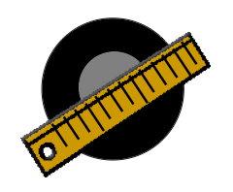
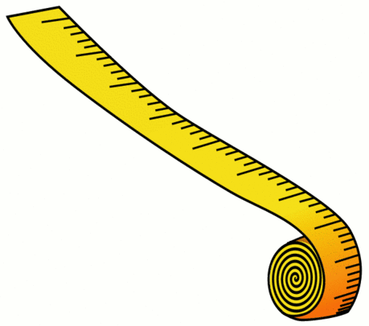
Draw a sketch of your toy car or truck in this box.

Directions: Look at the table below and read the description of each section of the table.

Wheel’s Diameter | Circumference Calculation | Estimate the Length of the Taped Distance | Number of Rotations the Car/Truck Made | Distance Using the Wheel’s Circumference | Actual Distance
Measure the wheel’s diameter in inches. | Calculate the circumference of the wheel using C = pi x d  Use 3.14 for pi | Look at the taped distance on the floor and estimate the length in inches. | Mark the wheel on your toy car or truck so that you can count the number of rotations. Drive the car or truck and count how many rotations were made. | Use the number of rotations made and the wheel’s circumference to calculate the length of the taped distance on the floor. | Measure the taped distance on the floor with a tape measure or ruler.
EXAMPLE  5/8 inches | C = pi x d  C = 3.14 * 5/8 (.625)  C = 1.9625 inches | 15 inches | 9 rotations | 9 rotations x 1.9625  17.6625 inches | 19 inches

Questions

- How did your estimate compare to the distance calculated with the wheel’s circumference?

- How did your estimate compare to the distance measured with a measuring tape or ruler?

- How did your calculation of the length using the wheel’s circumference compare to the measurement using a measuring tape or ruler?

