SPIRIT 2.0 Lesson:
“A Sputtering Image” (Heredity)

============================= Lesson Plan ==============================

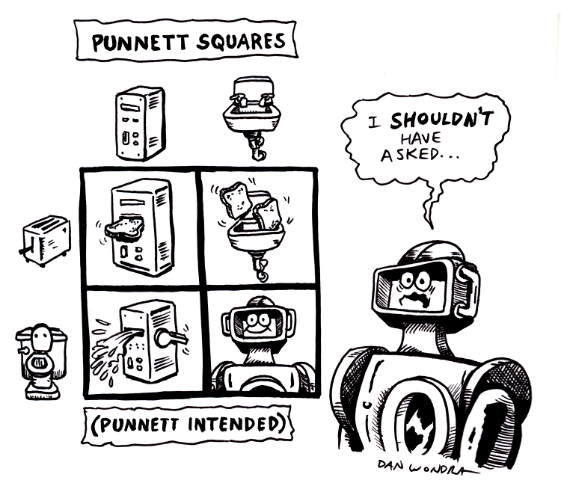
Lesson Title: A Sputtering Image
Draft Date: December 31, 2008
Author (Writer): Derrick A. Nero
Topic: Heredity, with an emphasis on Punnett squares and probability
Grade Level: Middle

Outline of Lesson

Content (what is taught):
- Application of Punnett squares to determine genetic characteristics
- Ratios
- Probability
Context (how it is taught):
- CEENBot construction components are determined though the use of Punnett squares.
- CEENBot parents’ genotypes are randomly selected and recorded.
- CEENBot offspring’s genotypes and phenotypes are determined and recorded.

Activity Description:
In this lesson students investigate how Punnett squares are used to determine the probability of genotypes and phenotypes in offspring of two parents. Genotypes (component characteristics) will be randomly selected and recorded for two parents (CEENBots). The offspring’s genotype and phenotype will be determined using Punnett squares. An offspring’s component characteristics will be determined, and constructed, using the results of completed Punnett squares.

Standards:

Science Math Technology
A1, A2 , C2, C5 A1 A3, C4

Materials List:
CEENBot construction kit
“Heredity Laboratory” worksheet
Engineering notebook

ASKING Questions (A Sputtering Image)

Summary: Students are asked what would the offspring of two different CEENBots look like.

Outline:
- Present the parent CEENBots.
- Facilitate an evaluation of CEENBot characteristics.
- Ask students about expected offspring CEENBot characteristics.

Activity:
The teacher will present both parent CEENBots to the class. Students will observe and evaluate the usefulness of characteristics of each parent CEENBot.

Questions | Possible Answers
- What characteristics from either parent would be the best for the offspring to have? | Various.
- What environmental conditions would determine the “best” characteristics should the offspring have? | Various. Answers should be relative to given/realized environmental conditions (e.g., high-traction tires would be beneficial for “hilly” road conditions.
- Should the offspring have both characteristics from both parents (i.e., double the characteristics)? | Yes! Why not have the best of both worlds.
EXPLORING Concepts (A Sputtering Image)

Summary: Students explore the probability an offspring’s genotype and phenotype.

Outline:
- Students will explore the probability of phenotypes.
- Students will randomly select a parent’s genotypes.

Activity:
Working in student pairs (dyads), dyads each receive a “gene pool” (paper sack) for the “mother” and “father” CEENBots. A gene pool contains genotypes for particular CEENBot component characteristics (see table below). Dyads select genotypes from the mother’s gene pool and the father’s gene pool. The first genotype selected for each particular component characteristic for each parent will be the genotype for that parent and set aside. Subsequent genotypes for a previously selected component characteristic will be disregarded and placed aside. Genotypes will be selected until all component characteristics have been chosen.

To provide formative assessments as students are exploring these concepts ask yourself or your students these questions:
- Did students “desire” particular genotypes before the activity?
- Did students predict the genotype selected?
- Did students compare genotypes between their mother and father? Or, with other dyads’ parents?
- Did students try to predict the genotypes of their respective offspring?

Sample “Gene Pool” (Genotypes) – CEENBot Component Characteristics

TT  Treaded tires | DD  One deck | WW  Wired controller | CC  No counter
Tt  Treaded tires | Dd  One deck | Ww  Wired controller | Cc  No counter
tt  Smooth tires | dd  Two decks | ww  Wireless controller | cc  Digital counter

Heredity
Heredity is the process of passing genetic traits from parent to offspring. These traits are contained in the genes of the parents and during the process of reproduction are combined and transferred to the offspring in a mathematically predictable way. Gregor Mendel discovered the prediction of inheritable genetic traits in the 1860’s. This work created the modern science of genetics. His tool for the prediction of inheritable traits is called the Punnett square.

Definitions

Inheritable genetic traits
These are characteristics such as eye or hair color, height, dimples, etc. In reproduction, a gene is one set of instructions for an inherited trait. If the parents have different traits for a particular characteristic, such as one parent has black hair and the other light brown, the characteristic (trait) observed in their offspring is the dominant trait. This observed trait is known as the offspring’s phenotype. However, although not observed, the other parent’s trait is contained within the offspring. Both parents’ genetic contribution to the offspring is known as the offspring’s genotype.
Alleles
An allele is one of the alternative forms of a gene that governs a characteristic. Alleles can be either dominant or recessive. As an example, let black hair be represented as the dominant hair color (B) and light brown as the recessive hair color (b). Dominant alleles will “dominate” the characteristic. Consider that each parent provides a hair color allele. The offspring could have BB (“black hair”, homozygous dominant), Bb (“black hair”, heterozygous dominant), or bb (“light brown”, homozygous recessive).
Punnett Square
A Punnett square is a simple table to organize the probability an offspring’s genotype occurrence. The probability of either of these genotypes can be determined using a Punnett square. The mother and father’s genotypes are listed in the table’s header column and row. The possible offspring’s genotypes are a combination of the allele provided by the mother (above) and father (to the left).

 |  | Mother
 |  | B | b
Father | B | BB | Bb
Father | b | Bb | Bb
Therefore, the probabilities of particular genotypes of the offspring (in bold) are:
- BB (“black hair”, homozygous dominant) – one out of four chance (1 in 4) or 25%,
- Bb (“black hair”, heterozygous dominant) – two out of four chance (2 in 4) or 50%, or
- bb (“light brown”, homozygous recessive) – one out of four chance (1 in 4) or 25%.

A few concluding thoughts
This discussion presented here is a very simplified discussion of genetics. The Punnett Square used above is for a monohybrid cross where only one gene is looked at. It is possible to make Punnett Squares for multiple genes called dihybrid crosses. These squares are more complicated but like the simpler Punnett Squares the mathematical probability of each possible combination of the genes can be calculated.
ORGANIZING Learning (A Sputtering Image)

Summary: Students use a data table and Punnett squares to record the randomly selected parent genotypes and offspring’s genotypes and phenotypes.

Outline:
- Collect data as student pairs randomly selected parents’ genotypes.
- Utilize Punnett squares to determine offspring’s genotypes.
- Compute the probability of each offspring’s genotype.

Activity:
Students will complete the “Heredity Laboratory” worksheet (see attached “Heredity Laboratory” worksheet). Students will randomly select the parents’ genotypes from their respective gene pools and fill in the first two blank columns with the genotypes selected from the respective gene pools (see Table 1 below). Next, students complete a Punnett square for each inherited trait (see Illustration 1 below). Then, students fill in the fourth column with the genotype with the highest probability of occurrence (in the case of a “tie”, the students may chose between the two genotypes). Finally, students complete the fourth blank column with the phenotype (physical description) of the offspring.
Table 1
CEENBot Family Traits
Trait | “Mother” genotype | “Father” genotype | “Offspring” genotype | “Offspring” phenotype
Tires, type
Decks, number
Controller, type
Counter type

Illustration 1

Tires
TT –
Tt –
tt –

Decks
DD –
Dd –
dd –

Controller
WW –
Ww –
ww –

Counter
CC –
Cc –
cc –

Worksheet: Heredity Laboratory

UNDERSTANDING Learning (A Sputtering Image)

Summary: Students write an essay about the occurrence of particular traits within their own families.

Outline:
- Formative assessment of use of Punnett squares.
- Summative assessment of application of Punnett squares.

Activity:

Formative Assessment
As students are engaged in learning activities ask yourself or your students these types of questions:
1. Can students explain the concept of genotype and phenotype?
- Can students proficiently complete a Punnett square, and compute the probability of the offspring’s genotypes, given two sets of genotypes?

Summative Assessment
Students will complete a descriptive essay about heredity, given the following prompt:
- “I would describe myself as…”.
  - Students must describe as least five phenotypes about themselves
  - Students must provide information about the parent, or ancestor, from whom they inherited the given phenotype.
  - Students must provide an example of a completed Punnett square displaying the possible genotypes of their parents, offspring genotypes, and computed offspring genotype probabilities.
  - Students must fulfill required writing conventions’ criteria.

