SPIRIT 2.0 Lesson:
Incredible Bread Chip Circuit
============================Lesson Header ============================
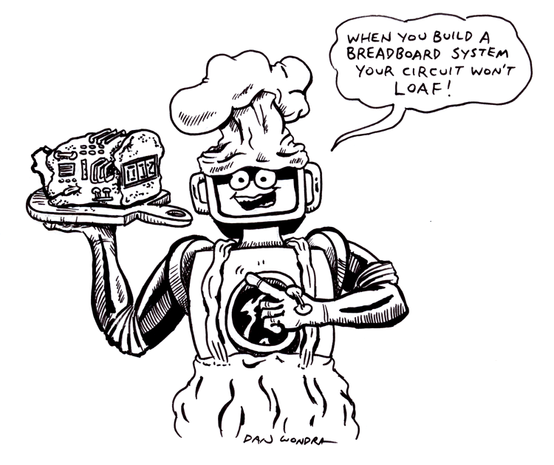
Lesson Title: Incredible Bread Chip Circuit
Draft Date: 6/22/09
1st Author (Writer): Brian L. Moeller
Electronics: Building a Circuit on a Breadboard
Grade Level: 9 - 12

Outline of Lesson
- Students will be able to build a circuit on a breadboard
- Students will be able to determine how far the CEENBoT can travel while the LED is on.
- Students will be able to replace the value of R1 to change the time period the LED is on.
- Students will be able to repeat the time the LED stays on while driving the CEENBoT.
Content (what is taught):
- Building a circuit using the reusable breadboard on the CEENBoT.
- Replacing components to change the time a light will stay on.
- How to read and build a schematic.
- The formula for changing time of the LED. Time Period, T=1.1 x R1 x C1
- For further information see 555 monostable.
Context (how it is taught):
- Student work in Problem Based Case Learning groups of 5 students for this activity.
- Students use a multimeter to trouble shoot the new circuit.
Activity Description:
Students will use the breadboard on the CEENBoT to learn about electric current and circuits. The breadboard will be configured to have a complete electric circuit with a timer controller to have an LED light up for different time periods. The students will change the time the LED is lit based on resistors and capacitors that are placed in the circuit.

Standards:

Math D2, E1 Science B3, F5

Technology A3, D2, F3 Engineering A2, B2

Materials List:
- CEENBoT & Breadboard 7) 2 - Capacitors 0.01uF, 100 uF
- Diagram of Circuits 8) Jumper Wires – 2Blue, 1Black, 2Red
- Resistors 470Ω, 10kΩ, 47kΩ 9) One 555 IC
- 9V Battery 10) Multimeter
- Push Switch 11) 3 extra resistors 10kΩ, 5kΩ, 3kΩ
- LED any color
Asking Questions: Incredible Bread Chip Circuit

Summary: Students will recognize components found on the breadboard circuit. Students are asked how to use a breadboard to make temporary circuits.

Outline:
- Show the class how the CEENBoT will work for this project.
- Point out the breadboard and have students explain how it works.
- Show students the schematic of the circuit.

Activity: Point to different components (resistors, capacitors, IC555 Timer, push switch and LED) on the schematic. Have the students identify these components and see if they can find any of these parts on the CEENBoT. Demonstrate how to change the time period the light will stay on and show the students how to use the formula for calculating time. (T=1.1 x R1 x C1)

Questions | Answers
How many resistors are used in this circuit and what size are they? | Three resistors R1=10kΩ, R2=470Ω, R3=47kΩ
What is the formula for changing the time the light will stay on? | The formula is Time Period, T = 1.1 x R1 x C1
If a component does not have a suitable lead such as a switch what should you do? | You must solder your own lead on using single- core plastic-coated 0.6mm wire.
What three parts need to be on the board a specific direction? | The 555 IC, 100uF capacitor and the LED
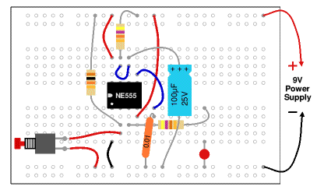

Exploring Concepts: Incredible Bread Chip Circuit

Summary: Students will examine the components found on the 555 timer circuit and how it can be adjusted to make the light turn on for a different amount of time.

Outline:
- Students will identify some of the components found on the schematic.
- Students will use the breadboard on the CEENBoT to build the circuit on.
- Students will be introduced to a breadboard, how it works, etc.

Activity: Show students a diagram of a breadboard so they will understand where the positive and negative sockets/holes are located. The top & bottom rows run horizontally and will be connected to the positive and negative terminals of the battery. The 2nd & 3rd set of 5 rows are attached vertically with the 555 IC crossing the two sections. After placing the IC in the center of the breadboard, build around it with the rest of the components to complete the project.

Students will take turns driving the CEENBoT while others place components on the breadboard. They will need to build the circuit by following directions how to complete the 555 timed circuit. The instructions can be found at the following web site: http://www.kpsec.freeuk.com/555timer.htm
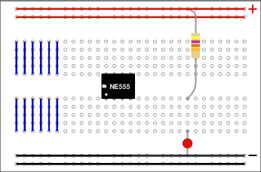

Instructing Concepts: Incredible Bread Chip Circuit

Electric Current

Putting “Electric Current” in Recognizable terms: Electric current is the flow of electric charge from one location to another. This charge is usually an electron but can actually be any charge that is in motion.

Putting “Electric Current” in Conceptual terms: Having an electric field to move the electric charges creates an electric current. In a closed circuit that includes an electric field source, such as a battery, and a conductor, such as a wire, electrons will flow in the wire as an electric current, drifting toward the positive terminal of the battery. If there is an open circuit, the current will not flow and any device connected will not function. For instance, if you flip a light switch you close the circuit and charges are allowed to flow through the light. Part of that loop is the thin wire in the light bulb that becomes hot from the electrons passing through it and begins to glow causing light.

Putting “Electric Current” in Mathematical terms: Electric current does not flow without loss of energy. This loss of energy is called resistance. The direct current resistance of a material can be defined by the formula $R=ρ\frac{l}{A}$ where R is the resistance, l is the length of the material in meters, A is the cross sectional area of the material in square meters, and $ρ$ is the electrical resistivity measured in ohm-meters and is specific to each conducting material.
Resistance can be measured using the formula$R=\frac{V}{I}$ where I is the current in amperes, which is the amount of charge that flows past a point in a given amount of time, V is the potential difference in volts, which is energy per unit charge, and R the resistance of the material measured in ohms.

Putting “Electric Current” in Process terms: Since no closed system is completely efficient, there is energy loss as the current flows through the circuit. The resistance in the material that the circuit is made of causes this loss. Sometimes the amount of energy that flows through a circuit needs to be limited or controlled. This restriction can be accomplished by inserting a resistor in the circuit. A resistor is a device that limits the flow of electricity. That reduction in flow is measured in ohms. Resistors come in different sizes that are coded by colored bands representing the digits 0 to 9, which is called the “Resistor Color Code”. The first two color bands indicate the first two digits of the resistance and the third band indicates the number of zeros. A color code of brown-yellow-red would indicate a resistance of 1400 ohms since brown = 1, yellow = 4, and red = 2. The Greek letter omega, W, is used to represent ohms, so you might see 1400 ohms written as 1400 W.

Putting “Electric Current” in Applicable terms: Electric current or electricity is an essential part of our modern lives. We take for granted the use of electric current and the work that it provides us. The applications of electric current have become more widespread as technology becomes more prevalent in society.
Organizing Learning: Incredible Bread Chip Circuit

Summary: Students will complete the breadboard activity on the CEENBoT.

Outline:
Students will diagram the circuit in their engineering notebook.
Students will receive components they will place on the CEENBoT.
Students will complete the formula and make educated guesses to how long the light will stay on.
Everyone will work as a team to put the component on correctly.

Activity:
Students will use the following instructions to build their breadboard
- Connect a wire (black) to 0V.
- Connect the 10k resistor to +9V.
Connect a push switch to 0V (you will need to solder leads onto the switch)
- Connect the 470 resistor to a used block of 5 holes, then...
Connect an LED (any color) from that block to 0V (short lead to 0V).
- Connect a wire (red) to +9V.
- Connect the 0.01µF capacitor to 0V.
You will probably find that its leads are too short to connect directly, so put in a wire link to an unused block of holes and connect to that.
- Connect the 100µF capacitor to 0V (+ lead to pin 6).
Connect a wire (blue) to pin 7.
- Connect 47k resistor to +9V.
Check: there should be a wire already connected to pin 6.
- Connect a wire (red) to +9V
Understanding Learning: Incredible Bread Chip Circuit

Summary: Students will create the 555 circuit on a breadboard.

Outline:
1) Formative assessment of building a circuit on a breadboard and adjusting the time the light stays on by using the formula, T = 1.1 x R1 x C1.
2) Summative Assessment of the circuit students will show how they adjust the time the LED stays on and how the easy the components go on if you follow the given directions.

Activity:
Formative Assessment
As students are engaged in the lesson ask these or similar questions:
- What happens when you change the value of resistor 1?
- What direction should is the dot pointed on the 555 IC?
- Can anyone list another component that has a Pos and Net?
- Black wires are hook to what part of the breadboard?
Summative Assessment
1) How many volts does the battery have?
- Name the smallest resistor we used?
- What size IC did we us in this circuit?
- How many jumper wires did we use?
- Can you name a practical use for this circuit?

STEM - PBCL Rubrics

Student: ______________________ Course: _________________ Date: ____________

Scoring Criteria  The student | Excellent  4 | Good  3 | Needs Improvement  2 | Unacceptable  1
Participates in group discussions.
Encourages others to join the activities.
Maintains the pace of the activity to achieve goals.
Shares ideas and thoughts.
Offers constructive criticism and recommendations.
Credits others for their contributions and ideas.
Empathizes with others.
Requests input from others to reach an agreement.
Expresses ideas and thoughts.
Total Score:

