CEEN Power

Definition of Horsepower:_______________________________________________________

______________________________________________________________________________
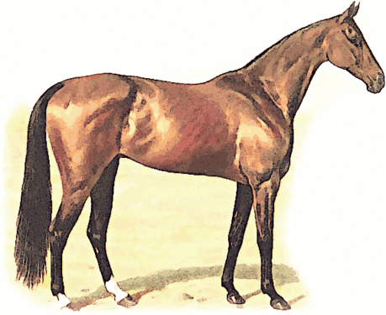
1 Horsepower
=
33,000 Foot-Pounds per Minute

Object | Weight of Object | Speed of Bot While Pushing Object

