CEEN Power

Directions: You will connect different objects to your robot during this activity. List the objects and their weights in the table below. Also, calculate the speed of the Bot as it pulls each object. Use the information in your table to calculate the CEENBoT’s horsepower.

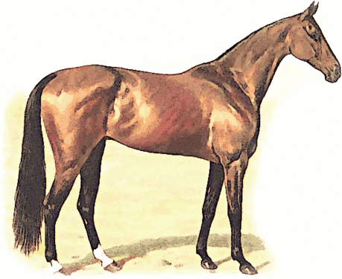
1 Horsepower
=
33,000 Foot-Pounds per Minute

Object | Weight of Object | Speed of Bot While Pushing Object

Estimated horsepower of the CEENBoT:_____________________________________________

Use the back of this sheet to document your work.

