SPIRIT 2.0 Lesson:
CEEN Power
==========================Lesson Header ==========================
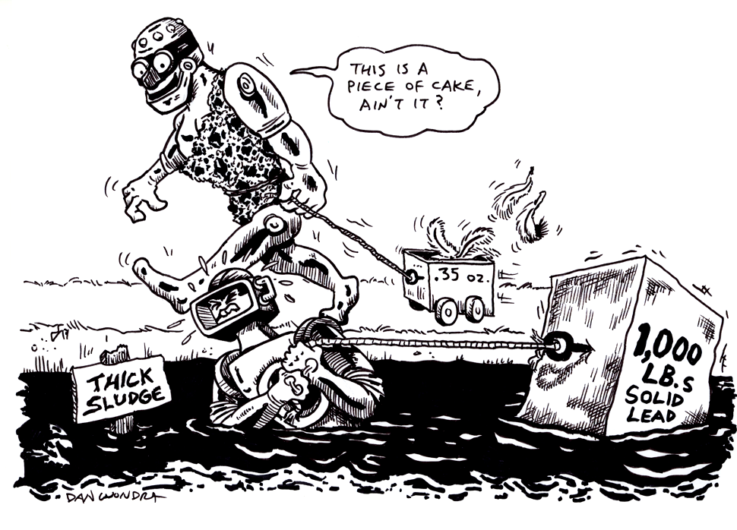
Lesson Title: CEEN Power
Draft Date: June 22, 2009
1st Author (Writer): James Hoyt
Science Topic: Measurement
Grade Level: Middle School and High School

Content (what is taught):
Units of Measurement

Context (how it is taught):
- Teacher will provide an introduction to measurements.
- Teacher will demonstrate the capabilities of the CEENBoT.
- The CEENBot will be tested in different weight moving tasks.

Activity Description:
Measurement calculations will be discussed. In the industrial world, different forms of measurements are used to express power (i.e. horse power, torque, foot-pounds, and pounds per square inch).
In this activity, students will be introduced to the CEENBoT and its abilities. The CEENBoT will be used to develop a new measuring tool that will be used to apply to smaller weights. The students will then devise the formula for interpreting weights into CEEN Power.

Standards:

Math: D1 Science: A1, A2
Technology: A1, A2

Materials List:
CEENBoT Extra batteries Weights
String Stop watch Journals
Graph paper Tape measure
ASKING Questions: CEEN Power

Summary:
Students will discuss various automated measuring systems. Traditional measurements will be discussed. The use of the CEENBoT as the base of the measurement will be discussed.

Outline:
- Identify at least six measurements used in industry.
- Identify an application for each measurement.
- Identify various scenarios where the new measurement could be used.

Activity:
In this activity, students will identify measurements and compare/contrast how they are used in industry. Students may do research on the internet first and then come back as a class to discuss findings. As a group, students will discuss a new measurement tool that can be applied to modern industrial needs.

Questions:
How are some measurements used in industry? | Answers will vary.
What measurement is applicable in each situation? Give a variety of situations. | Answers will vary.
Why would it be important to have a new form of measurement? What would be a disadvantage of a new form of measurement? | One disadvantage would be having to teach everyone about the new form of measurement. It is important for everyone to ‘speak the same language’ when it comes to measurement so people are not confused.
Where would this type of measurement be used and why would it be better than an existing measurement? | Answers will vary.

Online Resources: The following links take you to www.howstuffworks.com where you can find possible answers to the questions above. You can also type in ‘Units of Measurement’ at www.google.com to find various links for a variety of grade levels.
http://www.howstuffworks.com/horsepower.htm
http://auto.howstuffworks.com/auto-parts/towing/towing-capacity/information/fpte.htm
EXPLORING Concepts: CEEN Power

Summary: Students will practice using the CEENBoT to move various sized objects and figure horsepower of the CEENBoT. Students will determine what other measurements would be appropriate to develop for the CEENBoT. Energy limitations will be discussed because the robot only has a 20-minute charge. This is important because as the energy in the battery decreases, it may effect the horsepower the Bot is able to produce.

Outline:
- With the remote, have students use the Bot to move various objects as determined by the instructor.
- Measure speed while moving various objects.
- Construct a graph displaying the weight / speed relationship.

Activity:
First students should use the remote and use the Bot to push or pull objects that have been set out by the teacher. The objects need to have their weight measured as well has the speed of the Bot while pushing the objects. All measurements should be recorded. Students will journal about the exercise and estimate what they think the horsepower of the Bot is. Once horsepower is defined to be the power required to lift 33000 pounds one foot high in one minute, students will discuss a new measurement called “CEEN Power” that could be a standard of power for the CEENBoT.

Horsepower Connection:
Students will discuss how the developed power measurement could be used as an industry standard to replace horsepower.

Worksheet: S027-CEENPower_E_WS.doc

INSTRUCTING Concepts: CEEN Power

Measurement

Putting “Measurement” in Recognizable terms: Measurement is the process of estimating the magnitude some characteristics of an object such as weight, length, volume, air pressure, etc. Measurement will always be an estimate because we are never capable of finding the exact value of a measurement. No matter how careful or precise we try to be, there will always be measurement error created by the precision of the instrument used.

Putting “Measurement” in Conceptual terms: Measurement is the act of quantifying a magnitude that relates to an object. You can achieve this through the use of instruments. For instance, to measure length you would use a ruler or meter stick. For mass you would use some type of scale. When we are estimating a quantity there is always measurement error. Ideally, the person measuring will minimize the error as much a possible by working carefully and using precision instruments. Typically, the more precise the instrument used, the lower the measurement error.

Putting “Measurement” in Mathematical terms: The measurement of an object can be estimated to one smaller division than your instrument is marked. For instance, if you are measuring length and the meter stick is divided up into millimeters, you can estimate to tenths of a millimeter. Thus an object could be measured to be 857.2 mm long with this meter stick. The 857 would be the closest division to the length of the object and the .2 would be a closer estimate. If a yardstick is only divided up into inches you can measure to tenths of an inch. Since the divisions are much larger, the estimation will not be as close and the error will be increased. In summary, the more precise the instrument is marked the smaller the measurement error.

Putting “Measurement” in Process terms: Thus, measurement is about estimating the magnitude of an object and at the same time reducing the error associated with that estimate. A measurement should have three parts: 1) the measurement, 2) the margin error, and 3) the confidence that your measurement will fall within the margin of error. For instance, if you measure the weight of an object to be 5.43 kg with a margin of error of .01 kg with 95% confidence, you mean that 95% of the time the weight you measured will be within .01 kg. Basically, measurement is about making the best possible guess.

Putting “Measurement” in Applicable terms: Measurement applies in everything we do. All jobs require precision measurement for success to be attained. If measurements are done inaccurately or carelessly the board the carpenter cut might not fit, the rocket NASA designs might not fly, or the brakes on your car might not stop you. The old carpenter’s adage comes to mind, “measure twice and cut once”. This means you should be as sure of your measurements as you possibly can because your life or someone else’s might depend on it.

ORGANIZING Learning: CEEN Power

Summary:
Students will keep a log of their activity showing problems they encountered during the activity. Students will also sketch a graph of their findings.

Outline:
- Take actual measurements of the Bot as it moves various objects.
- Graph the measurements.
- Estimate the horsepower of the Bot.
- Test if multiple robots can lift proportional amounts of weight.

Activity:
Students will use the setup detailed below to find the maximum amount of weight the Bot can lift as well as the “CEEN Power” required to lift it. If possible, provide another robot that has decreased battery power to see if it produces less “CEEN Power” than a fully charged CEENBoT. As the battery power is drained, students will document any changes in speed the robot displays. Pose the question: Could multiple robots lift a proportional amount of weight? The students can test their hypothesis by hooking multiple robots in tandem to see if two or three Bots can lift a proportional amount of weight.

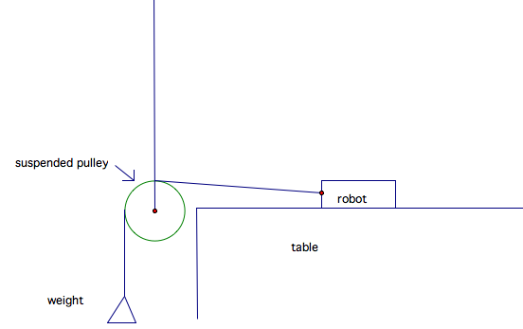

Worksheets: S027-CEENPower_O_WS.doc and S027_O_Extension.doc (this is an extension worksheet on automobile power-to-weight)

UNDERSTANDING Learning: CEEN Power

Summary: The instructor will evaluate each group’s findings to check for understanding.
The group’s journal will be evaluated to determine the process they went through to find their calculations.

Outline:

Formative assessment of measurement.

Summative assessment of measurement.

Activity:

Formative Assessment
As students are working ask these or similar questions:
- How are accurately are students measuring the desired quantities?
- Do students understand the importance of measuring properly?
- Are students able to combine measurements to create new quantities?

Summative Assessment

The journals the groups kept through the lesson should be evaluated to give a summative grade.
Students can answer the following writing prompt:
Describe how your group measured the speed, distance, weight and any other quantities in this lesson. As you do this be sure to discuss the accuracy of your measurements and why this is accuracy is important.

