SPIRIT 2.0 Lesson:
Power Up Your Breadboard
==========================Lesson Header ==========================
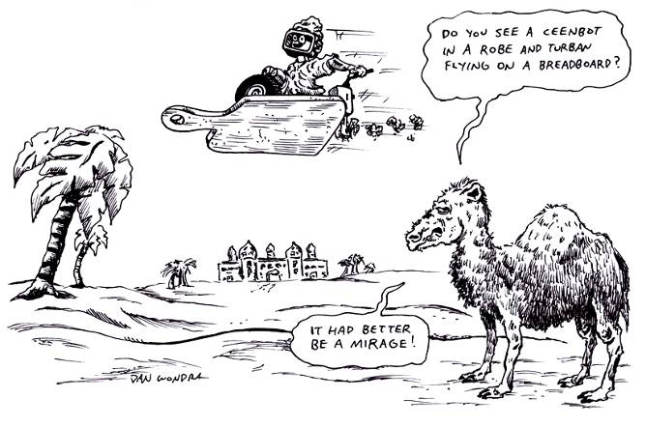
Lesson Title: Power Up Your Breadboard
Draft Date: 6/22/09
1st Author (Writer): Brian L. Moeller
Electronics: Ohms Law, Series and Parallel Circuits
Grade Level: 9 - 12

Outline of Lesson
- Students find resistance using Ohms law.
- Students read resistance using a multimeter.
- Students will be able to drive the CEENBot in a series circuit while students place components on the Bot.
- Students will be able to maneuver the CEENBot around a parallel circuit as students put on components.
Content (what is taught):
- Measure Resistance using Ohm’s law.
- Make & record readings using the multimeter.
- Build series and parallel circuits.
- Understand resistance while driving and building circuits on the Bot.
Context (how it is taught):
- Students will be working in Problem Based Case Learning activities in groups of 5 students or less.
- Students will be able to recognize parallel and series circuits.
- Students could be seen using a multimeter to read resistance, current and DC volts.
- Students will be able to draw series and parallel circuits.
Activity Description:
This lesson will give students an opportunity to build series and parallel circuits with the help of the Breadboard on the CEENBot. The Bot will be driven in series/parallel showing how electrons will be flowing through the circuit and the effect resistance has on a circuit. Students will need to know the formula for Ohms law and be able to operate a multimeter.
Standards:

Math D2, E1 Science A2, B3, F5

Technology A3, D2, F3 Engineering A2, B2

Materials List:
1) CEENBot 6) 9V Batteries
2) Diagram of Circuits taped on the floor. 7) Series Circuit R1=3k, R2=10k, R3=5k
3) Model battery and resistors 8) Parallel Circuit R1=10k, R2=2k, R3=1k
4) Multimeter 9) Handout of Formulas & Circuits
5) Engineers Notebook 10) Resistor color Code
Asking Questions: Power Up Your Breadboard

Summary: Students will identify Ohms Law and make a series and parallel circuit.
Outline:
- Point out the different resistors used in the circuits.
- Show students the schematic of a series and parallel circuit.
- Demonstrate the function of the robot and breadboard.
Activity:
Students will be able to calculate resistance using Ohms law.
Students will be able to read resistance using the multimeter.
Students will be able to drive the CEENBot in a series circuit while students place components on the Bot.
Students will be able to maneuver the CEENBot around a parallel circuit as students put on components.

Questions | Possible Answers
What are the 3 Formulas for Ohms law | V = I x R, I = V/R, R = V/I
Can anyone identify the component you will be using in a series circuit? | 9V battery, resistors 3k, 10k, 5k, and 0.6mm diameter wire.
Can anyone identify the components you will be using in a parallel circuit? | 9V battery, resistors 10k, 2k, 1k, and 0.6 mm diameter wire.
What components will we be using that are similar to those found on the CEENBot. | A DC battery and resistors

R1 3kΩ

+
Finish +
Start the Bot –
Follow
-
R2 10kΩ

R3 5kΩ
Exploring Concepts: Power UP Your Breadboard

Summary: Students will use the CEENBot to demonstrate resistance in a circuit.

Outline:
- Students will drive the CEENBot through a series circuit while observing and recording what they discover.
- Students will drive the CEENBot through a parallel circuit while observing and recording what they discover.

Activity:
Explain to students how they will place the components of the circuit on the breadboard of the CEENBot as it travels along series and parallel circuits. During these activities, students will review the formula for Ohm’s law to figure out resistance, current, and voltage. As students complete these activities they will write down their findings in their engineering notebook.

Series Circuit Parallel Circuit
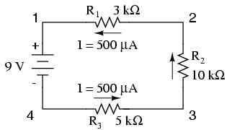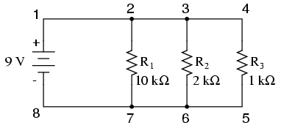

Instructing Concepts: Power UP Your Breadboard

Ohm’s Law

Putting “Ohm’s Law” in Recognizable terms: Ohm’s Law is a mathematical relationship that is present in electric circuits. The version discussed here is for direct current but it is possible to modify Ohm’s Law to work for alternating current.

Putting “Ohm’s Law” in Conceptual terms: Ohm’s Law shows how current (I), voltage (V), and resistance (R) are related in an electric circuit. Current is the continuous flow of electrons in a conductor. This movement is called flow and is similar to water moving through a hose. Voltage is the energy per unit charge that motivates the flow of electrons in an electrical circuit. Electrons move through the conductor with some degree of friction. This friction is call resistance.

Putting “Ohm’s Law” in Mathematical terms: Ohm’s Law is a mathematical formula that relates the voltage (V), current (I), and resistance (R) in an electrical circuit. The formula states that $V=\text{IR}$ where unit of voltage is Volts, current is Amperes, and resistance is Ohms ($Ω$). This equation can be transformed into two other formulas. These are $I=\frac{V}{R}$ and $R=\frac{V}{I}$. Each case is equivalent to the others but depending what you are trying to find one is easier to use. If current through a resistor is measured for different voltages and the data is graphed, you will find a linear relationship. If voltage is plotted on the y-axis and current on the x-axis, the slope of the resulting line will be the resistance.

Putting “Ohm’s Law” in Process terms: Thus, the relationship between voltage, current, and resistance is fixed. The current (I) is directly proportional to the voltage (V) and inversely proportional to the resistance (R). If one of the values is held constant the other two will change very predictably. Be sure to note that temperature needs to remain constant for Ohm’s Law to apply. If the temperature changes the values must be measured again and a new equation created. Resistance increases as the temperature increases.

Putting “Ohm’s Law” in Applicable terms: This law is important in many applications. In science and industry one goal is to reduce the resistance of electrons to flow in the circuit. This resistance creates heat that can be harmful in computers or other settings where electricity is present. Ohm’s law gives you an easy way to compute resistance.
Organizing Learning: Power Up Your Breadboard

Summary: Students will calculate voltage, current, and resistance for circuits.

Outline:
- Students will complete a chart showing the voltage, current and resistance.
- Students will create a circuit following the schematic.
- Students will list the activities completed in their engineering log.
- Students will label components used to complete their circuits.

Activity: Complete the following tables, calculating voltage, current, and resistance for each circuit.

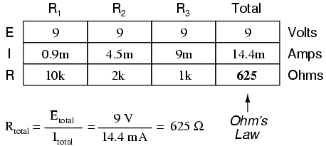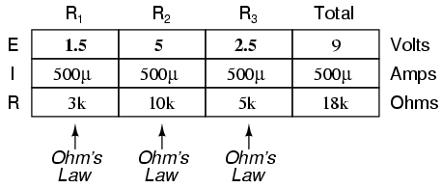
Understanding Learning: Power Up Your Breadboard

Summary: Students will build series and parallel circuits in the lab.

Outline:
- Students will be instructed on Ohms law.
- Students will build series and parallel circuits.
- Students will be able to operate a multimeter.

- Formative assessment of Ohms Law, Resistance, Series & Parallel circuits.
- Summative assessment of Ohms Law, Resistance, Series & Parallel circuits.

Activity:
Formative Assessment
As students are engaged in the lesson ask these or similar questions:
- What does V stand for in Ohms law?
- How much resistance is in resistor 2?
- Why do we use resistors?

Summative Assessment
- What formula is used to figure current, resistance and voltage?
- Figure out the resistance of a Black, Brown, Orange and Gold Resistor?
- What does resistance do to the flow of Electrons?
- When the CEENBot runs into the resistors what happens?
- How many Ohms are in the circuit?

