SPIRIT 2.0 Lesson:
The Addiction With Friction
============================Lesson Header ============================
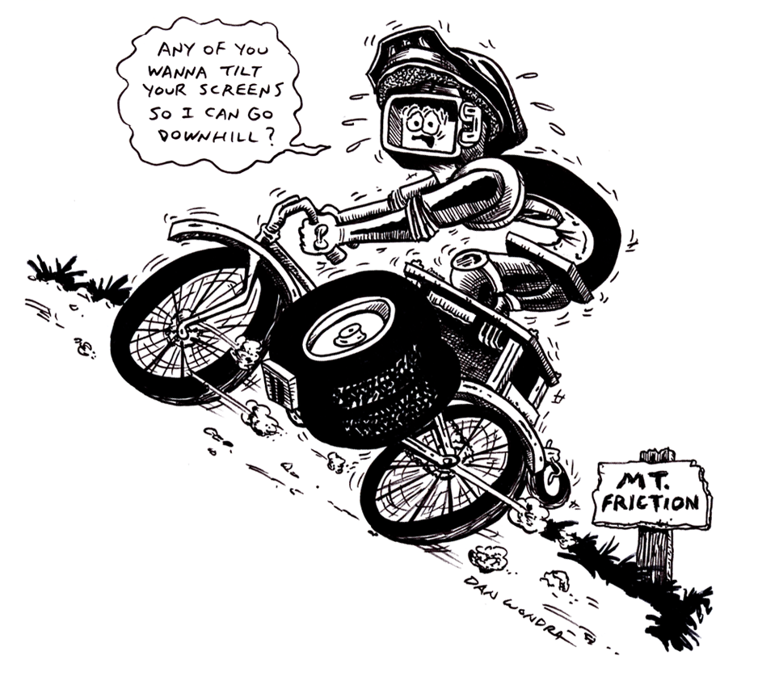
Lesson Title: The Addiction With Friction
Draft Date: April 21, 2009
1st Author (Writer): Sara Bowen
Science Topic: Friction
Grade Level: Upper Elementary

Content (what is taught):
- Friction is the force that results when two materials rub against each other
- Friction slows down the motion of an object or prevents it from moving
- Friction depends on qualities of the objects that are pushing or pulling against one another, unlike other forces

Context (how it is taught):
- Students will investigate the parts of a bicycle and how friction affects the different parts of the bike
- Students will investigate the parts of a CEENBoT and determine how friction affects the different parts
- Students will label the parts on a diagram of a bicycle and a diagram of a CEENBOT comparing the functions on both that explore and help define friction
- Students will complete a Venn diagram noting the similarities and differences with friction on the CEENBoT and the bicycle
Activity Description:
Students will understand how friction affects different parts of a bicycle and the rider of a bicycle. At the same time, the students will explore the CEENBoT and how friction affects the CEENBoT and the driver of the CEENBoT. By exploring both the bicycle, which is a very identifiable object, and the CEENBoT, the student will be able to acquire a better understanding of how friction works and what it is. Students will team up with a partner to discuss the different functions of the bicycle and CEENBoT they discovered that helped them understand friction.

Standards

Math - C1, C4, E1, E3 Science - B1, B3, E1 Technology - A1, A3, B1, B2, B4

Materials List:
CEENBoT Colored Markers
Bicycle diagram Whiteboard
CEENBoT diagram Venn diagram
Asking Questions: The Addiction With Friction

Summary: Define, discuss, and understand friction.

Outline:
- Students will define friction
- Determine situations where friction exists (i.e. –sliding on a smooth floor with socks on as opposed to trying to with shoes on)

Activity: Discuss the following with the students:

Questions | Answers
What is friction? | Friction is a force that acts to slow down the motion of an object, or keep the object from moving (or starting to move).
Where can you find friction? | Friction can be found anywhere something moves. Nothing can move in this world without friction.
What factors can affect the amount of friction between two objects? | The amount of friction depends on the surface type and the force pressing two surfaces together. The shape, speed, or texture of an object also affects friction.
Would there be more or less friction if you rubbed your hand across it – A smooth or rough surface? | A rough surface.
If the robot were to travel on roads made of the materials listed below, which roads would create the most friction?  - Wood  - Rubber  - Concrete  - Steel  - Glass | Answers will vary. Be sure to have students explain their reasoning.

Exploring Concepts: The Addiction With Friction

Summary: Students will examine different vehicles with wheels (bikes, cars, CEENBoT, etc.) and different surfaces. Students will discuss how friction can be increased or decreased.

Outline:
- Have students examine different vehicles with wheels.
- Students will order the vehicles from those creating the least friction to those creating the most friction on a given surface.
- Discuss how given vehicles could be modified to create more or less friction.

Activity:
Show pictures of bicycles (mountain bikes, racing bikes, etc.), cars (monster trucks, tractors, family cars), and the CEENBoT. Students can discuss similarities and differences in the vehicles. Give students a sample road material (wood, concrete, granite, glass, etc.) and have them order the vehicles from those creating the least friction to those creating the most friction. Would the order change for different surfaces?
Questions | Answers
How are the vehicles similar? | They are alike in that they move, the parts they each have, and their function.
How are the vehicles different? | The CEENBoT is steered by a person using a remote control. The bicycle and truck are steered and controlled by a person who is riding/driving it.
What can you observe about where friction takes place on the vehicles? | Friction takes places when two things are rubbing or dragging across each other. Students will most likely point out the friction that takes place between the wheels on each vehicle and the surface it is traveling on.
If we were to create a road out of ________ (fill in blank with any material-glass, wood, concrete, etc.) in our classroom, which vehicle would create the least friction? The most friction? | Answers will vary depending on vehicles and surface given.
How could a bicyclist create more/less friction? How could an engineer create more/less friction for the CEENBoT? | Pose these and similar questions based on the different vehicles shown. Answers will vary, but probe students for explanation for summative assessment.

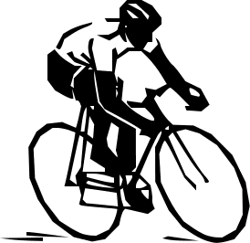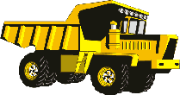
Instructing Concepts The Addiction With Friction

Friction

Putting “Friction” in Recognizable terms: Friction is a force between two objects that tends to “damp out” or oppose motion. It always acts in complete opposition to another force applied to an object. There are two main types of friction. Static friction is the frictional force opposing putting an object at rest into motion. Kinetic friction is the frictional force, which tends to slow an object in motion. Usually static friction is higher than kinetic friction meaning it takes a greater force to put an object into motion than it does to maintain motion.

Putting “Friction” in Conceptual terms: Friction opposes the force required to start or maintain an object in motion. It is dependent on the surfaces that are in direct contact. The rubbing or dragging of the surfaces across each other creates friction. Friction can be increased or decreased by modifying the surfaces.

Putting “Friction” in Mathematical terms: The coefficient of friction must be calculated for any surface because different surfaces provide different amounts of friction. The coefficient of friction can be found by taking the force of friction (either to start an object in motion, “static” or to keep an object in motion, “kinetic”) divided by the normal force (force a provided by a component of gravity) divided. The normal force is always found perpendicular to the surface. If the surface is NOT horizontal you must resolve the force of gravity perpendicular to the surface. In terms of a mathematical equation, it may be written: µ = F_{f} / F_{n} where the Coefficient of Friction equals the Frictional Force divided by the Normal Force.

Putting “Friction” in Process terms: Friction is the force that allows us to move. Without friction there would be no force to resist or act in opposition to our desired motion. Thus friction is the force that fulfills Newton’s 3rd law - for every action there is an opposite and equal reaction. We cannot move in a desired direction unless friction works against us in the opposite direction. Friction is desirable and necessary for motion as we understand it and yet we are always trying to reduce friction in many instances because it requires less energy to move an object. At other times we want to increase friction to keep an object at rest.

Putting “Friction” in Applicable terms: Friction is the force that allows us to walk, climb, drive, throw, or put any object in motion. Without friction we couldn’t move objects. Friction is both desirable and undesirable depending on if you want an object to move or stay at rest. Higher friction requires more energy input. Lower friction requires less energy input.
Organizing Learning: The Addiction With Friction

Summary: In groups, students will make a list of where friction exists for a given vehicle. Students will then complete a Venn diagram to show how friction on a CEENBoT and friction on another vehicle are alike and different.

Outline:
- Give each group a different vehicle. Have them make a list of where friction exists. Each group can present their list to the rest of the class.
- Groups will then put the likenesses and differences of their vehicle and the CEENBoT in a Venn diagram.
- Each group can post their Venn diagram for others to evaluate.
- Students can use sticky notes to comment on the Venn diagrams and add anything the group may have forgotten.

Activity:
Provide groups of 2-3 students with a diagram of a vehicle and a CEENBoT. Each group should label and describe where friction occurs on each vehicle. Students will transfer their information to a Venn diagram that will be posted for others to evaluate. When all groups have finished, students can use sticky notes to make comments about the Venn diagrams and add anything the group may have overlooked.

Example:
Bicycle
- The pads on the bikes brakes push against the tires to slow them down.
- The ball bearings decrease friction.
- The low handlebars allow the rider to bend down to decrease air friction.
- The texture of the foam on the handlebars increases friction between the rider’s hands and the handlebars and makes it easier to have a firmer grip.
- The rough tread on the tires increases the friction between the tire and the ground to keep the bike from sliding during turns.
CEENBoT
- The tires increase friction between the tire and the ground to keep it from sliding during turns.
- The texture of the remote control between the controller’s hands and the control make it easier to have a firm grip on the remote.

Resources: Images of vehicles can be found using Google.

Worksheet: AddictionWFrictionWS.doc
Understanding Learning: The Addiction With Friction

Summary: Students will compare and contrast where friction occurs on the parts of a robot and a bicycle.

Outline:
- Formative assessment of friction.
- Summative assessment of friction.

Activity:
Formative Assessment
As students are engaged in the lesson ask these or similar questions:
- Were the students able to find friction spots on the CEENBoT?
- Were the students able to find friction spots on the different vehicles?
- Were the students able to see the similarities and differences in the friction spots of the CEENBoT and vehicles?

Summative Assessment
Students can answer the following writing prompt:
Describe the concept of friction and how it can be useful in the real world.

Possible quiz questions
- Explain why friction is important to movement.
- Compare and contrast three parts of a bicycle (or other vehicle) and a CEENBoT as related to friction.
- What factors can affect the amount of friction between two objects?
- Discuss three objects that use friction and how friction helps or hinders those objects.

