SPIRIT 2.0 Lesson:
The Energy That Keeps Us Moving
==========================Lesson Header ==========================
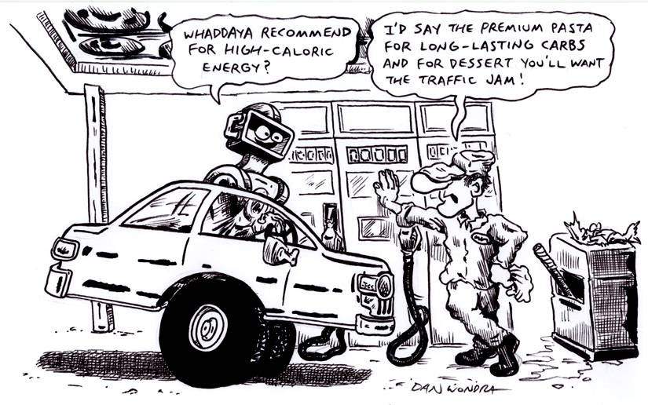
Lesson Title: The Energy that Keeps Us Moving
Draft Date: May 11, 2009
1st Author (Writer): Sara Bowen
Science Topic: Measurement
Grade Level: Middle School

Content (what is taught):
- Measurement: The act of measuring the size, length, or amount of something
- Measuring the amount of energy in food
- The different ways the CEENBoT acquires energy
Context (how it is taught):
- Students will learn about the huge array of things that can be measured and the many different meanings of measurement depending on the situation.
- Students will be taught about the energy people need to live and that the energy in food is measured by using calories.
- The class will discuss different ways that the CEENBoT gets energy to move.
- A Venn diagram will be completed on the whiteboard about how humans and the CEENBoT acquire and use energy in the same and different ways
Activity Description:
Students will learn about the different things that can be measured and very briefly how they are measured. The class will then discuss that people need energy to move and in order to get that energy they must eat food. The way that we measure the energy in foods is by using calories. We will then discuss the ways that CEENBoTs get energy in order for them to move. Finally, we will create a large Venn diagram as a class on the board comparing and contrasting how CEENBoTs and humans get and use energy and how it is measured.
Standards:

Math – A1, A2, B3, D1, D2

Science – A1, A2, B3, E1, E2

Technology – A1, A3, B2, B4, C2, C4, D1, D2, D3, D4, E1, E2, E3, F1, F2, F3, F4
Materials List:
A CEENBoT to examine
Whiteboard
Pen/Pencil/or Marker
A chart of different foods and their calories
Venn diagram
Asking Questions: The Energy That Keeps Us Moving

Summary:
Discuss, define, and understand the measurement of food energy, the calorie, and discuss the calories in different foods.

Outline:
Students will be taught about the measurement of food energy, the calorie, and discuss different foods and their calories. As an extension activity, discuss which foods are better to eat and the other measurements that are found in foods (fat, carbohydrates, sodium, etc.). Also discuss the different types of energy (kinetic, potential, chemical, and nuclear).

Activity:

Questions | Answers
What is measurement? | The act of measuring something
How is energy in food measured? | The calorie
An apple has 90 calories; 1 cup of ice cream has 580 calories. What is the difference between the two? | 490 calories
Which is healthier for your body, an apple or a cup of ice cream? | An apple

Online Resources:
A calorie counter can be found at http://www.labpixies.com/
Students can learn about calories at http://kidshealth.org/kid/stay_healthy/food/calorie.html
For additional online resources, search for ‘calories and kids’ at google.com

Exploring Concepts: The Energy That Keeps Us Moving

Summary:
The teacher will display the CEENBoT to the class and discuss/explore the different things that keep the CEENBoT moving as well as the types of energy it exerts and how.

Outline:
The class will discuss the ways that the CEENBoT moves and the ways that the CEENBoT gets that energy. Students can make the following chart in their notebook:

Way the CEENBoT Moves | Ways the CEENBoT Gets Energy

Activity:
The teacher will explain to the students that the human body gets its energy from food calories and how the CEENBoT gets its energy. Providing a diagram for the class to examine the CEENBoT to visualize these types of energy may be helpful for them. The class will use the internet to find ten examples of different foods and the calories that those foods have. Students will then discuss with a partner the ways that the CEENBoT gets its energy.

Online Resources:
A calorie counter can be found at http://www.labpixies.com/
Students can learn about calories at http://kidshealth.org/kid/stay_healthy/food/calorie.html
For additional online resources, search for ‘calories and kids’ at google.com
Instructing Concepts: The Energy That Keeps Us Moving

Measurement

Putting “Measurement” in Recognizable terms: Measurement is the process of estimating the magnitude some characteristics of an object such as weight, length, volume, air pressure, etc. Measurement will always be an estimate because we are never capable of finding exactly what an object measures. No matter how careful or precise we try to be, there will always be measurement error created by the precision of the instrument used.

Putting “Measurement” in Conceptual terms: Measurement is the act of quantifying a magnitude that relates to an object. You can achieve this through the use of instruments. For instance, to measure length you would use a ruler or meter stick. For weight you would use some type of scale. When we are estimating a quantity there is always measurement error. Ideally, the person measuring will minimize the error as much a possible by working carefully and using precision instruments. Typically, the more precise the instrument used, the lower the measurement error.

Putting “Measurement” in Mathematical terms: The measurement of an object can be estimated to one smaller division than your instrument is marked. For instance, if you are measuring length and the meter stick is divided up into millimeters, you can estimate to tenths of a millimeter. Thus an object could be measured to be 857.2 mm long with this meter stick. The 857 would be the closest division to the length of the object and the .2 would be a closer estimate. If a yardstick is only divided up into inches you can measure to tenths of an inch. Since the divisions are much larger, the estimation will not be as close and the error will be increased. In summary, the more precise the instrument is marked the smaller the measurement error.

Putting “Measurement” in Process terms: Thus, measurement is about estimating the magnitude of an object and at the same time reducing the error associated with that estimate. A measurement should have three parts: 1) the measurement, 2) the margin error, and 3) the confidence that your measurement will fall within the margin of error. For instance, if you measure the weight of an object to be 5.43 kg with a margin of error of .01 kg with 95% confidence, you mean that 95% of the time the weight you measured will be within .01 kg. Basically, measurement is about making the best possible guess.

Putting “Measurement” in Applicable terms: Measurement applies in everything we do. All jobs require precision measurement for success to be attained. If measurements are done inaccurately or carelessly the board the carpenter cut might not fit, the rocket NASA designs might not fly, or the brakes on your car might not stop you. The old carpenter’s adage comes to mind, “measure twice and cut once”. This means you should be as sure of your measurements as you possibly can because your life or someone else’s might depend on it.
Organizing Learning: The Energy That Keeps Us Moving

Summary: Students will fill in a Venn Diagram listing the similarities and differences of energy in food vs. the CEENBoT.

Outline:
- Brainstorm ideas
- Fill in Venn Diagram
- Discuss the Venn Diagrams and how energy is the same and different in food and in the CEENBoT

Activity: Complete the Venn diagram with the class. Discuss the major similarities and differences with the class. Discuss measurement of energy in terms of food, mechanical, potential, kinetic and any other deemed appropriate. Robots can have potential, electrical, kinetic, and chemical types of energy. With the students, look at the similarities between the ways the body and the robot uses/stores food energy. For instance the robot stores chemical energy (battery) and the body stores energy (fat) for later use. These similarities can be explored in a number of different levels. When comparisons are found have student briefly write a synopsis of the relationship. This would also be a great time for an extension on a health activity about foods and the healthiness of them versus how many calories and other ingredients are in those foods.

Worksheet: S030_EnergyKeepsUsMovingWS.doc

Understanding Learning: The Energy That Keeps Us Moving

Summary:
Students will describe how humans get energy from food and how the CEENBoT gets energy.

Outline:
- Formative assessment of measurement.
- Summative assessment of measurement.

Activity:

Formative Assessment
As students are experimenting in the experiment with their partner ask these or similar questions:
- How is food energy measured?
- How does a CEENBoT get its energy?
- How are the ways the body and the robot use energy similar/different?

Summative Assessment
Students can answer the following writing prompt
- How are a CEENBoT and a human alike and different in terms of their energy?
- How is energy that a human and robot measured?
- Describe the different types of energy that can be present in a situation in which a robot is present and how the robot might use them.

