Newton’s 2nd Law of Motion
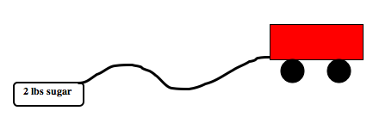

Organizing Learning

Directions: Fill in the data table below for each trial and calculate the average. Then, create a graph of the data.

Trial | CEENBoT  No Extra Mass | CEENBoT  2 lb Extra Mass | CEENBoT  4 lb Extra Mass
1 | seconds | seconds | seconds
2 | seconds | seconds | seconds
3 | seconds | seconds | seconds
Average

