SPIRIT 2.0 Lesson:
Newton’s 2nd Law of Motion
============================Lesson Header========================
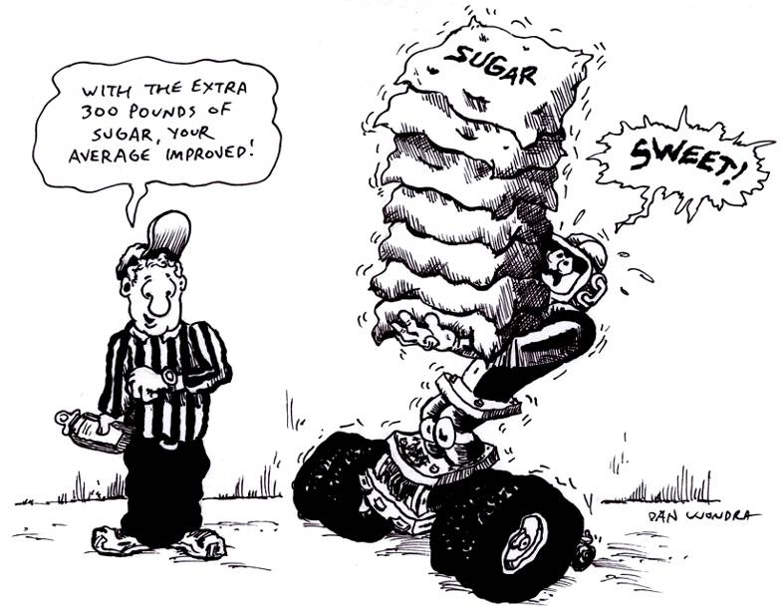
Lesson Title: Newton's 2nd Law of Motion
Draft Date: March 2009
1st Author (Writer): Nancy Polodna
Science Topic: Momentum
Grade Level: Upper Elementary, Middle School

Content (what is taught): Newton's 2nd Law of Motion

Context (how it is taught):
The CEENBoT will be timed on a track 3 times to get the average. It will then be timed 3 more times, on the same track, but this time pulling a 2 pound sack of sugar, and then 4 lbs of sugar.

Activity Description:
A track will be made consisting of 2 meter sticks lying end to end, taped to the floor. The CEENBoT will be placed at one end and a student will time how long it takes to travel the 2 meters. Each try will be recorded so an average can be found. The CEENBoT will then be hooked up to 2 lbs of sugar with a bungee cord. It will be timed on the same track, 3 more times. The average will be found on those runs as well. The last trial will be made with 4 lbs of sugar, finding the average after 3 runs.

Standards:
Math –
Science –
Technology –

Materials List:
- CEENBoT
- 2 meter sticks and tape
- Lab sheet
- 2 – 2 lb bags of sugar
- Ziploc bag and bungee cord
- Timers
- Worksheets/pencils
ASKING Questions: Newton's 2nd Law of Motion

Summary: Students will explore Newton’s 2nd Law of Motion and discuss what happens to the speed of things when weight is added.

Outline:
- Ask students when Newton's 2nd Law of Motion would affect them or their parents. NOTE: Depending on students prior knowledge of Newton’s 2nd Law of Motion, students could do research online or in textbooks to facilitate a conversation about the law.
- Talk about how Newton’s 2nd Law of Motion could be tested.

Activity:
Questions | Answers
What is Newton’s 2nd Law of Motion? | The net force acting upon an object is a product of its mass multiplied by its acceleration.
When does Newton’s 2nd Law of Motion affect you? | Accept reasonable answers.
How could we test Newton's 2nd Law of Motion? | Set up a track and record the time it takes for the CEENBoT to travel a given distance. Then we could add weight to it and try it again.
How can we measure the speed? | Set up a track and time the CEENBoT traveling a given distance.
How could we organize and show our results? | Make a table and graph it.
How much does mass effect the acceleration of the CEENBoT? | It will make it go slower!

Online Resources: Several resources can be found at www.google.com by searching for ‘Newton’s 2nd Law of Motion’

2 lbs sugar

EXPLORING Concepts: Newton's 2nd Law of Motion

Summary: Students will experiment with having the CEENBoT travel 2 meters carrying different loads.

Outline:
- Divide students into groups of 3 with the following roles: driver, recorder, calculator
- After taping two meter sticks end-to-end, the driver will drive the CEENBoT from start to finish 3 times. The recorder will record the time after each trial. The calculator will determine the average time.
- Students will attach a 2 lb bag of sugar to the bungee cord and to the Bot.
- Repeat the timing, recording, and averaging
- Students will attach 4 lbs of sugar to the Bot and repeat the timing, recording and averaging
- All students will complete the chart and compare the times

Activity: Before beginning the experiment, review the terms: force, mass, acceleration and Newton's 2nd Law of Motion.
Have students copy the tables below into their notebook. Divide students into groups of 3 with the following roles: driver, recorder, calculator. After taping two meter sticks end-to-end, the driver will drive the CEENBoT from start to finish 3 times. The recorder will record the time after each trial. The calculator will determine the average time. Students will attach a 2 lb bag of sugar to the bungee cord and to the Bot, repeating the process described above. Students will then attach 4 lbs of sugar to the Bot, repeating the same process.

Trial #  (Nothing Attached) | Time to Travel 2 Meters
1
2
3
Average Time:

Trial #  (2 lbs of Sugar Attached) | Time to Travel 2 Meters
1
2
3
Average Time:

Online Resources:
Newton's Laws: http://www.grc.nasa.gov/WWW/K-12/airplane/newton.html
An online quiz on force, mass and acceleration:
http://www.softschools.com/quizzes/science/force_mass_acceleration/quiz389.html
INSTRUCTING Concepts: Newton's 2nd Law of Motion

Newton’s 2nd Law of Motion

Putting “Newton’s 2nd Law of Motion” in Recognizable terms: Newton’s 2nd Law of Motion states that the acceleration of an object is produced by a net force in the same direction as the acceleration, is directly proportional to the magnitude of the net force, and inversely proportional to the mass of the object. This means that the acceleration (a) of an object is dependant on a force applied to the object and the mass of the object.

Putting “Newton’s 2nd Law of Motion” in Conceptual terms: Newton’s 2nd law basically says the net force (unbalanced) (F_{net}) is equal to the mass (m) times the acceleration (a) and as a result the object will accelerate in the same direction as the (unbalanced) net force.

Putting “Newton’s 2nd Law of Motion” in Mathematical terms: Using the formula that can be derived from Newton’s 2nd law, a = F/m or F = m * a, you are able to calculate acceleration of a object given the unbalanced force applied to the object and the mass of the object. Remember this law doesn’t state that the object in motion stays in motion or if at rest stays at rest (Newton’s 1st law), it discusses how the object's velocity changes as a result of an unbalanced force applied and the mass of the object.

Putting “Newton’s 2nd Law of Motion” in Process terms: Thus, because of Newton’s 2nd law of motion, the acceleration of an object is a quantifiable concept. We are able to use this Law of Motion to make predictions about the acceleration of an object given the net force and mass. The implications here are four fold: 1) if the net force increases and the mass stays the same the acceleration increases, 2) if the net force decreases and the mass stays the same the acceleration decreases, 3) if the net force remains constant and the mass decreases the acceleration increases, and 4) if the net force remains constant and the mass increases the acceleration decreases. It is also possible to show that if mass and force both increase or decrease the acceleration will have no change as illustrated below.

Putting “Newton’s 2nd Law of Motion” in Applicable terms: Newton’s 2nd law is easiest easily explained by looking at the free fall of 2 different objects with no air resistance. If one object weighs 1000 kg its net force would be 9800 N (1000 * 9.8) and a second object weighs 1 kg its net force would be 9.8 N (1 * 9.8). The result is that the acceleration for both objects is exactly the same (i.e. 9.8 m/sec²) because the acceleration is affected directly by the increased net force and inversely by the increased mass. (9800/1000 = 9.8/1 = 9.8 m/sec²) This clearly shows that acceleration is related to net force and mass.

ORGANIZING Learning: Newton's 2nd Law of Motion

Summary:
Students will record data in tables and graph the results.

Outline:
- Students will analyze data collected.
- Students will use the data to complete a graph.

Activity:
Students will put all the data collected in a table and then graph the results. Examples may be used, or students may come up with their own design. Remember that Newton’s 2nd Law relates force (the push created by the CEENBoT), the mass of the object (CEENBoT plus sugar), and acceleration. In our example we will assume that the force applied by the CEENBoT is the same in each of the trials.

Worksheet: S-031-Newtons2nd-OWS.doc

Online Resource:
Website for Graphing: http://nces.ed.gov/nceskids/createAgraph/default.aspx

UNDERSTANDING Learning: Newton's 2nd Law of Motion

Summary: Students will complete their table and graph. They will then complete the worksheet answering all the questions.

Outline:
- Collect tables and graphs
- After completion of the worksheet, class will discuss their answers and work through any questions concerning the activity.

Activity:

Formative Assessment
As students are engaged in the lesson ask these or similar questions:
- Do students see the acceleration of the CEENBoT changes and the mass is increased?
- Do students understand that the force in the experiment is constant and the CEENBoT supplies it?
- Are students able to make accurate measurements for the time and realize if the time is longer, the acceleration is less?
Students will hand in their tables and graphs.
Students will hand in their completed worksheet.

Summative Assessment
Students can answer the following writing prompt: Describe a situation in the real world where Newton’s 2nd law is evident. In your example, list the force, mass, and acceleration and how they are related.

Students will answer the following questions and then discuss their answers in a large group class discussion.
1) What is your conclusion concerning Newton’s 2nd Law of Motion?
2) What is Newton's 2nd Law of Motion?
3) Which part used in the lab was the force?
4) Which part used in the lab was the mass?
5) How did this lab show Newton's 2nd Law of Motion?

