SPIRIT 2.0 Lesson:
The Wheels on the Bot go Round and Round, Part I

============================Lesson Header=============================
Lesson Title: The Wheels on the Bot Go Round and Round, Part I
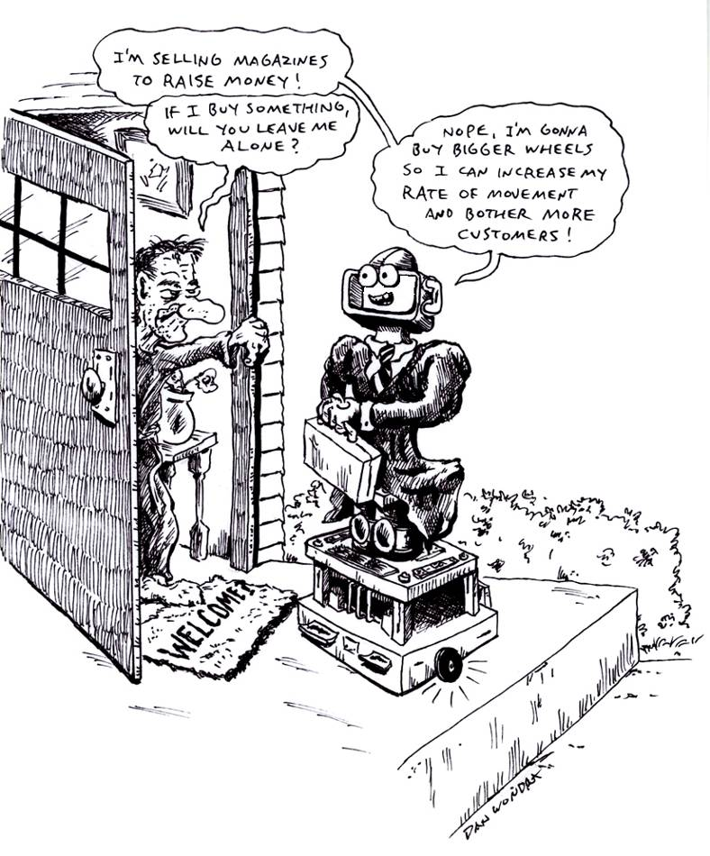
Draft Date: 3/21/09
1st Author (Writer): David Porter
Science Topic: Rate of Movement and Scientific Inquiry
Grade Level: 4th-8th

Content (what is taught): Rate of Movement and Scientific Inquiry

Context (how it is taught): Students will first learn how to determine the rate of movement in the appropriate units of feet or meters per second with the CEENBoT. They will then create a hypothesis whether smaller wheels will make a difference in the CEENBoT’s rate of movement. Students will then design and conduct an experiment to test their hypothesis.

Activity Description: A small group of students will consider how rate of movement (speed) is normally determined (cars as a frame of reference). They will apply this to the CEENBoT and determine appropriate units of distance and time given the CEENBoT’s rate of movement. They will then measure an appropriate test track, conduct several timed trials, and determine its rate of movement. Students will then create a hypothesis if and how smaller drive wheels will make a difference on the CEENBoT’s rate of movement. They will be challenged to create an experimental design and then conduct the experiment controlling as many variables as possible (tire composition and the charge state of the CEENBoT’s battery).

Standards:
Math – D1, E1 Science – A1, A2 Technology – C1

Materials List:
CEENBoT and different sized drive wheels Wrench 7/16 or adjustable to change wheels
Large rubber bands String
Timer Tape Measure
Masking Tape

ASKING Questions: The Wheels on the Bot go Round and Round, Part I

Summary: How is rate of movement measured? Students will talk about appropriate rates of motion for different scenarios.

Outline:

Ask students if they are familiar with any rates of motion (i.e. cars can drive 75 miles per hour on the interstate, a runner can run 100 meters in 15 seconds or about 7 meters per second, etc.).

Ask students for appropriate rates of motion for different scenarios.

Activity: Brainstorm different rates of motion. Pose different scenarios and have students decide on an appropriate rate of motion. Students can also create their own scenarios and ask the rest of the class for possible answers.

Questions | Possible Answers
How is rate of motion measured? | A given measurement over a unit of time.
What are some sample rates of motion? | 1 foot/second, 10 mm/minute, 1 gallon/hour, etc.
What do rates have in common? | The denominator is always 1
Scenario 1: A tortoise and a hare were having a race. What would be an appropriate rate of motion for the tortoise? The hare? | Accept reasonable answers.
Scenario 2: A 2009 Mustang and a 1970 Mustang were having a race. What would be an appropriate rate of speed for each car? | Accept reasonable answers.
Scenario 3: Tiger Woods is playing golf with a 7th grade student who won a contest. They both tee-off on the first hole. What would estimate the speed of each person’s ball to be? | Accept reasonable answers.
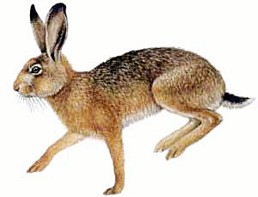
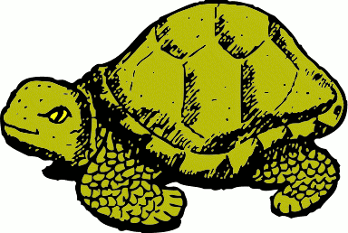
FINISH

EXPLORING Concepts: The Wheels on the Bot go Round and Round, Part I

Summary: Students will determine the CEENBoT’s rate of movement by experimentation. Students will explore the relationship between tire size and the CEENBoT’s rate of movement.

Outline:
- Students will time the CEENBoT as it travels a pre-measured distance.
- Students will discuss the question of whether different sized tires will affect the CEENBoT’s rate of movement.

Activity: Have students copy the table below in their notebook. Students will conduct timed trials so that the rate of movement can be determined for the CEENBoT. Students will take turns driving, timing, recording, and computing. Next, students will determine the average rate of movement. Finally, students will discuss, theorize, and hypothesize the effect on the rate of movement after changing the wheel/tire size on the CEENBoT.

Trial | Distance  (pre-measured distance) | Time | Rate  Rate = Distance / Time

1

2

3

4

Average Rate

INSTRUCTING Concepts: The Wheels on the Bot go Round and Round, Part I

Scientific Inquiry
Scientific Inquiry Process
Scientific Inquiry is a very systematic processes that scientist use to understand phenomena that are present in the world. The process must be followed exactly without any deviation or any results that are obtained might not be valid. There are six basic steps to the scientific inquiry process.

Step One: Ask a question.
In this step you ask a question that you want answered about something that you have observed. If scientific inquiry is to provide an answer, the question must be framed in such a way that it can be measured preferably with a number.

Step Two: Make a set of observations regarding the phenomenon being studied.
The scientist will observe the phenomenon that is being studied without out any bias. It is important that the phenomena be researched in addition to observing it so that past information will be noted and past mistakes will not be repeated.

Step Three: Form a hypothesis that might explain the observations.
The hypothesis should be framed in a format like “If I do this, then this will happen”. This hypothesis must be measurable and should help you answer your original question.

Step Four: Test your hypothesis by doing an experiment.
You will conduct an experiment that will prove your hypothesis true or false. It is important that the experiment be unbiased and fair. To do this you can only change one variable at a time and keep everything else the same. Doing this insures that any change observed will be as a result of your experiment and not some other factor.

Step Five: Analyze your data and draw conclusions.
Once your experiment is done you need to analyze your measurements and see if your hypothesis is true or false. If your hypothesis is false (a common occurrence), you should start the entire process again with a new hypothesis. Even if you find your hypothesis to be true you may want to devise another experiment to test your hypothesis again. Multiple experiments that validate your hypothesis make your conclusion stronger.

Step Six: Communicate your results.
If your hypothesis stands up to multiple tests you should report your results in a final report. This might take the form of a journal article in a professional or scientific journal.

ORGANIZING Learning: The Wheels on the Bot go Round and Round, Part I

Summary: Students will each create a written hypothesis of the impact of smaller wheels on the CEENBoT. Students will make a data chart showing the results of the timed trials.

Outline:

A scientific process form is completed by each group (or individually)

Activity: Students will complete the scientific inquiry form, which includes the steps of the scientific process. Possible steps are listed in red below.
- Name the problem or question (Does the size of the CEENBoT’s wheels affect its rate of motion?)
- Form an educated guess (hypothesis) of the cause of the problem and make predictions based upon the hypothesis (The smaller the wheel, the faster the CEENBoT’s rate of motion)
- Test your hypothesis by doing an experiment or study (with proper controls) list needed materials. (same robot, same distance traveled on the same surface, same number of trials conducted, etc.)
- Check and interpret your results (Check calculations with a calculator, graph the data if appropriate, interpret the data)
- Report your results (After conducting my trials, I have found my hypothesis to be _______ (true or false))

The students will work together to determine the rate of movement for each timed trial. The following table can be used.

Wheel | Distance  (pre-measured distance) | Time | Rate  Rate = Distance / Time

Wheel 1

Size:________

Trial 1

Trial 2

Trial 3

Average Rate for Wheel 1
Wheel | Distance  (pre-measured distance) | Time | Rate  Rate = Distance / Time

f

Trial 1

Trial 2

Trial 3

Average Rate for Wheel 2

Worksheet: Scientific Process

UNDERSTANDING Learning: The Wheels on the Bot go Round and Round, Part I

Summary: Students will report the results from their scientific inquiry.

Outline:
- Formative assessment of scientific inquiry
- Summative assessment of scientific inquiry

Activity:
Formative Assessment: As students are engaged in the lesson, ask these or similar questions:
- Are students able to formulate a question for the scientific inquiry?
- Are students able to formulate a testable hypothesis?

Summative Assessment: The scientific inquiry forms should be collected and scored for each step of the
scientific process. Scientific process rubrics can be found online at www.google.com by typing in
‘rubric for scientific process’.

