SPIRIT 2.0 Lesson:
Profess The Compress
============================Lesson Header ============================
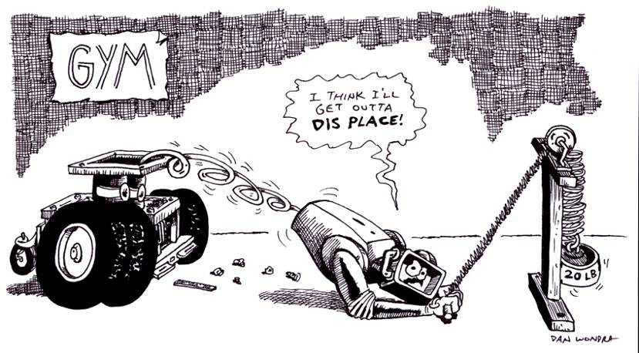
Lesson Title: Profess the Compress
Draft Date: June 18, 2009
1st Author (Writer): Sara Bowen
Science Topic: Hooke’s Law
Grade Level: Middle School

Content (what is taught):
- The stretch or compression of a spring is proportional to the force applied to it as long as this load does not exceed the elastic limit of the spring.
- Hooke’s Law allows the limits of a spring to be predicted and how the spring will behave given a displacement of the spring.
- Hooke’s Law applies anytime that springs are utilized such as trampolines, garage doors, car suspensions, and numerous other cases.

Context (how it is taught):
- Students and teacher will discuss where springs are found on different everyday items (trampolines, garage doors, car suspensions, etc.).
- Students will add weights to hanging springs to measure their extension or compression.
- Students will add weights to measure the ground clearance of the CEENBoT, which directly relates to the spring suspension on the CEENBoT to access Hooke’s Law.

Activity Description:
Students will begin by experimenting with springs and measuring (with rulers) the compression and extension of the springs after adding and taking away weights. Students will then begin to think about how springs relate to the CEENBoT and its suspension system. Students will start by measuring the ground clearance from the CEENBoT to the ground. Then students will add weights to the CEENBoT and measure the ground clearance to see how the spring’s suspension has changed.

Standards

Math - A1, A2, A3, C1, D1, D2, E1, E2, E3

Science - A1, A2, B1, B2, B3, E1, E2, F5

Technology - A1, A2, A3, A4, B1, B2, B3, B4, C1, C2, C3, C4, E1, E2, E3, F1, F2, F4

Materials List:
CEENBoTs Springs
Rulers Weights
Asking Questions: Profess The Compress

Summary: Discuss, define, and understand Hooke’s Law

Outline:
- Have students look for where springs are used in the real world. Be sure to find examples where springs are compressed and stretched.
- Discuss any mathematical relationships that may be present in spring applications.
- Discuss the meaning of Hooke’s Law with the students and give examples of where Hooke’s Law can be found.
- Have students brainstorm other areas where Hooke’s Law can be found.

Activity:
First have students think about where springs are used in the world. When an example is cited, discuss if it is a compression or stretch application. As examples are found, pose the question about whether there is a mathematical relationship present in the spring. After several examples have been located, mention Hooke’s Law and briefly discuss how it applies. Possible spring applications include clocks, car suspensions, trampoline, screen doors, etc.

Questions | Answers
What is a compression spring? | When you put a load on the spring and make it shorter, it pushes back against the load and tries to go back to its original length.
Where are compression springs found? | Ballpoint pens, pogo sticks, and valve assemblies of gasoline engines.
What is an extension spring? | Extension springs are attached at both ends. When the things the ends are attached to move apart, the spring tries to bring them together again.
Where are extension springs found? | Garage doors, vise-grip pliers, and carburetors.
Is there a mathematical relationship present in springs? | Yes and it depends on the spring.
Does the relationship change if it is compressed rather than stretched? | No. It is the same.
What is Hooke’s Law? | The stretch or compression of a spring is proportional to the force applied to it as long as this load does not exceed the elastic limit of the spring.
When does Hooke’s Law apply? | Anytime springs are used
What are different objects that use springs where Hooke’s Law would apply? | Answers will vary.

Exploring Concepts: Profess The Compress

Summary: Students will experiment with springs and weights to explore the compression and extension.

Outline:
- Students will be given springs, weights and rulers to explore how springs work and how far they extend and compress with different weights.

Activity:
First give students many different springs of different sizes and weights to compress and stretch. Students will also need rulers to measure the displacement. The different springs will allow for students to see how different springs stretch and compress. Divide students up into groups with each group having a different spring. Have students place weights on the different springs and record the weight applied and the displacement it caused. Repeat the process on each spring several times with different weights. The following chart can be copied into student notebooks.

Spring | Weight | Displacement | Compression or Stretch | Notes
Trial 1
Trial 2
Trial 3
Trial 4

After doing several trials, have students graph the weight vs. displacement for their spring. The graph should be roughly linear. Generally the greater the weight applied, the greater the displacement. As an extension, students can use their graph to make a prediction about displacement given a different weight.


Instructing Concepts: Profess The Compress

Hooke’s Law
Putting “Hooke’s Law” in Recognizable terms: Hooke’s Law states that the extension of a spring is in directly proportional to the load added to it as long as this load does not exceed the elastic limit of the spring.

Putting “Hooke’s Law” in Conceptual terms: Hooke’s Law allows the limits of a spring to be predicted and how the spring will behave given a displacement of the spring. The relationship represented by Hooke’s Law is linear meaning that the larger the displacement of the spring the larger the restoring force or the smaller the displacement the smaller the restoring force. This relationship will hold until the elastic limit of the spring is reached or the spring is completely compressed.

Putting “Hooke’s Law” in Mathematical terms: Hooke’s Law can be mathematically represented by the formula F = - kx where F is the restoring force of the spring in Newton’s, x is the displacement of the spring from equilibrium, and k is the spring constant determined by the size of the spring and the material or of which it is made. The formula has a negative because the restoring force of the spring is always in the opposite direction to the displacement of the spring.

Putting “Hooke’s Law” in Process terms: Thus, Hooke’s Law allows for very consistent predictions to be made about how the spring will behave. The restoring force is a function of the displacement of the spring. If you measure the displacement of the spring and measure the restoring force, the user can calculate the spring constant for the given spring. After finding the spring constant, the restoring force of the spring can be calculated given a displacement.

Putting “Hooke’s Law” in Applicable terms: Hooke’s Law applies anytime that springs are utilized such as trampolines, garage doors, car suspensions, and numerous other cases. In all these cases, the spring will be displaced whether by bouncing (trampoline), opening the door (garage door), or hitting a hole in the roadway (car suspension) and will be restored by the restorative force of the spring. Springs allow for the easing of rapid (jarring) motion in a predictable manner.
Organizing Learning: Profess The Compress

Summary: Students will explore the suspension system of the CEENBoT.

Outline:
- Students will measure the ground clearance (in millimeters) between the CEENBoT and the ground
- The students will add weights to the CEENBoTs and measure the ground clearance after the weight is added.
- Students will graph their data and make a prediction.

Activity:
Have students copy the chart below into their notebook. After filling out the chart, students should graph the weight vs. ground clearance for the different weights. The graph should look fairly linear. After the graph has been created, students should make a prediction about how much ground clearance a new weight will cause to happen and then test it to see how accurate their prediction is. It is important to note that the CEENBoT can be bottomed out with too much weight. This is will not be the theoretical spring limit because of the design of the suspension, but some predictions will not work because the spring cannot be compressed far enough.

Ground Clearance before weight  was added | Amount of weight added to the CEENBoT | Ground clearance after the weight  was added | Difference between ground clearance before and after weight was added  (in millimeters)
Understanding Learning: Profess The Compress

Summary: Students will understand Hooke’s Law and where it exists.

Outline:
- Formative assessment of Hooke’s Law.
- Summative assessment of Hooke’s Law.

Activity:
Formative Assessment
As students are engaged in the lesson ask these or similar questions:
- Do students understand the difference between stretch and compression?
- Do students understand there is a mathematical relationship for each spring and that different springs have different relationships?
- Why is a suspension system important for your CEENBoT?
- Does Hooke’s Law apply to all vehicles?

Summative Assessment
Students can answer the following writing prompt:
1) Explain the mathematical relationship present in a spring that Hooke’s Law identifies and give an explanation why each spring is different.
2) Why is Hooke’s Law useful for mechanics, engineers, or scientists?

Possible quiz questions
- Give 5 examples of where Hooke’s Law exists?
- Explain how Hooke’s Law applies to vehicles and why it is important.

