SPIRIT 2.0 Lesson:
No Flaw With Newton’s 1st Law
==========================Lesson Header ==========================
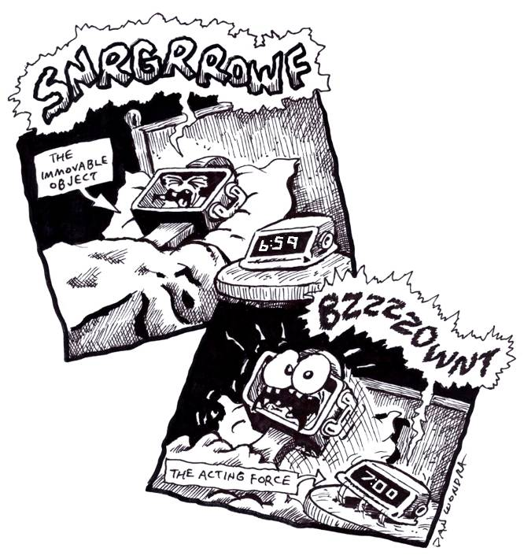
Lesson Title: No Flaw With Newton’s 1st Law
Draft Date: May 4, 2009
1st Author (Writer): Sara Bowen
Science Topic: No Flaw With Newton’s 1st Law
Grade Level: Middle School

Content (what is taught):
- Unless a net force acts on an object, the object will remain in constant motion
- An object at rest stays at rest until a net force acts on it
- The tendency of an object to resist any change in motion is known as inertia
- Objects with a lot of mass have more inertia than objects with less mass

Context (how it is taught):
- Students will learn about Newton’s 1st Law of Motion and discuss everyday occurrences where this law happens.
- Students will learn how Newton’s 1st Law of Motion affects the CEENBoT.
- Students will explore and discover new ways how Newton’s 1st Law of Motion occurs or could occur when using a CEENBoT.
Activity Description:
Students will learn what Newton’s 1st Law of Motion is and understand what it means. Together the class will discuss different occurrences that fit this Law of Motion. The class will begin to discuss general ways this laws affects or could affect the CEENBoT. Students will pair up with a partner to explore and brainstorm different ways Newton’s 1st Law occurs or could occur with the CEENBoT.

Standards:

Math – C4, E2, E3, E4 Science – A1, A2, B1, E1, E2

Technology – A1, A3, A4, B2, B3, B4, C1, C2, C4, D1, D2, D3, D4, E2, F1, F4

Materials List:
- CEENBoTs
- Paper
- Pen/Pencil/or Marker
- Whiteboard
Asking Questions: No Flaw With Newton’s 1st Law

Summary: Discuss, define, and understand Newton’s 1st Law of Motion.

Outline:
- Students will be taught the definition of Newton’s 1st Law of Motion and discuss different situations in which this law exists. For example,
  - The force that forces you against the side of a car when it turns
  - What makes your body rise up from a seat in a roller coaster
  - What keeps space probes moving through space
  - Kicking a football and it keeps moving
  - Seat belts prevent you from going through a windshield
  - A fully loaded truck has more inertia than an empty truck. It will take more effort to make it speed up or stop.

Activity:
Discuss the following questions:

Questions | Answers
What is Newton’s 1st Law of Motion? | Newton’s 1st Law of Motion states that an object at rest tends to stay at rest and an object in motion tends to stay in motion unless acted on by an unbalanced force.
What does this mean? | An object wants to continue doing what it is doing if nothing else changes.
What is inertia? | The resistance an object has to a change in its state of motion.

Online Resources: Several resources can be found online by typing in ‘Newton’s 1st Law’ at www.google.com. In fact, students can do research online first and then come together to discuss their findings.

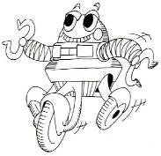

Exploring Concepts: No Flaw With Newton’s 1st Law

Summary: Students will experiment and discuss the ways in which Newton’s 1st Law affects or could affect the CEENBoT during different situations

Outline:
- Students will examine the CEENBoT and brainstorm ways the 1st Law of Motion affects it or could affect it if it was put in different situations

Activity: First put the students in groups with each group having a robot. Groups should be given time to move the robot about room to explore and experiment about possible forces that can be observed or created by manipulating the environment. As students are engaged in this activity, move from group to group and observe what is occurring. Be sure that students are thinking about all possible forces: gravity, inertia, etc. It is OK for students to locate applications of Newton’s 1st law anywhere in the room, not just robotic applications.

Online Resources: Prior to exploration with the robots, students can visit several websites to research and learn about Newton’s 1st Law of Motion. For example, http://www.neok12.com/Laws-of-Motion.htm offers educational videos on Newton’s Laws of Motion.

Newton’s 1st Law of Motion

Putting “Newton’s 1st Law of Motion” in Recognizable terms: Newton’s 1st Law of Motion states that an object at rest tends to stay at rest and an object in motion tends to stay in motion unless acted on by an unbalanced force. This means that an object that is moving will continue to move unless something (a force) acts to change that motion and an object that is at rest will stay at rest unless something (a force) acts to change it.

Putting “Newton’s 1st Law of Motion” in Conceptual terms: Newton’s 1st law basically says that an object will continue doing what it is doing if nothing else changes. It is often called the law of inertia. Inertia means the resistance an object has to a change in its state of motion.

Putting “Newton’s 1st Law of Motion” in Mathematical terms: Newton’s 1st law has mathematical implications concerning the forces that are acting on the object. Since an object in motion wants to remain in motion it will take a force applied in the opposite direction to slow the motion. An object at rest wants to stay at rest so it will take a force to start the object moving.

Putting “Newton’s 1st Law of Motion” in Process terms: Thus, because of Newton’s 1st law of motion, we know that it takes a larger force to change the motion of an object than to just maintain the motion. The implication is that it takes more energy input to change the motion of an object.

Putting “Newton’s 1st Law of Motion” in Applicable terms: Newton’s first law is possibly easiest explained by these two cases. 1) A moving object will continue its motion is evident when you hit the brakes in your car. Your body’s tendency is to continue forward at the same speed and direction as it had before the brakes were applied. Your body will continue to move with a constant velocity unless your seatbelt creates a force that restrains your movement. 2) An object at rest will remain at rest is evident when you attempt to move a heavy object. To get the object moving you will have to apply a force to the object that is greater than the sum of all frictional and resistance forces. This creates a non-zero net force or what can be referred to as an unbalanced force. An unbalanced force causes acceleration and the object will change its velocity.

Organizing Learning: No Flaw With Newton’s 1st Law

Summary: Students will discuss the different ideas they explored with the robot and write them down in a class chart.

Outline:
- Students will write down ideas explored with the robot.
- Students will discuss their ideas as a class.

Activity: Have students brainstorm ideas on how Newton’s 1st Law of Motion affects the CEENBoT. Regroup with the whole class and discuss those ideas and write them in a chart similar to the one below. If students are having a tough time getting started, give them some sample scenarios (see below).

If this happened…. | Then this would happen
A doll is sitting on top of the robot and the robot runs into the wall.
A doll is sitting on top of the robot and is tied to the robot (similar to a seatbelt). Then the robot runs into the wall.
The robot runs into a golf ball while driving around the room.
The robot runs into a bowling ball while driving around the room.

Understanding Learning: No Flaw With Newton’s 1st Law

Summary: Student will tell how Newton’s 1st Law of Motion affects the world around them.

Outline:
- Formative assessment of Newton’s 1st Law of Motion.
- Summative assessment of Newton’s 1st Law of Motion.

Activity:
Formative Assessment
As students are engaged in the lesson ask these or similar questions:
- Are students able to determine situations where the 1st Law of Motion exists?
- Do students understand the concept of inertia?
- Explain how kicking a football describes Newton’s 1st Law of Motion.

Summative Assessment
Students can answer one of these writing prompts
- Give 3 real world situations where you see Newton’s 1st Law of Motion in action and describe them.
- Describe inertia using the example of a semi-truck with a heavy load as opposed to one with a light load.

