SPIRIT 2.0 Lesson:
The Pork With Torque
==========================Lesson Header ==========================
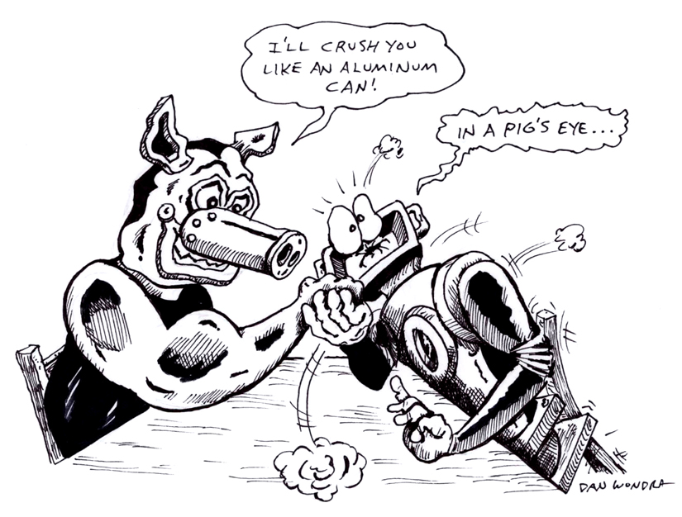
Lesson Title: The Pork With Torque
Draft Date: June 26, 2009
1st Author (Writer): Sara Bowen
2nd Author (Editor/Resource Finder):
Science Topic: Torque
Grade Level: Middle School

Content (what is taught):
- Torque is a measure of how much a force acting on an object will cause the object to rotate
- Torque can be increased in one of two ways; by increasing the moment arm or by increasing the perpendicular force applied to the moment arm
- If an object is at rest the torques on the object are balanced (they cancel out) and the sum of those torques is zero. If an object is in motion the torque on the object is still the sum of the individual torques but they will not completely cancel out
- Torque can be mathematically represented by the formula T = r * F (r is the distance from the pivot point to the location the force is being applied, the moment arm, and F is the force applied perpendicular to the moment arm)

Context (how it is taught):
- Students and teacher will discuss where the concept of torque can be found on different everyday items (teeter-totters, levers, hinged doors, etc…)
- Students will remove the tires on their CEENBoT and wrap a string around the wheel hubs to find the radius for the hub and see how much weight the motor can lift by lifting pails with different levels of water until the motor of the CEENBoT stalls
- Students will explore different websites describing and helping to understand torque

Activity Description:
Students will begin by removing the tires of the CEENBoT and wrapping the wheel hubs with string to find the radius of the hub. The students will add weight a little at a time using small pails with different levels of water until the motor stalls. The students will then find the weight of the water and pail that stalled the motor. They will multiply that by the radius of the wheel hub and that would be the CEENBoT’s torque. Find different size wheel hubs and try the experiment again. A larger radius of the hub would decrease the maximum weight lifted, the torque should remain constant.

Standards

Math - A1, A3, D1, D2, E1, E2, E3, E4 Science - A1, A2, B1, B2, B3, E1, E2

Technology - A1, A3, A4, B1, B2, B3, B4, C1, C2, C3, C4, D1, D2, D3, D4, E1, E2, E3, E4, F1, F2, F3, F4

Materials List:

- CEENBoT
- String
- Different sized wheels
- Pails and water
- Computers
- Scale

Asking Questions: The Pork With Torque

Summary: Students will discuss, define, and understand torque.

Outline:
- Discuss the concept of torque with students and give examples of where torque can be found.
- Have students brainstorm other areas where torque can be found.

Activity: Before asking questions, students may want to do some research on torque. This can be done in a textbook or online. After doing some initial research, discuss the following questions.

Questions | Answers
What is torque? | Torque is the measure of how much a force acting on an object will cause the object to rotate.
What is the formula for torque? | T = r * F ( T = torque, r is the distance from the pivot point to the location the force is being applied, and F is the force applied perpendicular to the moment arm
Where are examples in your life that you have seen torque? | Answers will vary. You may want to include some of the answers you have given earlier such as turning a wrench, closing a door, etc.

Online Resource: Students can type in “What is torque” at www.google.com to start their research. A learning activity can also be found at the following site:
http://www.wisc-online.com/objects/index_tj.asp?objID=CAD407
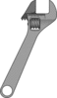
Exploring Concepts: The Pork With Torque

Summary: Students will experiment with the wheel hubs on the CEENBoT to find the torque.

Outline:
- Students will explore the torque of the CEENBoT with the tire hubs the way they are normally.
- Teachers will help the students change the size of the wheel hubs to have the students explore torque.

Activity:
Students will remove the wheels from the CEENBoT so that only the hubs are exposed. The radius of the hub will be measured with a string. Students will then wrap a string around the hub and tie it to a bucket, then position the CEENBoT so that it can lift the bucket by operating the wheel motor. The students will then see how much the motor can lift by adding water to the bucket until the motor can no longer lift it and it stalls out. The teacher will then help the students to add different sizes of wheel hubs to the CEENBoT and repeat the process to figure out the torque with the different sized hubs.

Worksheet: Data Collection

Instructing Concepts: The Pork With Torque

Torque
Putting “Torque” in Recognizable terms: Torque is a measure of how much a force acting on an object will cause the object to rotate. To maximize the amount of torque that is applied the force must be applied perpendicular to the moment arm (the distance from the pivot point to where the force is being applied).

Putting “Torque” in Conceptual terms: Since torque is conceptually discussing how a force causes rotation, it is important to understand how to change the torque on an object. Torque can be increased in two ways: 1) by increasing the moment arm or 2) increasing the perpendicular force applied to the moment arm. The opposite is true for decreasing torque. If an object is at rest the torques on the object are balanced (they cancel out) and sum of those torques is zero. If an object is in motion the torque on the object is still the sum of the individual torques but they will not completely cancel out.

Putting “Torque” in Mathematical terms: Torque can be mathematically represented by the formula T = r * F where T is the Torque done, r is the distance from the pivot point to the location the force is being applied (Moment arm), and F is the force applied perpendicular to the moment arm. To maximize torque you need to apply the force perpendicular to the moment arm. Any force applied that is not perpendicular will have to be broken up into its tangential vector (perpendicular to moment arm) and radial vectors (parallel to moment arm). The radial component has no affect on the torque.

Putting “Torque” in Process terms: Thus, torque is about a force causing rotation. The SI unit of Torque is the Newton-meter (N-m). If you lengthen the moment arm and apply the same force, the torque will be greater. Take the case of a hinged door. If you push on the side of the door with the hinges it is difficult to swing (rotate) the door. If you push on the side opposite the hinges the door swings easily (a longer moment arm with same force means more torque).

Putting “Torque” in Applicable terms: Torque applies anywhere that a force is applied causing a rotation. Simple machines that create mechanical advantage are the most common applications of torque. If you have ever sat on a teeter-totter (Lever) you have an understanding of torque. If two different masses, one large and one small, are placed the same distance away from the pivot point, the teeter totter will tip to the side with more mass because it has more torque. To “balance” the teeter-totter the heavier mass must move toward the pivot point thereby reducing the moment arm and lowering torque. Remember when using a lever the maximum torque comes when the force is applied perpendicular to the moment arm. If you are using a lever to move an object it is easy to apply a perpendicular force at first. As you raise the lever higher it becomes more difficult to apply the force perpendicular so the torque is lowered. This is why you see people reposition levers after using them so that they are able to continue to apply a perpendicular force.

Related “I” pieces: Force, Vectors.
Organizing Learning: The Pork With Torque

Summary: Students will explore websites dealing with torque.

Outline:
- Students will explore websites having to do with torque to revisit what they learned and to build on what they learned.
- Students will discuss with the class what they learned about torque and if there is something that they still don’t understand, it should be cleared up at this time.

Activity:
By typing in “What is Torque” at http://www.google.com, students will find several resources to help guide them in their research. You may want to have students judge the site from 3 different perspectives: As a teacher, as a student, and as an engineer. Some of the sites may be kid friendly and easy to understand whereas other sites are intended more for teachers who are teaching a lesson on torque.

The following website provides clear steps and it’s easy to navigate through the information.
http://www.wisc-online.com/objects/index_tj.asp?objID=CAD407

How Stuff Works provides good information on ‘How Force, Power, Torque and Energy Work’
http://auto.howstuffworks.com/auto-parts/towing/towing-capacity/information/fpte4.htm

Worksheet: Torque Research
Understanding Learning: The Pork With Torque

Summary: Students will understand torque and where it exists.

Outline:
- Formative assessment of torque
- Summative assessment of torque

Activity:
Formative Assessment
As students are engaged in the lesson ask these or similar questions:
- Why is learning about torque an important concept with dealing with CEENBoTs?
- What do car makers need to keep in mind about torque when building cars?

Summative Assessment
Possible Quiz Questions:
- What is torque?
- Give 3 examples of where torque exists?
- Explain how to measure torque given the following materials: A robot, a bucket, water, and string. Use a diagram to explain your answer.

