SPIRIT 2.0 Lesson:
Dude, Who Hit My Car?
============================Lesson Header ============================
Lesson Title: Dude, Who Hit My Car?
Draft Date: June 23, 2009
1st Author (Writer): Joan Lahm
Instructional Component Used: Scientific Inquiry
Grade Level: Middle/Secondary – Physical Science and Introduction to Forensics

Outline of Lesson – In order to analyze a hit and run accident scene, students will experiment with various angles of impact of a toy car hit by a CEENBoT and explain/draw what the results were. They will then observe the results of a “hit and run” and try to analyze at what angle the CEENBoT hit the car, as well as the speed and mass of the CEENBoT. Students will utilize their detailed laboratory report in order to solve the “hit and run” crime.

Content (what is taught):
- Students will determine the average speed at which a CEENBoT travels in order to determine at what speed a CEENBoT will impact another vehicle (toy car).
- Average Velocity (in a straight line) = Distance/Time (V = m/s in a straight line)
- Momentum = mass x velocity (p=m•v)
- Time of contact between the CEENBoT and toy car time = d/r (rate being constant, distance toy car is displaced)
- Students will follow steps involved in scientific inquiry (a scientific method) in order to solve a problem.

Context (how it is taught):
- Students will be shown a variety of accident photos. Students will brainstorm a variety of questions investigators may need to answer in order to solve a hit and run accident.
- Students will discuss in small groups how they can use the CEENBoT to recreate an accident scene.
- Students will write a detailed laboratory report following the steps of scientific inquiry – documenting the results of their findings. The laboratory report must include drawings on graph paper – to scale.
Activity Description:
Students will be given the opportunity to be inventive in determining how to recreate the hit and run accident. Each group will be given a toy car and a CEENBoT. Each group will need to determine the average velocity their CEENBoT can travel when impacting the toy car. They can experiment with various masses by adding weights to the top of the CEENBoT.

Standards:

Math - MD1, ME1 Science – SA1, SA2, SB1, SF5

Technology – TA1, TC1,TD1 Engineering – EA1, ED1

Materials List: CEENBoT, toy cars, metric weights, balance, stopwatch, metric tape measure, miscellaneous materials as deemed necessary by each group
Asking Questions (Dude, Who Hit My Car?)

Summary: Students will brainstorm a series of questions they believe investigators may use to solve a hit and run accident of a parked car.

Outline:
- Students will view various car accident scenes.
- Students will write down a variety of questions investigators may need to answer in order to solve the crime.

Activity: Based on questions/problems students believe should be addressed by investigators, students will reconstruct what may have occurred by causing “accidents” between their CEENBoT and a toy car. They may also change the mass of their CEENBoT as they reconstruct a variety of “accidents.”
Students will be asking their own questions. Teachers should guide students towards answering these questions as well.

Questions | Answers
Have any of you ever been in a hit and run car accident? | answers will vary
How fast was the CEENBoT traveling? | determined by students (speed = distance/time)
At what angle did the CEENBoT impact the car? | answered through trial and error
What was the momentum of the moving CEENBoT? | answers will vary
What will happen if the mass of the CEENBoT is altered? | answers will vary
What is the mass of the toy car? | answers will vary
How does the time of contact between the CEENBoT and toy car affect the displacement of the toy car from the parking space? | Time = distance/rate (rate being constant)  Distance = rate • time

Exploring Concepts (Dude, Who Hit My Car?)

Summary: Students will determine the average speed and mass of a CEENBoT. Students will also experiment with various angles of impact between a CEENBoT (with various masses) and a toy car.

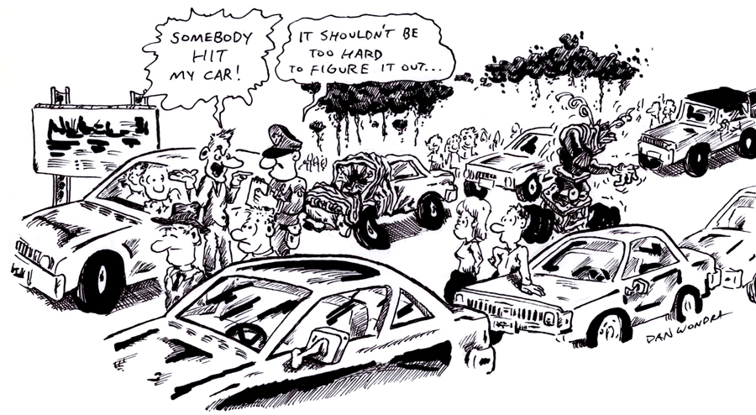

Outline:
- Students will be given stopwatches and a metric measuring tape in order to determine the average speed of their CEENBoT.
- A metric balance will allow students to measure the mass of their CEENBoT. Various metric weights will be available to students in order to change the mass of their CEENBoTs.
- Student groups will decide what method they will use to determine angle of impact. Parameter – a minimum of 3 angles on each side of the car must be tested for each change in mass (minimum of 2 mass changes). The method of testing is up to each group.
- Students will determine how time of contact between the CEENBoT and toy car affects the displacement of the toy car from the parking space.

Activity: Students will be conducting a variety of measurements – average speed, mass, angle of impact, and time of contact between the CEENBoT and toy car. They will be given a stopwatch, metric measuring tape and stick, compasses, weights, and a balance. Other objects will be available for students to use. Example - students can place a water-soluble marker on the front of the CEENBoT to mark the impact on the toy car.
Instructing Concepts (Dude, Who Hit My Car?)

Scientific Inquiry

Scientific Inquiry Process
Scientific Inquiry is a very systematic process that scientists use to understand phenomena that are present in the world. The process must be followed exactly without any deviation or any results that are obtained might not be valid. There are six basic steps to the scientific inquiry process.

Step One: Ask a question.
In this step you ask a question that you want answered about something that you have observed. If scientific inquiry is to provide an answer, the question must be framed in such a way that it can be measured preferably with a number.

Step Two: Make a set of observations regarding the phenomenon being studied.
The scientist will observe the phenomenon that is being studied without out any bias. It is important that the phenomena be researched in addition to observing it so that past information will be noted and past mistakes will not be repeated.

Step Three: Form a hypothesis that might explain the observations.
The hypothesis should be framed in a format like “If I do this, then this will happen”. This hypothesis must be measurable and should help you answer your original question.

Step Four: Test your hypothesis by doing an experiment.
You will conduct an experiment that will prove your hypothesis true or false. It is important that the experiment be unbiased and fair. To do this you can only change one variable at a time and keep everything else the same. Doing this insures that any change observed will be as a result of your experiment and not some other factor.

Step Five: Analyze your data and draw conclusions.
Once your experiment is done you need to analyze your measurements and see if your hypothesis is true or false. If your hypothesis is false (a common occurrence), you should start the entire process again with a new hypothesis. Even if you find your hypothesis to be true you may want to devise another experiment to test your hypothesis again. Multiple experiments that validate your hypothesis make your conclusion stronger.

Step Six: Communicate your results.
If your hypothesis stands up to multiple tests you should report your results in a final report. This might take the form of a journal article in a professional or scientific journal.
Organizing Learning (Dude, Who Hit My Car?)

Summary: Students will create a record sheet in order to record their findings.

Outline:
- Students will be required to turn in a well-organized, accurate, neatly written (or typed) record of their discovery by creating their own data tables, etc.
- The steps listed below must be included in each student’s record (lab report).
- Drawings must also be included in the laboratory report.

Activity: Students will create a thorough laboratory report of their findings which includes: average speed (velocity in one direction), mass, angle of impact/results, and how time of contact between the two vehicles affects displacement of the toy car. Drawings of results must also be included.

Step One: Questions – at least 3

Step Two: Make a set of observations regarding the phenomenon being studied.

Step Three: Form a hypothesis that might explain the observations. (or several)

Step Four: Test your hypothesis by doing an experiment.

Step Five: Analyze your data and draw conclusions.

Step Six: Communicate your results.
Understanding Learning (Dude, Who Hit My Car?)

Summary: Students will be assessed on their laboratory report – check list – and how they determined average speed, momentum, and mass. Students will analyze the displacement of a toy car which was involved in a “hit and run” accident by using their laboratory report.

Outline:
- Formative assessment: are students able to use a metric measuring tape, scale, stopwatch, compass; and use the formulas for average speed, momentum, and determine angle of impact
- Summative assessment: can students write out and calculate using the following formulas: s = d/t; p = m•v; can students write out an organized laboratory report with data tables, drawings, and steps; students will reconstruct a “hit and run” by using their detailed laboratory report

Activity:
Formative Assessment
As students are engaged in the lesson ask these or similar questions:
- Were students able to calculate speed?
- Were students able to measure mass?
- Were students able to determine how time of contact affects displacement?
- Were students able to evaluate and alter their testing strategies?
- Were students able to write an organized laboratory report?

Summative Assessment
1) Evaluate Laboratory Report – checklist
2) Quiz Questions:
1) What is the average speed of a CEENBoT that travels 15 meters in 11 seconds?
2) What is the momentum of a CEENBoT traveling at 1.2 m/s and has a mass of 1.5 kg?
3) Explain how momentum would change if you increase the mass of the CEENBoT?
3) Students will analyze the displacement of a parked toy car and reconstruct the “hit and
run” accident by using their detailed laboratory report.
Initial Car Position
Final Car Position
Displacement
Initial Car Position
Final Car Position
Displacement
Reconstructed CEENBoT direction
by students using lab report data
Given Student
Displacement Reconstruction

