SPIRIT 2.0 Lesson:
Converging Earthquake!
============================Lesson Header ============================
Note: Modified from Striking Earthquake!
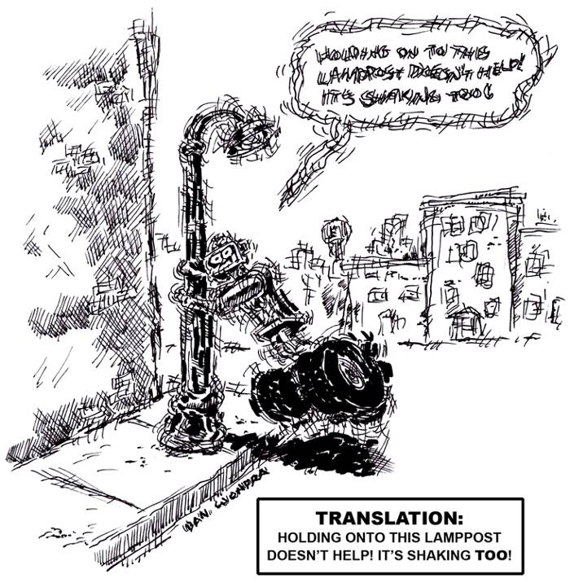
Lesson Title: Converging Earthquake!
Draft Date: June 28, 2009
1st Author (Writer): Shantelle Suiter
Instructional Component Used: Thrust Faults, Convergent Plate Boundaries
Grade Level: Middle School
Cartoon Illustration Idea: CEENBots manipulating a “fault line”

Content (what is taught):
- How two tectonic plates coming together create plate boundaries
- Convergent boundaries shift one plate down under the other
- Thrust fault lines are a vertical shift in the top plate

Context (how it is taught):
- Using the CEENBot to recreate the Himalayan Mountains
- Using the worksheets to visually show how the fault reacts
- Using worksheets to show tectonic plates and boundaries
Activity Description:
Create convergent boundaries that are:
- Continental-continental convergence
- Oceanic-oceanic convergence
- Oceanic-continental convergence

Standards:

Science – B1, B2, D1, F3

Technology – A3, B2

Math – C2

Materials List:
CEENBot
Two brown blankets (size of a receiving blanket)
Two blue blankets (size of a receiving blanket)
Two boards about 2” x 2” x 12”
Asking Questions: Converging Earthquake!

Summary: Identify parts and forces of convergent boundaries and strike thrust faults.

Outline:
- Discover the background knowledge students have of earthquakes
- Discover the background experiences students may have had with earthquakes
- Challenge the students to support their opinion of the benefits of earthquakes

Activity: Ask students the questions getting conversation, if not a debate, about the difficulties and benefits of earthquakes.

Questions | Answers
1. Who has been in an earthquake? | Vary according to experiences of students.
2. What causes earthquakes? | Energy released from the ground.
3. What difficulties do earthquakes cause? | Destroys buildings, roads, and bridges.
4. Are there benefits to earthquakes? | Creates new land and mountains.

Online Resources: Images of fault lines in the Himalaya Mountains and Nazca Mountains can be found at http://images.google.com/

A wealth of earthquake information as well as images can be found at http://pubs.usgs.gov/gip/dynamic/understanding.html#anchor5798673
Exploring Concepts Converging Earthquake!

Summary: Identify parts and forces of convergent boundaries and strike thrust faults.

Outline:
- Two CEENBots push a landscape together in thrust fault fashion

Activity: Facing the bots towards each other with two brown blankets between them, drive the bots together allowing the blankets to crumple up. This is land to land convergence.
Do the same with one brown and one blue and this represents ocean to land convergence (hopefully the brown folds over onto the blue). Do this again with the two blue blankets to show ocean to ocean convergence.

Plate Tectonics

Introduction:
Plate tectonics is the motion of the outer part of the earth called the lithosphere. The lithosphere is comprised of the earth’s crust and upper part of the mantel. Currently, it is thought that there are 8 major plates and many minor plates that are moving across the surface of the earth. The cause of their movement is believed to be from radioactive material deep below the earth’s surface decays releasing heat, which produces convection currents. This movement forces plates to interact in three different types of boundaries: 1) convergent, 2) divergent, and 3) transform.

1) Convergent boundaries are where plates compress or collide with one another. The formations created by this action depends on the types of plates involved. If an oceanic plate collides with a continental plate, the denser plate (typically oceanic) will be sub ducted (go below) the other plate. Mountains tend to be formed although they generally are not that large (i.e. Cascade Mountain Range). Also, an oceanic plate can collide with another oceanic plate. Again one plate (the denser) will be sub ducted below the other. In this instance there can be two formations: deep-ocean trenches located near the second formation of volcanic islands chains (i.e. Aleutian Islands). Finally, a continental plate can collide with another continental. In this instance, some subduction may occur, but widely more folding and faulting action of the rock layers is present due to increased compression as the density of the crust is less than the lower mantel forcing the layers into large mountains (i.e. Himalayan Mountain Range).

2) Divergent boundaries are where tension occurs or plates are moving away from each other. If the boundary is between two oceanic plates, then mid-oceanic ridges occur (i.e. Mid-Atlantic Ridge) from the rising of magma weakening the crust and moving the plates apart. If the boundary is between continental plates it can produce an ocean basin (i.e. Red Sea) or fault zone (i.e. New Madrid Fault).

3) Transform boundaries is where plates slide past one another or shearing occurs. This can cause some vertical and horizontal movement between the plates forming a special type of fault zone. Transform boundaries (faults) can be found in the oceans but the best known are on land (i.e. San Andreas Fault). These types of boundaries are well known for producing earthquakes, although any boundary can produce an earthquake.

Earthquakes are caused by two plates (either major or minor) moving along a fault (breaks in the earth’s crust along a boundary). As the plates move along a fault, they gradually build up stress on one another. When the stress becomes too great, the plates can slip rapidly against each other, causing lots of energy to be released changing the shape of the landscape. The changes of the landscape depends on the type of fault: 1) dip slip faults where the major movement is vertical, 2) strike slip faults where the major movement is horizontal, and 3) oblique faults where the major movements are both horizontal and vertical.

The Richter Scale can measure the energy of earthquakes. It is a logarithmic scale that assigns a number of magnitude for an earthquake. Since the scale is a base 10 logarithm the difference between a 4.1 and 5.1 magnitude earthquake is a factor of 10. This means that an 8 magnitude quake is 100,000 times more powerful than a 3 magnitude quake (Note: to get 100,000 take 10 x 10 x 10 x 10 x 10…5 times).
Organizing Learning Converging Earthquake!

Summary: Identify parts and forces of convergent boundaries and strike thrust faults.

Outline:
- Label maps of fault lines and tectonic plates
- Label pictures (found or hand drawn) of the vocabulary

Activity: To learn about where the types of plate are, the students will need to label a world map. Diagrams will need to be made in their science notebooks as to the sheer forces and their direction of force. Some vocabulary to be defined include: force, epicenter, sheer direction, relative movement, and foci.

Images and maps can be found online at http://images.google.com/
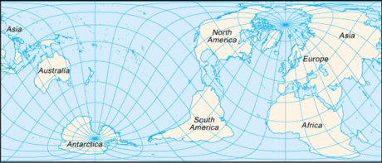

Map image from Public Domain Clip Art (http://www.pdclipart.org)
Understanding Learning Converging Earthquake!

Summary: Identify parts and forces of convergent boundaries and strike thrust faults.

Outline:
- Formative assessment of finding items at home they could use to show family these type of faults and how they react.
- Summative assessment is a quiz having students label the plates, faults, and vocabulary.

Activity:
Formative Assessment
As students are engaged in the lesson ask these or similar questions:
- What materials were used and why?
- What qualities did the materials need and why?
- What could you use to represent each of the vocabulary words?

Summative Assessment

Label the appropriate pieces (plates, faults, and vocabulary) in the given diagrams. Images can be taken from a science textbook or found online.
Draw a diagram of the fault line and label all pieces.

