SPIRIT 2.0 Lesson:
Normal (dip-slip) Earthquake!
==========================Lesson Header ==========================
Note: Modified from Striking Earthquake! (I and U are the same)
Lesson Title: Normal (dip-slip) Earthquake!
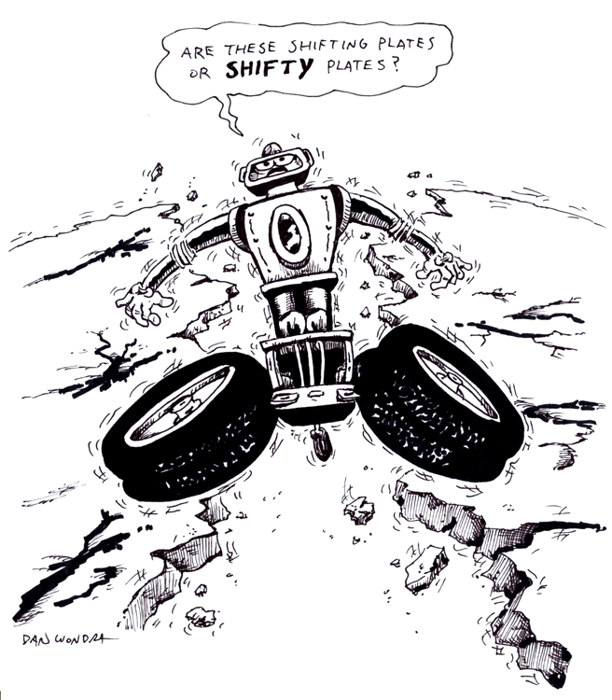
Draft Date: June 28, 2009
1st Author (Writer): Shantelle Suiter
Instructional Component Used: Normal (dip-slip) Faults, Divergent Plate Boundaries
Grade Level: Middle School
Cartoon Illustration Idea: CEENBoTs manipulating a “fault line”

Content (what is taught):
- How two tectonic plates coming together create plate boundaries
- Divergent boundaries shift two plates apart
- Normal or dip-slip fault lines are a separation of the land and creation of new land and volcanoes

Context (how it is taught):
- Using the CEENBoT to recreate the Mid-Atlantic Ridge
- Using the worksheets to visually show how the fault reacts
- Using worksheets to show tectonic plates and boundaries
Activity Description:
Create divergent boundaries that are
- Create new land
- Create Hot Spot
- Create chasms

Standards:

Science – B1, B2, D1, F3 Technology – A3, B2 Math – C2

Materials List:
CEENBoT Hole Puncher (optional) Markers
Yard/Meter Sticks (2) Rubber Bands (2)
Construction Paper (Red or Orange)
Asking Questions: Normal (dip-slip) Earthquake!

Summary: Identify parts and forces of convergent boundaries and strike thrust faults.

Outline:
- Discover the background knowledge students have of earthquakes
- Discover the background experiences students may have had with earthquakes
- Challenge the students to support their opinion of the benefits of earthquakes

Activity: Ask students the questions getting conversation, if not a debate, about the difficulties and benefits of earthquakes.

Questions | Answers
1. Who has been in an earthquake? | Vary according to experiences of students.
2. What causes earthquakes? | Energy released from the ground.
3. What difficulties do earthquakes cause? | Destroys buildings, roads, and bridges.
4. Are there benefits to earthquakes? | Creates new land and mountains.

Images of fault lines like the Mid-Atlantic Ridge, Iceland, and Lava shoots can be found at http://images.google.com
Exploring Concepts Normal (dip-slip) Earthquake!

Summary: Identify parts and forces of convergent boundaries and strike thrust faults.

Outline:
- Two CEENBoTs pull “lava” up from the fault line to create new ocean floor

Activity:
- Place the CEENBoTs on top of the two papers facing opposite directions (papers should make a long road end to end) so their back tires are only a few inches apart.
- Place the yardsticks together between the back tires of the bots with about 4 inches of paper sticking up between them.
- Each sheet of construction paper needs to be attached to the bot that is on it. (a hole punch can allow the paper to fit over the rear wheel pin). Label the left paper “American Plates” and the right paper “Eurasian/African Plate”.
- Drive bots at the same time in opposite directions will pull the paper out from under them showing the growth of faults like the Mid-Atlantic Ridge.
- The yard sticks may need to be held to keep location of ridge still. If paper won’t move, add folded paper between the yardsticks between the rubber bands.

Plate Tectonics

Introduction:
Plate tectonics is the motion of the outer part of the earth called the lithosphere. The lithosphere is comprised of the earth’s crust and upper part of the mantel. Currently, it is thought that there are 8 major plates and many minor plates that are moving across the surface of the earth. The cause of their movement is believed to be from radioactive material deep below the earth’s surface decays releasing heat, which produces convection currents. This movement forces plates to interact in three different types of boundaries: 1) convergent, 2) divergent, and 3) transform.

1) Convergent boundaries are where plates compress or collide with one another. The formations created by this action depends on the types of plates involved. If an oceanic plate collides with a continental plate, the denser plate (typically oceanic) will be sub ducted (go below) the other plate. Mountains tend to be formed although they generally are not that large (i.e. Cascade Mountain Range). Also, an oceanic plate can collide with another oceanic plate. Again one plate (the denser) will be sub ducted below the other. In this instance there can be two formations: deep-ocean trenches located near the second formation of volcanic islands chains (i.e. Aleutian Islands). Finally, a continental plate can collide with another continental. In this instance, some subduction may occur, but widely more folding and faulting action of the rock layers is present due to increased compression as the density of the crust is less than the lower mantel forcing the layers into large mountains (i.e. Himalayan Mountain Range).

2) Divergent boundaries are where tension occurs or plates are moving away from each other. If the boundary is between two oceanic plates, then mid-oceanic ridges occur (i.e. Mid-Atlantic Ridge) from the rising of magma weakening the crust and moving the plates apart. If the boundary is between continental plates it can produce an ocean basin (i.e. Red Sea) or fault zone (i.e. New Madrid Fault).

3) Transform boundaries is where plates slide past one another or shearing occurs. This can cause some vertical and horizontal movement between the plates forming a special type of fault zone. Transform boundaries (faults) can be found in the oceans but the best known are on land (i.e. San Andreas Fault). These types of boundaries are well known for producing earthquakes, although any boundary can produce an earthquake.

Earthquakes are caused by two plates (either major or minor) moving along a fault (breaks in the earth’s crust along a boundary). As the plates move along a fault, they gradually build up stress on one another. When the stress becomes too great, the plates can slip rapidly against each other, causing lots of energy to be released changing the shape of the landscape. The changes of the landscape depends on the type of fault: 1) dip slip faults where the major movement is vertical, 2) strike slip faults where the major movement is horizontal, and 3) oblique faults where the major movements are both horizontal and vertical.

The Richter Scale can measure the energy of earthquakes. It is a logarithmic scale that assigns a number of magnitude for an earthquake. Since the scale is a base 10 logarithm the difference between a 4.1 and 5.1 magnitude earthquake is a factor of 10. This means that an 8 magnitude quake is 100,000 times more powerful than a 3 magnitude quake (Note: to get 100,000 take 10 x 10 x 10 x 10 x 10…5 times).
Organizing Learning Normal (dip-slip) Earthquake!

Summary: Identify parts and forces of convergent boundaries and strike thrust faults.

Outline:
- Label maps of fault lines and tectonic plates
- Label pictures (found or hand drawn) of the vocabulary

Activity: To learn about where the types of plate are, the students will need to label a world map. Diagrams will need to be made in their science note books as to the sheer forces are and their direction of force. Some vocabulary to be defined: force, epicenter, sheer direction, relative movement, foci

Understanding Learning Normal (dip-slip) Earthquake!

Summary: Identify parts and forces of convergent boundaries and strike thrust faults.

Outline:
- Formative assessment of finding items at home they could use to show family these type of faults and how they react.
- Summative assessment is a quiz having students label the plates, faults, and vocabulary.

Activity:
Formative Assessment
As students are engaged in the lesson ask these or similar questions:
- What materials were used and why?
- What qualities did the materials need and why?
- What could you use to represent each of the vocabulary words?

Summative Assessment

Label the appropriate pieces (plates, faults, and vocabulary) of a map. Draw a diagram of the fault line and label all pieces.

