SPIRIT 2.0 Lesson:
Striking Earthquake!
==========================Lesson Header ==========================
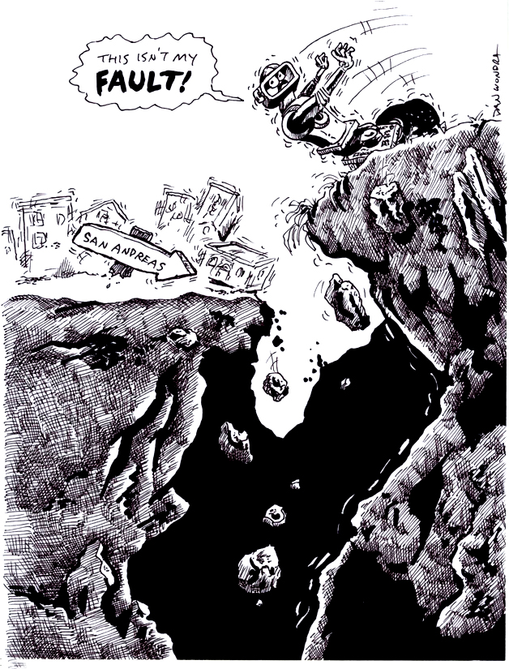
Lesson Title: Striking Earthquake!
Draft Date: June 24, 2009
1st Author (Writer): Shantelle Suiter
Instructional Component Used: Strike Slip Faults, Transforming Plate Boundaries
Grade Level: Middle School

Content (what is taught):
- How two tectonic plates coming together create plate boundaries
- Transform boundaries shift horizontally
- Strike slip fault lines are horizontal shifts of the tectonic plates

Context (how it is taught):
- Using the CEENBoT to recreate the San Andreas Fault
- Using the worksheets to visually show how the fault reacts
- Using worksheets to show tectonic plates and boundaries
Activity Description:
The CEENBoTs, with a large picture of a town or country seen is cut in half and taped to them, will chaotically move in opposite directions to show how a strike slip and a transforming boundary moves. The students will then be able to identify and label all parts of the fault line and tectonic boundary and show all forces of motion.

Standards:

Science – B1, B2, D1, F3 Technology – A3, B2 Math – C2

Materials List:
CEENBoT
Construction Paper with a Landscape Drawn on it
Tape
Asking Questions: Striking Earthquake!

Summary: Identify parts and forces of transform boundaries and strike slip faults.

Outline:
- Discover the background knowledge students have of earthquakes
- Discover the background experiences students may have had with earthquakes
- Challenge the students to support their opinion of the benefits of earthquakes

Activity: Ask students the questions getting conversation, if not a debate, about the difficulties and benefits of earthquakes.

Questions | Answers
1. Who has been in an earthquake? | Vary according to experiences of students.
2. What causes earthquakes? | Energy released from the ground.
3. What difficulties do earthquakes cause? | Destroys buildings, roads, and bridges.
4. Are there benefits to earthquakes? | Creates new land and mountains.

Images of fault lines like the San Andreas Fault line or the Explorer Ridge can be found at http://images.google.com
Exploring Concepts Striking Earthquake!

Summary: Identify parts and forces of transform boundaries and strike slip faults.

Outline:
- Two CEENBoT “rip” a landscape apart in a strike slip fashion

Activity: Two CEENBoTs are to be placed side –by- side, but facing opposite directions. Place a drawn image of a town (with a road going across both bots) that has been cut in half (parallel to the bots) on top of the bots and tape. Have two students slowly and chaotically “shake” the bots forward and backwards until the picture no longer lines up.
Plate Tectonics

Introduction:
Plate tectonics is the motion of the outer part of the earth called the lithosphere. The lithosphere is comprised of the earth’s crust and upper part of the mantel. Currently, it is thought that there are 8 major plates and many minor plates that are moving across the surface of the earth. The cause of their movement is believed to be from radioactive material deep below the earth’s surface decays releasing heat, which produces convection currents. This movement forces plates to interact in three different types of boundaries: 1) convergent, 2) divergent, and 3) transform.

1) Convergent boundaries are where plates compress or collide with one another. The formations created by this action depends on the types of plates involved. If an oceanic plate collides with a continental plate, the denser plate (typically oceanic) will be sub ducted (go below) the other plate. Mountains tend to be formed although they generally are not that large (i.e. Cascade Mountain Range). Also, an oceanic plate can collide with another oceanic plate. Again one plate (the denser) will be sub ducted below the other. In this instance there can be two formations: deep-ocean trenches located near the second formation of volcanic islands chains (i.e. Aleutian Islands). Finally, a continental plate can collide with another continental. In this instance, some subduction may occur, but widely more folding and faulting action of the rock layers is present due to increased compression as the density of the crust is less than the lower mantel forcing the layers into large mountains (i.e. Himalayan Mountain Range).

2) Divergent boundaries are where tension occurs or plates are moving away from each other. If the boundary is between two oceanic plates, then mid-oceanic ridges occur (i.e. Mid-Atlantic Ridge) from the rising of magma weakening the crust and moving the plates apart. If the boundary is between continental plates it can produce an ocean basin (i.e. Red Sea) or fault zone (i.e. New Madrid Fault).

3) Transform boundaries is where plates slide past one another or shearing occurs. This can cause some vertical and horizontal movement between the plates forming a special type of fault zone. Transform boundaries (faults) can be found in the oceans but the best known are on land (i.e. San Andreas Fault). These types of boundaries are well known for producing earthquakes, although any boundary can produce an earthquake.

Earthquakes are caused by two plates (either major or minor) moving along a fault (breaks in the earth’s crust along a boundary). As the plates move along a fault, they gradually build up stress on one another. When the stress becomes too great, the plates can slip rapidly against each other, causing lots of energy to be released changing the shape of the landscape. The changes of the landscape depends on the type of fault: 1) dip slip faults where the major movement is vertical, 2) strike slip faults where the major movement is horizontal, and 3) oblique faults where the major movements are both horizontal and vertical.

The Richter Scale can measure the energy of earthquakes. It is a logarithmic scale that assigns a number of magnitude for an earthquake. Since the scale is a base 10 logarithm the difference between a 4.1 and 5.1 magnitude earthquake is a factor of 10. This means that an 8 magnitude quake is 100,000 times more powerful than a 3 magnitude quake (Note: to get 100,000 take 10 x 10 x 10 x 10 x 10…5 times).

Organizing Learning Striking Earthquake!

Summary: Identify parts and forces of transform boundaries and strike slip faults.

Outline:
- Label maps of fault lines and tectonic plates
- Label pictures (found or hand drawn) of the vocabulary

Activity: To learn about where the types of plate are, the students will need to label a world map. Diagrams will need to be made in their science note books as to the sheer forces are and their direction of force. Some vocabulary to be defined: force, epicenter, sheer direction, relative movement, foci.
Understanding Learning Striking Earthquake!

Summary: Identify parts and forces of transform boundaries and strike slip faults.

Outline:
- Formative assessment of finding items at home they could use to show family these type of faults and how they react.
- Summative assessment is a quiz having students label the plates, faults, and vocabulary.

Activity:
Formative Assessment
As students are engaged in the lesson ask these or similar questions:
- What materials were used and why?
- What qualities did the materials need and why?
- What could you use to represent each of the vocabulary words?

Summative Assessment

Label the appropriate parts (plates, faults, and vocabulary) of a map. Draw a diagram of the fault line and label all pieces.

