SPIRIT 2.0 Lesson:
Secondary Robot
============================Lesson Header ============================
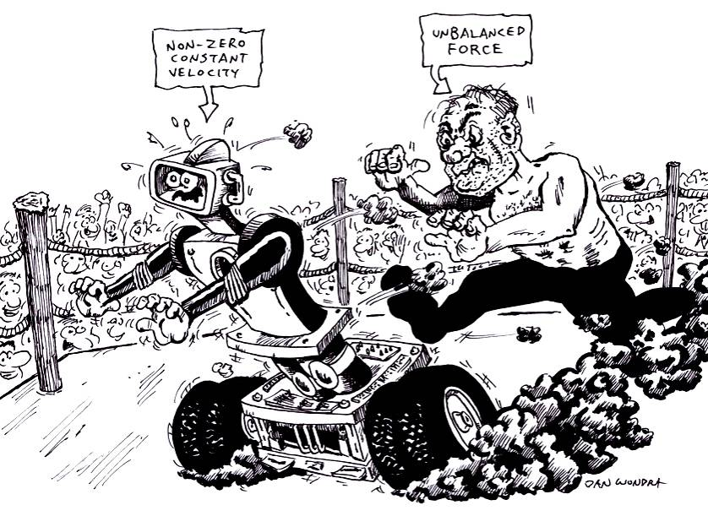
Lesson Title: Secondary Robot
Draft Date: June 26, 2009
1st Author (Writer): Thomas Salyard
Instructional Component Used: Newton’s Second Law (zero acceleration/zero net force)
Grade Level: Secondary

Outline of Lesson

Content (what is taught):
- Applying Newton’s Second Law to cases where F_{net}= 0 with particular attention to situations where the Bot has a non-zero constant velocity. Students will be led to the conclusion that an object with a non-zero constant velocity has no unbalanced forces acting on it.

Context (how it is taught):
- Students will consider the forces acting on a Bot in two situations:
  - Where F_{net}=0 (at rest)
  - Where F_{net}=0 (with a constant non-zero velocity).

Activity Description:
Students will be asked to identify, name, and measure the forces acting on a Bot in two situations where F_{net}=0.

Standards:

Math - MB3 Science - SB2

Technology - TA1 Engineering - EB1

Materials List:
CEENBoT
Spring scale
Asking Questions (Secondary Robot)

Summary: Students will examine a stationary Bot and be asked to name some of the forces acting on the Bot. They will then consider the same Bot with a (non-zero) constant velocity and again name forces acting on the Bot.

Outline:
- Students will examine a stationary Bot and be asked to name some of the forces acting on the Bot.
- Students will then consider the same Bot with a (non-zero) constant velocity and again name forces acting on the Bot.

Activity: Start by having the Bot on a tabletop. Ask students to identify the state of motion and the forces acting on the Bot. NOTE: Students should be able to answer these questions based on prior instruction. Put the Bot in (constant) motion and ask students to identify all of the forces acting on the Bot and their relative magnitudes.

Questions | Answers
What kind of motion does the Bot have? | Forward and back. Possible up and down if on inclines.
Is the Bot moving with a constant velocity? | It seems to but might not actually be.
What forces are acting on the Bot in each case? | Gravity, normal force friction force, etc
How do the sizes of the various forces compare in each case. | Answers will vary.

Exploring Concepts (Secondary Robot)

Summary: Students will make a free-body diagram (on paper) of the Bot in each case and will be asked to compare the relative sizes of the various forces acting on the Bot. Where possible, students will be encouraged to measure the size of the various forces.

Outline:
- Give each group of students a Bot and a spring scale.
- Students will make a free-body diagram (in accord with prior instruction) of the Bot at rest and with uniform motion.
- Students will be asked to show relative sizes of the various forces acting in each case. They will also be asked to determine the specific size of any and all forces as is possible.

Activity: The free-body diagram for the Bot at rest should have two forces (the weight of the Bot and the normal force from the table-top) acting, and that the forces are equal in size. The weight can be measured directly with the scale, and the magnitude of the normal force can be inferred to be equal to the magnitude of the weight since the net force acting on the Bot is zero (since the acceleration of the Bot is zero). In the second case, two additional forces will likely be identified—frictional forces acting horizontally to oppose motion and a forward force somehow connected to the motor. Students may be hazy as to the nature of the forward force, and may well believe that the forward force is greater than the frictional force since the Bot is moving forward.
F_{norm}
F_{app}
F_{grav}
F_{frict}
Instructing Concepts (Secondary Robots)

Newton’s 2nd Law of Motion

Putting “Newton’s 2nd Law of Motion” in Recognizable terms: Newton’s 2nd Law of Motion states that the acceleration of an object is produced by a net force in the same direction as the acceleration, is directly proportional to the magnitude of the net force, and inversely proportional to the mass of the object. This means that the acceleration (a) of an object is dependant on a force applied to the object and the mass of the object.

Putting “Newton’s 2nd Law of Motion” in Conceptual terms: Newton’s 2nd law basically says the net force (unbalanced) (F) is equal to the mass (m) times the acceleration (a) and as a result the object will accelerate in the same direction as the (unbalanced) net force.

Putting “Newton’s 2nd Law of Motion” in Mathematical terms: Using the formula that can be derived from Newton’s 2nd law, a = F/m or F = m * a, you are able to calculate acceleration of an object given the unbalanced force applied to the object and the mass of the object. Realize the 2nd law includes the 1st law as a special case, for when the net force is zero, the acceleration will be zero, and so an object in motion stays in motion or if at rest stays at rest. The 2nd law also includes how the object's velocity changes as a result of an unbalanced force applied and the mass of the object.

Putting “Newton’s 2nd Law of Motion” in Process terms: Thus, because of Newton’s 2nd law of motion, the acceleration of an object is a quantifiable concept. We are able to use this Law of Motion to make predictions about the acceleration of an object given the net force and mass. The implications here are four fold: 1) if the net force increases and the mass stays the same the acceleration increases, 2) if the net force decreases and the mass stays the same the acceleration decreases, 3) if the net force remains constant and the mass decreases the acceleration increases, and 4) if the net force remains constant and the mass increases the acceleration decreases. It is also possible to show that if mass and force increase or decrease by the same factor, the acceleration will have no change as illustrated below.

Putting “Newton’s 2nd Law of Motion” in Applicable terms: Newton’s 2nd law is easily explained by looking at the free fall of 2 different objects with no air resistance. If one object is 1000 times more massive, it will have 1000 times more force acting on it due to gravity. If an object has a mass of m and a force of gravity of W (Weight), then the heavier object will have a mass of 1000*m and a force of gravity of 1000*W. The acceleration of both objects will be the acceleration of gravity, g, since by Newton's 2nd Law, a = F/m, in this case g = W/m = (1000*W)/(1000*m). This shows that, with no air resistance, all objects no matter the mass will accelerate at the same rate when acted on by gravity. This is illustrated by Galileo's famous experiment where he dropped a small metal ball and large cannon ball from the Leaning Tower of Pisa. Both balls accelerated at the same rate and hit the ground at the same time.
Organizing Learning (Secondary Robots)

Summary: Students will properly identify all forces acting on the Bot in both situations, and measure all forces acting, either directly or indirectly.

Outline:
- The weight of the Bot can be measured directly, and the normal force acting on the Bot indirectly (its magnitude is equal to that of its weight).
- Students can gain insight into the nature of the forward force by allowing the Bot to run over the palm of their hand as the Bot moves forward. Eventually students will recognize that the forward force is really half of a pair of forces joined by Newton’s Third Law. The wheel pushes backward on the palm of the hand (action) and the palm pushes forward on the wheel (reaction).
- Students can attempt to measure the size of the forward force by pulling against the Bot until it is stationary (with the wheels moving).
- Since the net force acting on the Bot when it is moving forward at the constant rate is zero (there is no acceleration), students can be led to the conclusion that the frictional forces and forward or propulsive force are equal.

Activity: Research in Physics Education has suggested that students sometimes have difficulty applying the Second Law to cases of constant velocity. Students often believe that if an object is moving to the right, then the sum of forces acting to the right on the object must be greater than the forces acting to the left. The notion that once an object is moving to the right it will stay moving to the right (inertia) unless an unbalanced force acts is counterintuitive to many students. The instructor may need to provide guidance through this process within the smaller groups or with the large group as a whole.
Understanding Learning (Secondary Robots)

Summary: Students will be asked to complete several free-body diagrams on a worksheet (zero and non-zero net forces) to demonstrate understanding. In addition, students will be asked to experimentally measure the force of friction acting on a block pulled across a table top at a constant velocity by examining the forces acting. Finally, students will be asked to analyze (with free-body diagrams) the extended motion of a Bot starting from rest, reaching a constant velocity, and then slowing to a stop.

Outline:
- Formative assessment of free-body diagrams of the Bot at rest and in uniform motion.
- Summative assessment of the (changing) motion of a Bot as it accelerates from rest, maintains a constant velocity, and slows to a stop.

Activity:
Formative Assessment
As students are engaged in the lesson ask these or similar questions:
- Were the students able to identify all of the forces acting?
- Were the students able to construct accurate free-body diagrams?
- Were the students able to state that when an object has an acceleration of zero, all horizontal and vertical forces must balance?

Summative Assessment
Students can answer one of the following writing prompts:
- Describe all the forces at work on an object when it is at rest or moving at constant velocity.
- Explain the concept of inertia and how it applies to the forces at work on an object moving at a constant velocity.

Performance assessment
Provide students with different examples where objects show acceleration or constant velocity. For each example students should draw a free-body diagram and state the forces at work on the object.

