SPIRIT 2.0 Lesson
You’re Tugging At Me!!
====================================================================
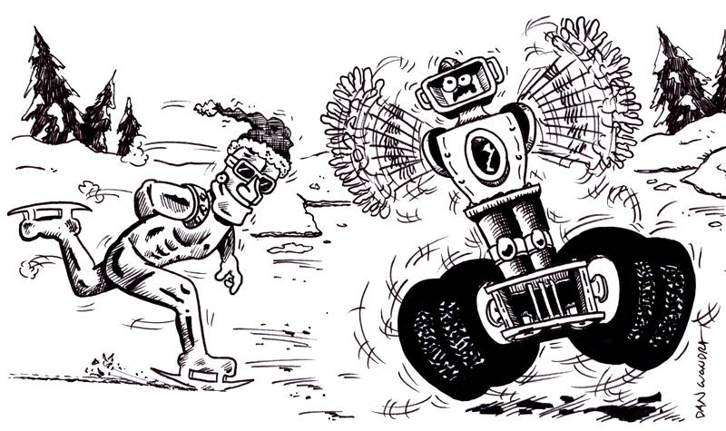
Lesson Title: You’re Tugging At Me!!
Draft Date: June 17, 2009
1st Author: Ryan Schroeder
Science Topic: Sliding vs. Rolling Friction
Grade Level: Middle School

Content (what is taught)
- Sliding and Rolling Friction (Static and fluid can also be introduced at this time).
- Forces required to move objects of the same mass.
- Procedures for properly constructing a line graph.

Context (how it is taught)
- The students will use the robot to pull a cart on wheels and a sled to determine the amount of force required to move those objects. The students will then graph and analyze this data.

Activity Description: In this lesson, students will use the materials (see below for materials for each group) to determine the amount of force needed to move both the cart on wheels and the sled. The students will determine if the amount of force required to move the cart on wheels is the same as the amount of force needed to move the sled. Ultimately, the students are determining if the surface area of the cart on wheels and the surface area of the sled have an influence on the amount of force required to move these objects.

Standards
Science: SA1, SA2, SB1
Math: MA1, ME1, ME2

Materials
Classroom Robot (1 per group of 3)
Spring Scale
Sled (same mass as the cart on wheels)
Cart on Wheels (same mass as the sled)
Masses of Various Sizes
Recording Notebook
ASKING Questions (You’re Tugging at Me!!)

Summary: Students will make a prediction as to which requires less force to move – a sled or a cart on wheels.

Outline:
- Students will predict which will require a lesser force to move – a sled or a cart with wheels.
- Students will predict how surface area affects the amount of friction produced.

Activity: Students need to examine the sled and the cart on wheels. Ask the students to make predictions as to which will move with a smaller force applied to it. Topics that may need to be discussed prior may include any of the following: Force, Friction (sliding & rolling), What influences Friction, Surface Area, and Calculation of Surface Area.
It would also be helpful in this activity if the students know how to properly read a spring scale (in Newtons) and use units.

Questions | Possible Answers
What is a force? | A push or pull exerted by one object on another object.
What affects the amount of friction (either sliding or rolling) between two objects? | The amount depends on the types of surfaces in contact and the mass of the objects.
How does surface area affect the amount of friction produced by objects of the same mass? | The amount of surface area does not affect the amount of friction produced.
What part does the motion play in the total energy of the system? | The amount of energy does not change. (Law of Conservation of Energy)

Surface Area
Rectangular Region
length x width
length (l)
width (w)
Exploring Concepts (You’re Tugging at Me!!)

Summary: Students will use the cart on wheels and the sled to determine how the surface area affects the amount of sliding friction (sled) and rolling friction (cart on wheels).

Outline:
- The groups will determine the force needed to move a sled and a cart on wheels. The groups will learn that surface area does not affect the amount of friction between two objects.

Activity: Have the groups of three obtain the necessary materials. The groups will need to develop a system to test the amount of force needed using the materials that are listed above. The simplest system would have the CEENBoT attached to the spring scale which is attached to the sled or cart. The groups should develop an activity to measure the amount of force needed to pull the sled/cart. The groups should also be encouraged to run at least ten trials with the sled and ten trials with the cart. It would also be a good idea to overview the student’s plan prior to them conducting the activity. Have groups share (not take) results with other groups to double-check their results. If a group’s results seem skewed, they should conduct this activity again. Before starting again, they should double check the spring scale to make sure it is operating properly.

Worksheet: S043_Youre_Tugging_at_Me_Datasheet.doc

Spring Scale

Instructing Concepts (You’re Tugging at Me!!)

Friction

Putting “Friction” in Recognizable terms: Friction is a force between two objects that tends to “damp out” or oppose motion. It always acts in complete opposition to another force applied to an object. There are two main types of friction. Static friction is the frictional force opposing putting an object at rest into motion. Kinetic friction is the frictional force which tends to slow an object in motion. Usually static friction is higher than kinetic friction meaning it takes a greater force to put an object into motion than it does to maintain motion.

Putting “Friction” in Conceptual terms: Friction opposes the force required to start or maintain an object in motion. It is dependent on the surfaces that are in direct contact. Friction is created by the rubbing or dragging of the surfaces across each other. Friction can be increased or decreased by modifying the surfaces.

Putting “Friction” in Mathematical terms: The coefficient of friction must be calculated for any surface because different surfaces provide different amounts of friction. The coefficient of friction can be found by taking the force of friction (either to start an object in motion, “static” or to keep an object in motion, “kinetic”) divided by the normal force (force a provided by a component of gravity). The normal force is always found perpendicular to the surface. If the surface is NOT horizontal you must resolve the force of gravity perpendicular to the surface. In terms of a mathematical equation, it may be written: µ = F_{f} / F_{n} where the Coefficient of Friction equals the Frictional Force divided by the Normal Force.

Putting “Friction” in Process terms: Friction is the force that allows us to move. Without friction there would be no force to resist or act in opposition to our desired motion. Thus, friction is the force that fulfills Newton’s 3rd law - for every action there is an opposite and equal reaction. We cannot move in a desired direction unless friction works against us in the opposite direction. Friction is desirable and necessary for motion as we understand it and yet we are always trying to reduce friction in many instances because it requires less energy to move an object. At other times we want to increase friction to keep an object at rest.

Putting “Friction” in Applicable terms: Friction is the force that allows us to walk, climb, drive, throw, or put any object in motion. Without friction we couldn’t move objects. Friction is both desirable and undesirable depending on if you want an object to move or stay at rest. Higher friction requires more energy input. Lower friction requires less energy input.
Organizing Concepts (You’re Tugging at Me!!)

Summary: Students will calculate average and compare/contrast the forces required to move the cart with wheels and the sled. The students will also need to create a line graph showing the forces for each trial.

Outline:
- Students will determine the average for the trials of the CEENBoT with the cart and the average of the CEENBoT with the sled.
- Students will need to create a line graph showing the force for the cart with wheels and the sled (two lines).

Activity: Students should determine the average force required for the cart with wheels and the sled. Record this data on the data sheet. Students will need to create a line graph showing the data the group collected. Have graph paper available. It would be a good idea to have materials such as markers, pens, crayons, and other materials available for the students to use if they choose to get creative. Encourage the students on how to create a proper line graph. Remember graphs should have labels for the x-axis and y-axis, title, and proper scales. Also, remind students that the graph should be the entire page. Remind students to write the average somewhere on the graph.
Understanding Concepts (You’re Tugging at Me!!)

Summary: Students need to show their completed data sheet. The teacher should check to see if the data and average seem plausible. Students will then make modifications to the ASKING questions.

Outline:
- Formative assessment for sliding & kinetic friction
- Summative assessment for sliding & rolling friction
- Summative assessment on how surface area affects friction
- Summative assessment of proper graphing techniques & data tables

Formative Assessment
As students are developing their activities, be sure to visit with each group and ask questions such as the following:
a. What is sliding friction?
b. What is rolling friction?
c. How can these two types of friction be reduced?
d. How can these two types of friction be increased?

Summative Assessment
Students can answer the following writing prompt:
1. Explain how sliding and rolling friction are created.
2. On recent reports, it has been recommended that the tires be properly inflated to reduce friction. Explain if you agree or disagree with this statement.

Students will submit a formal lab write-up with the experimental procedure, the data, and the relationships calculated. The report should include all graphs and data tables.

