SPIRIT 2.0 Lesson:
Method Madness!!
==========================Lesson Header ==========================
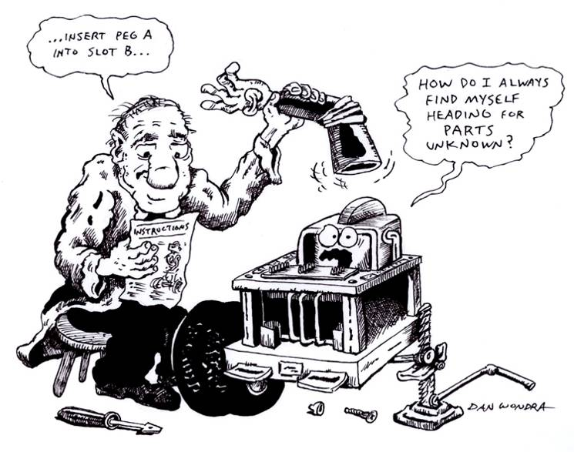
Lesson Title: Method Madness!!
Draft Date: June 23, 2009
1st Author (Writer): Mark Wemhoff
Instructional Component Used: Scientific Inquiry
Grade Level: 7-12

Outline of Lesson

Content (what is taught):
- What is engineering?
- How can you solve a problem?
- What is the Scientific Method?
- Design = Game challenge

Context (how it is taught):
- Students will define engineering in their own perception.
- Students piece together the points of the scientific method.
- Students will practice the scientific method.
- Students will design a game that will challenge their classmates in a local competition.
Activity Description:
Students will decide what is considered engineering and then have to list the steps of the scientific method. The students will then have to determine the part of the CEENBoT that is not functioning properly. They will first have to put a CEENBoT together by following the CEENBoT website directions. Then the teacher will bug the CEENBoT and the students will have to use the scientific method to debug the CEENBoT and get it to operate properly. The students will then have to design a game that will then challenge their classmates. (The game will have to be within certain parameters)

Standards:

Science: SA1, SA2, SE1, SE2, SG3 Technology: TD1, TD2, TD3, TF1, TF3, TF4

Engineering: EC1, ED1, ED2

Materials List:
CEENBoT
#1 & #2 Phillips screwdriver
¼”, 5/16”, 11/32”, ½”, & 7/16” socket or nut driver
6” pliers
Ruler or tape measure.
Asking Questions (Method Madness!!)

Summary: Students will explain and conduct the scientific method.

Outline:
- Students will be asked what is their definition of engineering.
- Students will need to come up with careers that relate to engineering.
- Students will complete a building of a CEENBoT and run effectively.
- Students will design a competitive game to challenge their classmates.

Activity:
Have the students develop a definition for engineering and compare it to a text book definition. The students will then indicate certain professions and objects that deal with engineering. Upon realizing that everything around them is derived from some type of engineering the students will have to build a CEENBoT and have to get it to function correctly using the scientific method. The groups will then design a game that will challenge their classmates.

Questions | Answers
What is an engineer? | The profession in which a knowledge of the mathematical and natural sciences gained by study, experience, and practice is applied with judgment to develop ways to utilize, economically, the materials and forces of nature for the benefit of mankind.
What is in this room that is not influenced by engineering? | Everything is influenced by engineering.
What are the main components of a CEENBoT? | Wheels, control boards, sensors, motors, battery, controller.
What are the steps of the scientific method? | Problem, Hypothesis, Research, Procedure, Collect and Analyze Data, Conclusion.
What is trouble shooting? | Eliminating possibilities of a system that could be creating a problem.
What is design? | "Design is an art practiced within the constraints of science” C. Sedlack
What is a game that you can design your challenge from? | Open ended
Can you combine games from multiple designs? | Open ended
Exploring Concepts (Method Madness!!)

Summary: Students will build a CEENBoT from scratch. After it is running correctly the teacher will cause a problem with the robot that the students will have to diagnose and correct the problem using the scientific method. After the problem has been corrected a game will be designed using the CEENBoT to create a challenge for classmates.

Outline:
Students will discover the process of the Scientific Method through the eyes of an engineer
by examining the parts and construction of a CEENBoT.
- The students will discover the design process of an engineer by creating a game or
challenge for their classmates.
Activity:
1. Pre lab: Discussion of concepts
2. Lab: See Below
3. Post Lab: Review of the lab and discussion of what was learned.

The teacher will discuss the purpose of engineering by using the UNO power point, “Intro to Engineering,” and, “Engineering Design Process.” The students will be paired into groups of 3-4. The students will then have to log onto the UNO CEENBoT website (http://www.ceen.unomaha.edu/TekBots/SPIRIT2/Tutorials/chasis/) and build their CEENBoT. The students will then trouble shoot their CEENBoT to make sure the machine is running the way it is supposed to. The teacher will then bug each groups CEENBoT over night. The students will then have to use the scientific method to figure out what is the defect in their CEENBoT. (Teacher record what you have bugged for each Bot). Once the group has debugged their CEENBoT they will proceed in designing a game or challenge that will need to be explained the objective and rules to the other groups. Each group will have to collect data on how the other groups perform during their game or challenge. The group can then create a graph or chart for the performances of the game done by the other groups. And then present the results to the class.

If you want to shorten this lesson you could eliminate the building step by starting with completed CEENBoTs. The “bugged” CEENBoT and game could easily be done without the time intensive building step.
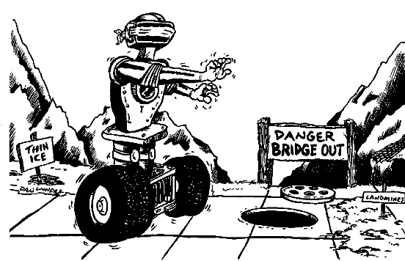

Instructing Concepts “Method Madness”

Scientific Inquiry

Scientific Inquiry Process
Scientific Inquiry is a very systematic process that scientist use to understand phenomena that are present in the world. The process must be followed exactly without any deviation or any results that are obtained might not be valid. There are six basic steps to the scientific inquiry process.

Step One: Ask a question.
In this step you ask a question that you want answered about something that you have observed. If scientific inquiry is to provide an answer, the question must be framed in such a way that it can be measured preferably with a number.

Step Two: Make a set of observations regarding the phenomenon being studied.
The scientist will observe the phenomenon that is being studied without any bias. It is important that the phenomena be researched in addition to observing it so that past information will be noted and past mistakes will not be repeated.

Step Three: Form a hypothesis that might explain the observations.
The hypothesis should be framed in a format like “If I do this, then this will happen”. This hypothesis must be measurable and should help you answer your original question.

Step Four: Test your hypothesis by doing an experiment.
You will conduct an experiment that will prove your hypothesis true or false. It is important that the experiment be unbiased and fair. To do this you can only change one variable at a time and keep everything else the same. Doing this insures that any change observed will be a result of your experiment and not some other factor.

Step Five: Analyze your data and draw conclusions.
Once your experiment is done you need to analyze your measurements and see if your hypothesis is true or false. If your hypothesis is false (a common occurrence), you should start the entire process again with a new hypothesis. Even if you find your hypothesis to be true you may want to devise another experiment to test your hypothesis again. Multiple experiments that validate your hypothesis make your conclusion stronger.

Step Six: Communicate your results.
If your hypothesis stands up to multiple tests you should report your results in a final report. This might take the form of a journal article in a professional or scientific journal.
Organizing Learning (Method Madness!!)

Summary: Students will produce lab reports. All reports must be typed and document not only the design process, but also the science steps. Students will produce a lab report with purpose, hypothesis, variables, materials, procedure, data, calculations, graph, and conclusion.

Outline:
- Collect information based on observation while building the CEENBoT and debugging it.
- Design a game, draw a diagram and explain rules.
- Record times or other components that deal with the group’s game or challenge.

Activity:
While the groups are building their CEENBoT they will have to keep detailed recordings of what they had placed in the wrong place or if they have to make adjustments to their CEENBoT. Upon completion of the building process the teacher will bug the CEENBoT and the group will have to debug their CEENBoT. (Teachers will record what has been bugged on each group’s Bot.) Each group will need to create a scientific method problem to help debug the CEENBoT. To do this they will need to record all information while solving the problem. The group will then design a game or challenge that will need to be documented and drawn onto a piece of paper. (The paper needs to have a diagram of the game and the rules for the game.) The group then needs to create a chart for their game that will allow them to collect the data that they would like to chart when the games have concluded.

Worksheet:
Game Data Sheet

Team | Time | # Obstacles hit | Average of 3 Trials | Rank

Write down the parts of the game that all groups had the most difficulties with while completing the game. Indicate the parts that the groups were able to master easily.

Understanding Learning (Method Madness!!))

Summary: Students will be assessed on their response to a writing prompt and on the charts and graphs that they create from their game.

Outline:
- Formative assessment of scientific method.
- Summative assessment of scientific method.

Activity:
Formative Assessment
As students are engaged in learning activities, ask yourself or your students these types of questions:
1. Were the students able to understand what an engineer does?
2. Can students explain how to build a CEENBoT?
3. Do students understand the steps of the scientific inquiry process?
4. Do students understand the reasons for the scientific inquiry process?
5. Were the students able to understand how to design a game for the CEENBoT?

Summative Assessment
Students can answer the following writing prompts:
- Describe the process of scientific inquiry and how you used it to “debug” your robot.
- Describe the steps of the scientific inquiry process in detail and how they work so that hypotheses can be tested and proven.

