SPIRIT 2.0 Lesson:
Friction Fanatics
==========================Lesson Header ==========================
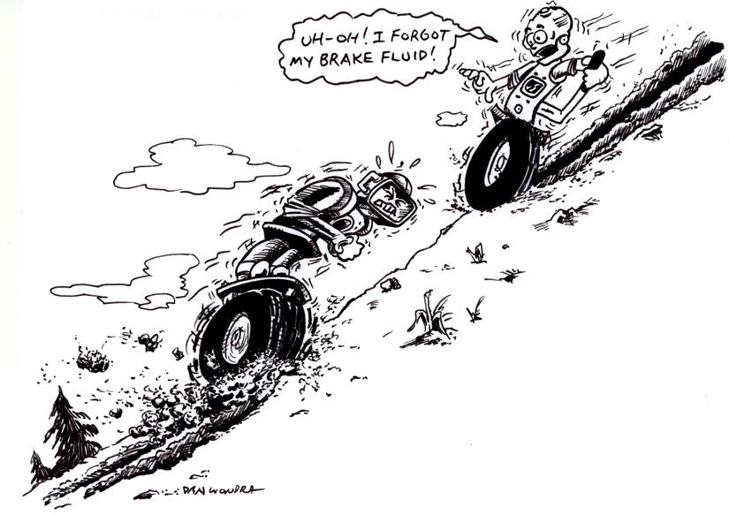
Lesson Title: Friction Fanatics
Draft Date: 6-23-09
Author (Writer): Krista Holliday
Instructional Component Used: Friction
Grade Level: 9-12

Outline of Lesson

Content (what is taught):
- Calculate the coefficient of friction by using the angle of an incline for of a braked CEENBoT as it just starts to slide (static friction) verses a CEENBoT trying to go the incline with spinning the wheels (kinetic friction).
- Calculate the friction of a free-wheeling CEENBoT (kinetic friction of wheels and motors)

Context (how it is taught):
- Drive a CEENBoT half way up a ramp and put on the brakes. Raise the ramp until the CEENBoT first starts to slide. Measure this angle from the floor.
- Use the equation tan θ = µ where θ is the angle between the floor and the board and µ is the coefficient of static friction between the two surfaces.
- Drive a CEENBoT up the ramp and change the angle of the ramp so that the CEENBoT is spinning and can’t climb anymore. This angle will be compared with the first angle.
- Find the angle at which a free-wheeling CEENBoT first starts to roll down an incline as you raise the incline.

Activity Description:
Students will use a CEENBoT to calculate the coefficient of static friction and compare that with a CEENBoT motoring up an incline until it spins out. They will then look at the angle at which a free-wheeling CEENBoT will start to roll down a ramp and note the differences.

Standards:
Math—A1, A2, B1, B2, B3, D1, D2 Science—A1, A2, B1, B3, E1, E2
Technology—B1, B4, C4, D3, F1

Materials List:
Plywood board, 2 by 4 foot, CEENBoT, large protractor, graph paper, data table, calculator
The plywood should be wide enough for the CEENBoT to spin its wheels while heading upward
Asking Questions (Friction Fanatics)

Summary:
Students will consider and compare the different types of friction: static, kinetic, and rolling.

Outline:
- Students respond to questions about friction.
- Students will recall or develop the idea that the equation to find the coefficient of friction on an incline is tan θ = µ when the object is moving down the incline at a constant speed.

Questions | Answers
What causes the amount of friction between two surfaces? | Force Normal and the coefficient of friction.  Weight & the type of surfaces
Who can name at least two types of friction? | Starting (static) Friction, Sliding (kinetic) Friction, Rolling Friction, and Fluid Friction
Which two types will have the closest coefficient of friction? | Braking CEENBoT and the CEENBoT spinning out. Students will answer this question through experiments.
How could these different types of friction be measured with the CEENBoT? | Sliding from a stop in braking mode, sliding while spinning the wheels, rolling in free-wheel mode but this includes friction of the motors, fluid friction would be difficult to measure with a CEENBoT
How could an incline be used to help determine the coefficient of friction? | If an object just starts moving (static), slides at a constant speed (kinetic) on an incline, or is rolling at a constant speed (rolling), down an incline set at an angle θ from the horizontal then the equation to find the coefficient of friction is tan θ = µ

Motoring Up
Braking Down
Free Wheeling
Exploring Concepts (Friction Fanatics)

Summary:
Students will use the CEENBoT to investigate the force of friction in different situations by changing the angle of an incline.

Outline:
- Students will place the CEENBoT on a 2 x 4 foot plywood board and then raise the board until the limit is reached for the frictional force.
- Student will investigate three types of frictional force: static friction, kinetic friction, and rolling friction.

Activity:
Students will use a CEENBoT to investigate how the different types of friction can be measured: static, kinetic, and rolling, Students will use a sheet of plywood to setup the different situations. Students should be encouraged to try different methods

If needed, suggest that the students try the following:

- Use the CEENBoT in braking mode on the incline.
- Use the CEENBoT in driving mode up the incline.
- Use the CEENBoT in free-wheeling mode down the incline.

Resource:
Students can research the different types of friction and the formula tan θ = µ using a physics textbook or can search the Internet using the terms: hyperphysics friction
Instructing Concepts (Friction Fanatics)
Friction on an Incline
θ
F_{g}
F_{f}
F_{n}
x-axis
y-axis
Figure 1

Putting “Friction on an Incline” in Recognizable terms: Friction on an Incline is a special case of friction on a horizontal surface. An incline is created by taking a surface and raising one end. Friction on an incline has the same basic results as friction on a horizontal surface and uses the same basic equations. The force of friction (F_{f}) still depends on the perpendicular force between the object and the surface, called the normal force (F_{n}). The different types of friction, static, kinetic, and rolling, can still occur on an incline.

Putting “Friction” in Conceptual terms: The main difference created by an incline is that the force of gravity is not perpendicular to the surface. As the angle of the incline is increased, the normal force is decreased, which decreases the frictional force. The incline can be raised until the object just begins to slide (static) or moves with a constant speed (kinetic or rolling). At this angle, the forces parallel to the incline are balanced.
F_{g}
θ
F_{y}
x-axis
y-axis
F_{x}
F_{x}
θ
F_{y}
F_{g}
Figure 2
Putting “Friction on an Incline” in Mathematical terms: The coefficient of friction, µ, is defined as µ = F_{f} / F_{n}. On an incline, the force of gravity, F_{g}, is resolved into two components, F_{x} and F_{y}. Since the angle between F_{g} and F_{y} is equal to the angle of the incline, a component triangle (see Figure 2) can be used to show that
F_{x} = F_{g} sin θ F_{y} = F_{g} cos θ
In the case of an incline being raised to an angle where the object just begins to slide or moves at a constant speed (see Figure 3), we assume F_{f} = F_{x}. Also, with no other forces acting but gravity and friction, we know that F_{n} = F_{y}. Putting these results together we can show that µ = tan θ
$μ=\frac{F_{f}}{F_{n}}=\frac{F_{x}}{F_{y}}=\frac{F_{g}\text{sin}θ}{F_{g}\text{cos}θ}=\frac{\text{sin}θ}{\text{cos}θ}=\text{tan}θ$
θ
F_{g}
F_{y}
F_{x}
F_{f}
F_{n}
x-axis
y-axis
Figure 3
Remember this result assumes the object is just starting to slide (static) or moving at constant speed (kinetic or rolling).

Putting “Friction on an Incline” in Process terms: Friction on an incline is a generalization of friction on a horizontal surface. As the angle of the incline is increased, the force of friction will decrease due to the change in normal force.

Putting “Friction” in Applicable terms: Friction on an Incline occurs when you walk up a ramp or a steep hill. By applying the concepts of friction on an incline you can determine at what angle your feet will begin to slide.
Organizing Learning (Friction Fanatics)

Summary:
Students will use a CEENBoT to calculate the coefficient of static friction and compare that with a CEENBoT motoring upward on an incline while spinning out. They will then look at the angle at which a free-wheeling CEENBoT will start to roll down a ramp and note the differences. Students will collect angle data in a table and will use that data to calculate the coefficient of static friction.

Outline:
- Students will place the CEENBoT on a 2 x 4 foot plywood board and then raise the board until the limit is reached for the frictional force.
- Students will collect data on the three types of frictional force: static friction, kinetic friction, and rolling friction.
- Students will organize their data using a table and graph

Activity:

- Drive a CEENBoT half way up a ramp and put on the brakes. Raise the ramp until the CEENBoT first starts to slide. Measure this angle from the floor and record the angle. Use the equation tan θ = µ where θ is the angle between the floor and the board and µ is the co-efficient of static friction between the two surfaces. For example, the angle of 43 degrees works for plywood making the coefficient of static friction µ = tan 43 = 0.93
- Drive a CEENBoT up the ramp and change the angle of the ramp so that the CEENBoT is spinning and can’t climb anymore. This angle will be analyzed and compared with the first angle of the braked CEENBoT. An angle of 35 degrees for plywood makes the coefficient of kinetic friction µ = tan 35 = 0.70
- Find the angle at which a free-wheeling CEENBoT first starts to roll down an incline as you raise it. IMPORTANT: This will represent the friction of the wheels and motors, not the surfaces! An angle of about 10 degrees works for a plywood incline.

The data table will have Static Friction (braked bot), Kinetic Friction (spinning out bot), and Rolling friction (free-wheeling bot) at the top. Along the side you can have the angle. Below static friction you should have a place to calculate the coefficient of static friction and this equation: tan θ = µ. They will then display their data using a bar graph for each situation. The bar graph will have angle on the y-axis and the three situations, Static Friction (braked bot), Kinetic Friction (spinning out bot), and Rolling friction (free-wheeling bot), at the top on the x axis. They will also write down their procedure, data, questions, observations etc. in a journal.

Resource:
Students can research the different types of friction and the formula tan θ = µ using a physics textbook or can search the Internet using the terms: hyperphysics friction
Understanding Learning (Friction Fanatics)

Summary:
Students will present their graphs and findings to the rest of the class and lead discussion about their activity. This will prepare them for essay and multiple choice test questions on the coefficient of friction and friction types.

Outline:
- Formative assessment of activity questions
- Summative assessment in the form of a presentation of their data and findings.

Activity:

Formative Assessment
As students are engaged in the lesson ask these or similar questions:

- What causes the amount of friction between two surfaces?
- Which two situations will have the closest coefficient of friction?
- Who can name at least two types of friction?
- You are using the angle of an incline to measure the coefficient of friction. In what situations can that be used and for what types of friction: static, kinetic, or rolling friction?

Summative Assessment
- Students will present their graphs and findings to the rest of the class and lead a discussion about their activity.
- Students will complete essay and multiple choice test questions on the coefficient of friction and friction types.

