SPIRIT 2.0 Lesson:
Voltage Vantage
==========================Lesson Header ==========================
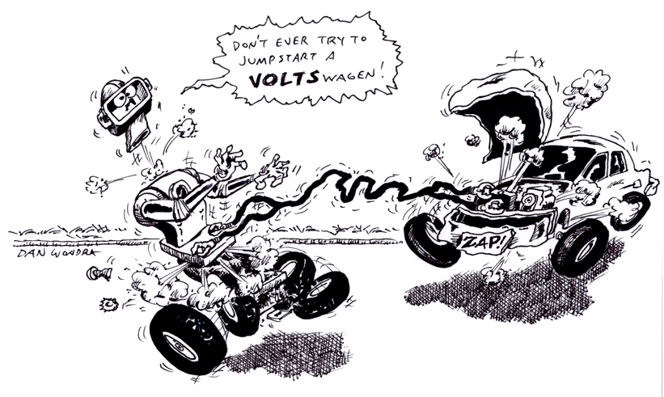
Lesson Title: Voltage Vantage
Draft Date: 6-22-09
1st Author (Writer): Krista Holliday
2nd Author (Editor):
Instructional Component Used: Voltage
Grade Level: Middle school/ High school

Outline of Lesson

Content (what is taught):
- What is voltage?
- How do you measure voltage?
- What happens to the voltage after different uses?

Context (how it is taught):
- Students practice measuring voltage using a multimeter or volt meter.
- Students measure the voltage discharge of the CEENBoT battery as the motors are used
- Student compare the battery discharge for motors with load, that is moving the robot, and without load, just a spinning motor and wheel.
Activity Description:
Run the CEENBoT in bump mode and record the voltage at the start and at 2-minute intervals for 20 minutes. Students will shut off the CEENBoT, unhook the battery and take the voltage reading. Meanwhile, another group of students will be running and recording the voltage of a CEENBoT with its front wheels jacked up so the motor experiences no load.

Standards:
- Math—A1, A2, B1, D1
- Science—B3, E1, E2
- Technology—F1, F4

Materials List:
Data table
2 CEENBoTs (each partner group needs one)
Digital multi-meter
Block of wood or device to lift the front wheels up for one CEENBoT
Stop watch
Asking Questions (Voltage Vantage)

Summary:
Introduce the ideas of voltage, potential difference, and then apply these ideas to the electrical motors of the CEENBoT.

Outline:
- Through questioning, define voltage and demonstrate how voltage is measured
- Ask questions about how voltage changes in a battery as energy is used by a device

Activity:

Questions | Answers
What is voltage? | Potential difference or electromotive force between two points; “pushes electrons thru conductors.”  Voltage is a measure of the difference in potential energy that a charge will experience when moving between two points.
How is voltage measured? | By using a multimeter or voltage meter. The meter must be hooked up across the device being tested, that is in parallel to the device.
How do devices change the voltage of a battery? | When a device uses the energy of a battery, the battery voltage will eventually be reduced. The greater the load the greater the reduction in voltage.
Would it take more energy for the motors to move a CEENBoT, or will the same energy be used if the motors are just allowed to spin? | It should take more energy when the motors must work against a load, such as when moving the CEENBoT. If the motors are just spinning, they use some energy as well.
0.24
Exploring Concepts (Voltage Vantage)

Summary:
Students will use the CEENBoT to measure voltage and see how battery voltage changes.

Outline:
- Students will measure the voltage of components on the CEENBoT including electronic components on the circuit boards and the voltage of the battery.
- Students will run the CEENBoT in bump bot mode and with the wheels jacked up so the motors and wheels just spin without resistance.
- Student will measure the voltage on the battery after using the CEENBoT

Activity:

Explain that because voltage is a potential difference between two points, the volt meter needs to be hooked up across the device to be measured. Depending on the experience level of the students, the teacher may want to demonstrate how to measure voltage with a volt meter on various electrical devices such as a battery, solar cell, battery charger, or circuit board.

Allow time for students to practice voltage testing on batteries and components of a circuit.

Students will also measure voltages on the circuit board of the CEENBoT. Have students find points with the highest voltage or lowest voltage, or points where the voltage changes as the CEENBoT motors are turned on and off. Students could check how the voltage changes to the motors if the motors are freely spinning or if the motors are held so that a load is applied. A load can be applied to the motors by touching the wheels to the floor or by loosely holding them.

0.24
Voltage
Putting “Voltage” in Recognizable terms: Voltage is frequently used to measure the electric potential difference which is the electric potential energy between two points per unit charge. In common applications a voltage measurement between two points in an electrical circuit indicates how much energy a charged particle will acquire as it moves between those two points.

Putting “Voltage” in Conceptual terms: Voltage is defined as a measure of the electric potential which indicates the potential energy per unit charge at a specific location in an electric field relative to a point of zero electrical potential energy. Each point in an electric field has an associated electric potential measured in volts. Work is performed in pushing a positively charged particle against an electric field. The electric potential energy of a charged particle at a point is defined as the amount of work required to move the particle from the point of zero electrical potential energy to the point of interest. Electric potential measures the amount of electrical potential energy per unit charge. A Coulomb (C) of charge is 6.24 x 10¹⁸ electrons.

Putting “Voltage” in Mathematical terms: Voltage is given the symbol V and is defined using the equation V = PE/q where “PE” is the potential energy at a point in an electric field and “q” represents a “test” charge that is used to test various locations in the field. The unit of voltage is called the volt (which also uses the letter V) where 1 volt = 1 joule/coulomb (1 V = 1 J/C).
Instead of the electric potential many applications of voltage use the electric potential difference (ΔV) which is found using the equation ΔV = V_{b} - V_{a} = ΔPE / q where V_{b} and V_{a} are the electric potentials at two points in the electric field, “ΔPE” is the change in electrical potential energy between two points measured in joules and “q” is the charge measured in coulombs. So for electric potential difference 1 volt indicates a difference in electrical potential energy of 1 joule for each 1 coulomb of charge. Other related equations considered more useful involve power and current, such as the equation: P = VI where “P” is power in watts, “V” is voltage in volts, and “I” is current in amperes. Amperes (amps or A) actually measures the flow rate of charge in coulombs pasting a point in 1 second (1 A = 1 C/s). Power is the number of joules of energy used per second (1 W = 1 J/s). For example, if 0.050 A of current from a battery is drawn at 12 V, then power would be P=VI = (12 V)(0.050 A) = 0.60 W. When the power is multiplied by time, energy can be found, so in the example above, if the 0.050 A is drawn from a 12.0 V battery in 2.0 s, the energy used is: E = Pt = VIt = (12 V)(0.050 A)(2.0 s) = 1.2 J.

Putting “Voltage” in Process terms: A voltage measurement of electrical potential difference describes the energy that is available to move electrical charges through a circuit. The charges will only move if there is a difference in potential energy. This can be viewed when using a voltmeter. A voltmeter has two probes. If the probes are touched together, the voltmeter reads zero, there is no electrical potential difference at a single point. If however the voltmeter probes are touched to the opposite terminals of a battery, an electrical potential difference is shown.

Putting “Voltage” in Applicable terms: All batteries and power supplies are designed to produce a specific voltage and electronic devices are designed to operate at a specific voltage. Batteries are rated in terms of total charge stored using the unit of milliamp-hours (mAh). A 7.2 V battery rated at 3000 mAh can deliver 3000 mA (3.0 A) for 1 hour. Using E = VIt the energy stored in the battery can be calculated: E = VIt = (7.2 V)(3 A)(3600 s) = 77,760 J.
Organizing Learning (Voltage Vantage)

Summary:
Students will make a table recording the voltage of the battery after each 2 minutes of use. They will then construct a line graph showing how the voltage changed over time. Students will share their data within their groups and present to the class.

Outline:
- Students work in groups and record the voltage of the CEENBoT battery at 2-minute intervals as the CEENBoT motors are used.
- Groups will be partnered and each pair of groups will do one of these tasks:
  - Collect data for the CEENBoT in bump mode were is moves around the room
  - Collect data for the CEENBoT with its wheels jacked up so the wheels just spin
- Students will make a line graph of their data

Activity:

Divide the students into groups of three: one student keeping track of time and measuring voltage, one student running the robot, turning it on and off, and disconnecting and reconnecting the battery, and one student recording the results. Students should change roles throughout the experiment.

Create "partner" groups where one of the partner groups will run the CEENBoT in bump mode and record the voltage at the start and at 2-minute intervals for 20 minutes. Meanwhile, the partner group of students will be running and recording the voltage in a similar way for a CEENBoT with its drive wheels jacked up, where the wheels will just spin.

Students will make tables showing time and voltage of the bump mode CEENBoT and the jacked up CEENBoT mode. The table will have time in seconds on the side in 2 minute intervals for 20 minutes. The table heading should also indicate the type of CEENBoT (jacked-up and bump bot mode). They will make a single line graph showing the comparison of the two with time being on the x axis and voltage on the y axis. The lines will be color coded for the two different type bots.
Understanding Learning (Voltage Vantage)

Summary:
Students will run the CEENBoT in bump mode and jacked up mode and measure and record the voltage at 2-minute intervals for 20 minutes.

Outline:

- Formative assessment of voltage reading and battery depletion.
- Summative assessment of the understanding and measuring of voltage.

Activity:

Formative Assessment
As students are engaged in the lesson ask these or similar questions:

- What types of robot activities will reduce the voltage in the battery the fastest?
- Why do you think one activity will deplete voltage faster?
- What are some other situations that could be used for battery load tests?

Summative Assessment
As students complete the activity, ask questions to be answered in a verbal or written form:

- What is voltage?
- How would you hookup a voltmeter to measure the voltage in a flashlight circuit?
- Which would deplete a battery faster, a CEENBoT going up a long sloping sidewalk, or a CEENBoT going down a along sloping sidewalk, or do they deplete the battery the same?

