SPIRIT 2.0 Lesson: Pulling with a CEENBoT
LESSON TITLE
==========================Lesson Header ==========================
Lesson Title: Pulling with a CEENBoT!
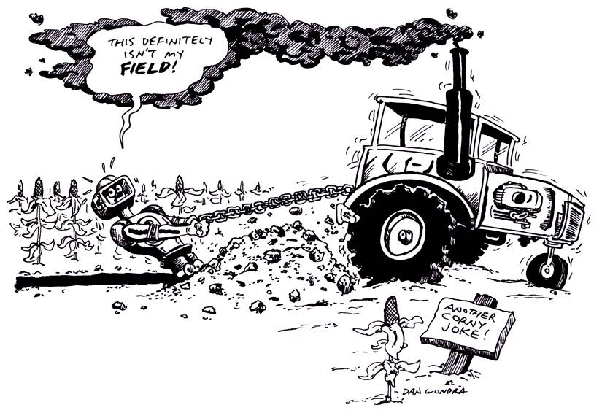
Draft Date: June 22, 2009
1st Author (Writer): Daniel Schmidt
Instructional Component: Friction
Grade Level: Secondary
Cartoon Illustration Idea: Picture of a CEENBoT pulling like a tractor pull, kicking up dust and belching smoke.

Outline of Lesson
- Figure out the kinetic coefficient for friction for a CEENBoT pulling on a horizontal surface.
- Manipulate the kinetic coefficient for friction to increase the pulling power of a CEENBoT.
Content:
- Motion, force, and friction
- Abilities necessary to do scientific inquiry
Context:
Students will set up an experiment.
CEENBoT will pull on chain apparatus and kinetic coefficient for friction will be calculated.
Students will be responsible for exploring how to increase the kinetic coefficient of friction.
Activity Description:
In this lesson, Students would explore the STEM concepts of forces and friction in this exercise by using the robots to pull up a 1/4 inch-link metal chain by pulling on a string connected to two pulleys that redirect the weight of the chain to a horizontal force acting on the CEENBoT. After pulling, the students will measure the amount of chain off of the ground and, using gravitational acceleration, figure out the maximum horizontal force that a robot can produce “as is”. Students will then explore ways of modifying the robot to allow it to pull more chain up by providing a greater pulling force with special emphasis on frictional forces.

Standards:
Science – SB1, SA1 Math - MC1, MD1, ME3
Technology - TA3, TF1 Engineering - EA1, EB3, EC1, EE6

Materials List:
CEENBoT | Notebook
Two pulleys and nylon string | Hook
Weight | Two Newton scales (one for each wheel)

Asking Questions (Pulling with a CEENBoT!)

Summary:
The questions asked are: can the pulling force of a CEENBoT be measured, and if so can the pulling force be increased?

Outline:
- How can the maximum horizontal pulling force produced by a CEENBoT be measured?
- What physics principles and formulas are needed to figure out the forces present with a CEENBoT.

Activity:
Students will set up pulleys according to the diagram provided and thread the string through the pulleys and tie one end to the chain and the other end to a hook that attaches to a CEENBoT.

Questions | Answers
Why can a robot only pull part of the chain off of the ground? | As the chain lifts up off of the ground, gravitational acceleration on the chain increases the force the chain produces on the string that the CEENBoT is pulling against.
What can be done to the robot to allow it to pull more chain up of the ground? | Adding weight to the CEENBoT should increase the normal force acting on the wheels. Changing the surface that the wheels contact should also change the coefficient for kinetic friction.

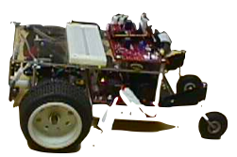
Exploring Concepts (Pulling with a CEENBoT!)

Summary:
Students explore the physical theories pertaining to Newton’s Second Law, and that friction is a force that opposes motion and that each pair of surfaces creating friction has a specific coefficient (constant).

Outline:
- Students will use the CEENBoT to pull a chain sequentially off of the ground until the force produced by the hanging chain causes the wheels of the CEENBoT to slip (chain’s weight becomes greater than the frictional forces of the CEENBoT’s wheels on the surface that it is traveling).
- Students will attempt to increase the kinetic coefficient of friction in order to increase pulling force.

Activity:
1. Pre lab: Discussion of concepts
2. Lab: See Below
3. Post Lab: Review of the lab and discussion of what was learned.

Students will break into assigned groups of three. Each group will weigh their chain, count the links, and determine the weight (in grams) of each link. The weight (in Newtons) of each pulling (front) wheel of a CEENBoT will be measured according to Diagram 1 (see file S047_CEENBoT_pull-E-Diagrams). This force will be designated F_{n}. Each group will then gather equipment and set up their lab station according to Diagram 2 (see file S047_CEENBoT_pull-E-Diagrams. A CEENBoT will be hooked to the string and chain with the chain resting completely on the ground. The CEENBoT will then drive away from the lower pulley until the pulling tires slip. One student will watch the chain as it is lifted and record the number of links that were raised off the ground. This will be done several times and data will be recorded each time.
The average mass of chain that was lifted each time will be computed and plugged into the equation F = ma (with a = gravitational acceleration = 9.8 m/s²) to find the largest force that the CEENBoT could pull before overcoming frictional forces. This force will be designated F_{f}.
F_{n} and F_{f} from above, will be placed in the equation: µ = F_{f} / F_{n} and the kinetic coefficient of friction will be computed.

Worksheet: S047_CEENBoT_pull-E-Diagrams.doc

INSTRUCTING Concepts (Pulling with a CEENBoT!)

Force

Putting “Force” in Recognizable terms: Force is a push or pull on an object that may results in an object with mass accelerating. The standard unit of force is a Newton (N) which is the amount of force required to give a 1-kg mass an acceleration of 1 m/sec². A force has both magnitude and direction and therefore it is a vector quantity. Typically forward, up, or to the right is chosen as the positive vector direction, that is, force and acceleration are positive in any of those directions. Therefore, force or acceleration that is backward, down, or to the left would be considered negative.

Putting “Force” in Conceptual terms: Force fits into two broad categories: contact and “action-at-a-distance”. Contact forces are forces that act directly on an object and might include: Frictional Force, Normal Force, Air Resistance Force, Applied Force, and Spring Force. Typical action-at-a-distance forces include: Gravitational Force, Electrical Force, and Magnetic Force. Forces can be balanced meaning that all forces acting on an object cancel out and the object is at rest or in a state of constant motion. When the forces on an object are unbalanced, the object will accelerate.

Putting “Force” in Mathematical terms: The force on an object can be calculated by looking at the individual (or components of forces) that are acting on the object. Newton’s first law states that an object at rest tends to stay at rest and an object in motion tends to stay in motion unless acted on by an unbalanced force. The net force on an object is the sum of all the forces (both contact and action-at-a-distance) acting on the object. If the object is at rest the sum of the forces are balanced and cancel out. If the object is moving under acceleration, the forces do not cancel and the direction and acceleration of the object can be determined by the unbalanced force applied to the object using Newton's Second Law: F_{net} = ma where F_{net} is net force, m is mass, and a is acceleration.

Putting “Force” in Process terms: Thus, the forces affecting an object can be calculated by looking at the sum of the individual forces at work on the object and the resulting movement, if any. By looking at individual forces on an object rather than just whether an object is moving or at rest can help you understand how and why the object is behaving the way it is.

Putting “Force” in Applicable terms: Force is a push on an object that may change its speed and direction as a result of acceleration. It can be thought of as the force required to change the motion of an object in a desired direction or to maintain an object at rest.
INSTRUCTING Concepts (Pulling with a CEENBoT!)

Friction

Putting “Friction” in Recognizable terms: Friction is a force between two objects that tends to “damp out” or oppose motion. It always acts in complete opposition to another force applied to an object. There are two main types of friction. Static friction is the frictional force opposing putting an object at rest into motion. Kinetic friction is the frictional force which tends to slow an object in motion. Usually static friction is higher than kinetic friction meaning it takes a greater force to put an object into motion than it does to maintain motion. Cases where kinetic friction is higher than static friction can occur with the use of lubricants which create a drag force that increases with velocity.

Putting “Friction” in Conceptual terms: Friction opposes the force required to start or maintain an object in motion. It is dependent on the surfaces that are in direct contact. Friction is created by the rubbing or dragging of the surfaces across each other. Friction can be increased or decreased by modifying the surfaces.

Putting “Friction” in Mathematical terms: The coefficient of friction must be calculated for any surface because different surfaces provide different amounts of friction. The coefficient of friction, µ, can be found by taking the force of friction, F_{f}, divided by the normal force, F_{n}, written as: µ = F_{f} / F_{n}. When the force to start an object in motion is used, the “static” coefficient is found. If the force to keep an object in motion is used, the “kinetic” coefficient is found. The normal force is the force component of the surface, perpendicular to the surface, acting on the object. If the surface and applied forces are horizontal, the normal force will be equal and opposite to the force of gravity, which is the weight of the object. If the surface and applied forces are NOT horizontal you must resolve the forces perpendicular to the surface.

Putting “Friction” in Process terms: Friction is the force that allows us to move. Without friction there would be no force to act in opposition to our desired motion. Thus friction is the force that fulfills Newton’s 3rd law - for every action there is an opposite and equal reaction. We cannot move in a desired direction unless friction works against us in the opposite direction. Friction is desirable and necessary for motion as we understand it and yet we are always trying to reduce friction in many instances because it requires less energy to move an object. At other times we want to increase friction to keep an object at rest.

Putting “Friction” in Applicable terms: Friction is the force that allows us to walk, climb, drive, throw, or put any object in motion. Without friction we couldn’t move objects. Friction is both desirable and undesirable depending on if you want an object to move or stay at rest. Higher friction requires more energy input. Lower friction requires less energy input.
Organizing Learning (Pulling with a CEENBoT!)

Summary:
Students will produce lab reports. All reports must be typed and document not only the design process, but also the science steps. Students will produce a lab report with purpose, hypothesis, variables, materials, procedure, data, calculations, graph, and conclusion.

Outline:
- Collect data as the CEENBoT pulls the chain up.
- Figure out kinetic coefficient of friction.
- Explore ways of increasing the kinetic coefficient of friction.

Activity:
The teams will calculate the coefficient of friction using the equations F = ma and µ = F_{f} / F_{n} .
They will then produce hypothesizes that would increase the kinetic coefficient of friction for the setup and then test those hypothesizes. Each group must turn in a lab report with calculated values for the coefficients of kinetic friction. All reports must be typed and document the design process and the science steps. Students will produce a lab report with purpose, hypothesis, variables, materials, procedure, data, calculations, graph and conclusion.

Understanding Learning (Pulling with a CEENBoT!)

Summary:
Students will be assessed on their understanding of force and friction by creating a lab write-up of their experiment and doing a writing prompt.

Outline:
- Formative assessment of force and friction.
- Summative assessment of force and friction.

Formative Assessment:
As students are engaged in the project, ask yourself or the students the following:
- Do students understand what kinetic friction is?
- Do students understand what effects kinetic friction and how it can be changed?
- How is the kinetic coefficient of friction determined (what information is needed and how is manipulated)?
- Were students able to create a method of increasing the kinetic friction of the CEENBoT?

Summative Assessment:
Students will write a formal lab write-up including the experimental procedure, the data, the graphs of the data, issues that might have effected the results, their hypothesis/method about changing the kinetic friction coefficient and result of testing the hypothesis.

Students can answer the following writing prompt:
1) If you are pulling a heavy load how would it be possible to change the coefficient of kinetic friction?
2) State a situation where increasing or decreasing the coefficient of kinetic friction would be desirable and why.

