SPIRIT 2.0 Lesson:
Circling Around the CEENBoT Way!
==========================Lesson Header ==========================
Lesson Title: Circling Around the CEENBoT Way!
Draft Date: June 24, 2009
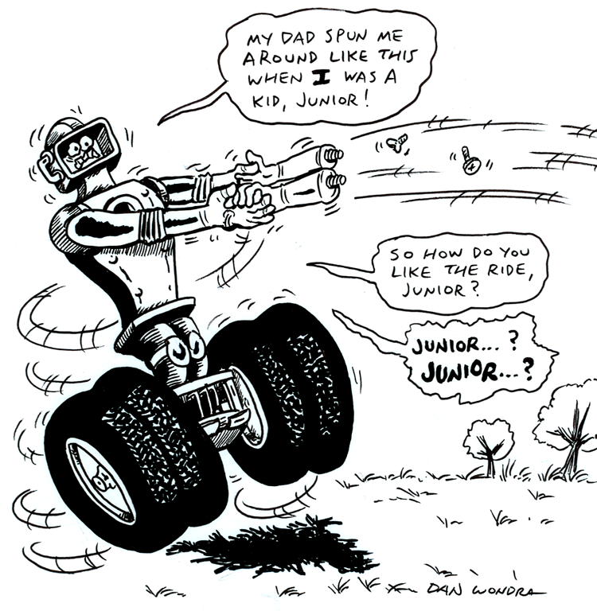
1st Author (Writer): Daniel A. Schmidt
Instructional Component Used: Centripetal Force, Force, and Friction
Grade Level: Secondary

Outline of Lesson
- Collect data on the centripetal force created by a CEENBoT traveling in a circle against a tether.
- Graphing collected data utilizing a XY Scatter Plot graph in Excel.
- Comparing collected data by comparing it with the centripetal force equation.

Content:
- Rotational motions and forces
- Friction
- Abilities necessary to do scientific inquiry

Context:
- Students will set up an experiment.
- CEENBoT pulls on tether and data is collected for the centripetal forces produced.
- Students explore how centripetal force is related to inertial force and orbital radii.
Activity Description:
In this lesson, Students would explore the STEM concepts of centripetal force and friction by using the CEENBoTs to provide an inertial force against which a tether can obtain centripetal force from forcing the CEENBoT to rotate in a circle. The forces produced on the tether by the CEENBoT and the measure of the radii producing those forces will be grafted and the data will be used to understand the centripetal force equation.

Standards:
Science – SA1, SA2, SB2 Technology - TA3, TF1
Engineering - EA1, EB3, EC1 Math - MC1, MD1, ME3

Materials List:
CEENBoT | Notebook
Tape measure | Two hooks
Nylon string | Newton scale

Asking Questions (Circling Around the CEENBoT Way!)

Summary:
The questions asked: can the centripetal force on a tethered circling CEENBoT be measured, and if so, does the force change with radius distance?

Outline:
- Can the centripetal force on a tethered CEENBoT be measured?
- Does the centripetal force change with radii distance?
- Does the real world data fit the model presented by the centripetal force equation?

Activity:
Students will attach the harness to the CEENBoT and test the force produced on it at various radii.

Questions | Answers
What actually produces the “centripetal force”? | Friction between the wheels and the floor surface produce the resisting force that is measured. Therefore the force will vary with the kinetic coefficient of friction that is present in the experiment.
Can data from an experiment like this be “fitted” into an equation that predicts the forces on orbiting objects such as the moon and earth? | As long as the range of forces are known for all parameters the equation will still work

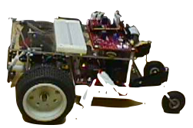

Exploring Concepts (Circling Around the CEENBoT Way!)

Summary:
Students explore the physical theories pertaining to centripetal force.

Outline:
- Students will use the CEENBoT as a rotating body and collect data in regard to the centripetal forces generated by the CEENBoT as it is forced to travel in a circle (orbit). Students will then attempt to apply the centripetal force equation to their real world data.

Activity:
1. Pre lab: Discussion of concepts
2. Lab: See Below
3. Post Lab: Review of the lab and discussion of what was learned.

Students will break into assigned groups of three. The students will make a harness to keep the CEENBoT perpendicular to the string and scale (see Diagram 1). The students will then proceed to an open area of smooth surface (like a gym or cafeteria) and set up in an area of about 20 meters by 20 meters. Starting with a radius of one meter, students will allow the CEENBoT to steadily crawl around in a circle with the string and scales as the tether providing the centripetal force (see Diagram 2). Record the radius and the centripetal force (the force, in Newtons, shown on the scales) for that distance and then continue testing and recording data with larger radii (one meter increases). Note: The speed of the CEENBoT should be kept constant for each trial and constant for all trials.

harness
Diagram 1

Scales (in Newtons) pivot point

CEENBoT

INSTRUCTING Concepts (Circling Around the CEENBoT Way!)

Circular Motion

Putting “Circular Motion” in Recognizable terms: Circular motion occurs when an object follows a circular path about a center point. When the speed of the object stays constant, the motion is called uniform circular motion.
r
v
v
a_{c}
a_{c}

Putting “Circular Motion” in Conceptual terms: With uniform circular motion, the speed (v) remains constant, but since the object is following the curved path of a circle, the direction of the velocity is changing. This changing velocity requires acceleration toward the center of the circle, called the centripetal acceleration (a_{c}). Since the object has mass, there will also be a centripetal force (F_{c}) acting on the object toward the center of the circle. The time for the object to go once around the circle is called the period (T).

Putting “Circular Motion” in Mathematical terms: The centripetal acceleration is found using the formula:
$a_{c}=\frac{v^{2}}{r}$ where v is the speed and r is the radius
Using Newton's Second Law of motion, the centripetal force can be found:
$F_{c}=m⋅a_{c}$
$F_{c}=\frac{m⋅v^{2}}{r}$ where m is the mass of the object
During one period, the object goes once around the circle and travels along the circumference of the circle. The speed can be found using the circumference and period:
$v=\frac{d}{t}$
$v=\frac{2⋅π⋅r}{T}$ where r is the radius and T is the period

Putting “Circular Motion” in Process terms: Centripetal acceleration describes the amount of acceleration an object will experience when following the circular path with uniform speed. Centripetal force is the amount of force needed to cause the uniform circular motion. The centripetal force is applied perpendicular to the direction of motion.

Putting “Circular Motion” in Applicable terms: When an object is twirled around on a string, the centripetal force is provided by the tension in the string. For the Moon in orbit around the Earth, gravity supplies the centripetal force. When a roller coaster goes over the crest of a hill, if the speed and radius are such that the centripetal acceleration is equal to the acceleration of gravity, the roller coaster riders will feel weightless. These results of uniform circular motion and many other special cases can be proven using Newton's Second Law of motion.
INSTRUCTING Concepts (Circling Around the CEENBoT Way!)

Friction

Putting “Friction” in Recognizable terms: Friction is a force between two objects that tends to “damp out” or oppose motion. It always acts in complete opposition to another force applied to an object. There are two main types of friction. Static friction is the frictional force opposing putting an object at rest into motion. Kinetic friction is the frictional force which tends to slow an object in motion. Usually static friction is higher than kinetic friction meaning it takes a greater force to put an object into motion than it does to maintain motion. Cases where kinetic friction is higher than static friction can occur with the use of lubricants which create a drag force that increases with velocity.

Putting “Friction” in Conceptual terms: Friction opposes the force required to start or maintain an object in motion. It is dependent on the surfaces that are in direct contact. Friction is created by the rubbing or dragging of the surfaces across each other. Friction can be increased or decreased by modifying the surfaces.

Putting “Friction” in Mathematical terms: The coefficient of friction must be calculated for any surface because different surfaces provide different amounts of friction. The coefficient of friction, µ, can be found by taking the force of friction, F_{f}, divided by the normal force, F_{n}, written as: µ = F_{f} / F_{n}. When the force to start an object in motion is used, the “static” coefficient is found. If the force to keep an object in motion is used, the “kinetic” coefficient is found. The normal force is the force component of the surface, perpendicular to the surface, acting on the object. If the surface and applied forces are horizontal, the normal force will be equal and opposite to the force of gravity, which is the weight of the object. If the surface and applied forces are NOT horizontal you must resolve the forces perpendicular to the surface.

Putting “Friction” in Process terms: Friction is the force that allows us to move. Without friction there would be no force to act in opposition to our desired motion. Thus friction is the force that fulfills Newton’s 3rd law - for every action there is an opposite and equal reaction. We cannot move in a desired direction unless friction works against us in the opposite direction. Friction is desirable and necessary for motion as we understand it and yet we are always trying to reduce friction in many instances because it requires less energy to move an object. At other times we want to increase friction to keep an object at rest.

Putting “Friction” in Applicable terms: Friction is the force that allows us to walk, climb, drive, throw, or put any object in motion. Without friction we couldn’t move objects. Friction is both desirable and undesirable depending on if you want an object to move or stay at rest. Higher friction requires more energy input. Lower friction requires less energy input.
Organizing Learning (Circling Around the CEENBoT Way!)

Summary:
Students will measure the various centripetal forces produced by a CEENBoT at various radii. An XY Scatter Plot graph will be produced with the data. The data will be compared with the centripetal force equation.

Outline:
- Collect data on circling CEENBoT.
- Produce XY Scatter graph with the data on Excel
- Compare actual data with the equation: F_{C} = mv²
R

NOTE: In this exercise mv² would be replaced with the constant of the frictional force
between the wheels and the floor surface since it is the frictional resistance that
ultimately provides the tension on the string. This would be in contrast to using
the torque of the rotating body (mv² – mass times velocity squared).

Activity:
The teams will gather data utilizing the CEENBoTs, create a graph from their data and then compare their actual data with what ideal conditions (utilizing the centripetal force equation) might yield.

Understanding Learning (Circling Around the CEENBoT Way!)

Summary:
Students will be assessed on their understanding of centripetal force by doing a writing prompt and some quiz questions involving the centripetal force equation. They will also present a formal lab write-up of the experiment.

Outline:
- Formative assessment of centripetal force and friction.
- Summative assessment of centripetal force and friction.

Formative Assessment:
As students are engaged in the project, ask yourself or the students the following:
- Were students able to understand what centripetal force is?
- Were the students able to use the centripetal force equation correctly?
- Are students understanding the relationships between forces present a rotational setting?

Summative Assessment:
Students will write a formal lab write-up including the experimental procedure, the data, the graphs of the data, and issues that might have effected the results. They will then use the centripetal force equation given a specific radius, mass, and velocity to calculate the cegtripetal force. The result can be tested by actually measuring the force using their experimental procedure.

Students can answer the following writing prompt:
You are swinging a rope with a ball attached to it around your body. Explain what forces are at work in this situation and how changing the length of the rope will affect those forces.

Students can answer the following quiz questions.
- You are swinging a 5-foot rope with a ball attached to it at a velocity of 5 m/sec. If the rock weighs 1 kg, what is the centripetal force of the rock?
- The centripetal force of a car on a curve is calculated to be 5000N. If the car weighs 2500 pounds and the radius of the curve is 200 feet, how fast is the car traveling in miles per hour?

