Lab exercise for S049 Stop Pulling My Bot Around
For this lab you will first have to convert the vertical pull from the pulley to a horizontal pull that the CEENbot can use. To do this you will need to create a setup like pictured below using a heavy block of weight with a pulley attached. This pulley does not create any mechanical advantage. It merely changes the direction of which the force is applied to parallel with the ground. In the lab you would attach the weight you are lifting where the chain is at in the diagram.

pulley

After creating the set up for the CEENbot, have students complete the lab exercises below. Data should be recorded in the appropriate data tables.

Part 1: Single Fixed Pulley
1. Attach the ring to the top of a doorway or the ceiling (be sure that what you attach to can take the strain). Attach one of the pulleys to the ring with the 10-cm long wire tie.
2. Tie a small loop at each end of a long piece of string. Then thread the string through the pulley as shown in figure 1 and then down through the directional changing pulley.
3. Wind a wire tie around the .5-kg weight and use the tie to attach the weight to a spring scale. Record its weight in newtons (N) under Resistance Force in the Data Table.
4. Remove the weight from the spring scale and attach the string directly below the pulley mounted above. Make the string long enough to go up through the pulley, back down again, and through the directional change pulley. Attach the other loop of the string to the spring scale. Then use the paperclip to hook the spring scale to the CEENbot.
5. Pull the spring scale with the CEENbot and measure the force needed to lift the mass 15 cm. Record this value as Effort Force in the Data Table.
6. Measure the length of string from where the CEENbot started to where it ended after lifting the mass 15 cm. Record this value as Effort Distance in the Data Table.
Part 2 : Block and Tackle
1. Remove the 0.5-kg mass and spring scale from the string.
2. Attach the string to the second pulley and thread the string through the pulleys as shown in figure 2 and then down through the directional changing pulley. Note the string will need to be longer.
3. Measure the weight of the 0.5-kg mass by attaching the mass to the spring scale. Record this value in the Data Table under Resistance Force (Fixed and movable pulley).
4. Attach the mass to the second pulley and then attach the spring scale to the loop on the free end of the string. Pull the scale with the CEENbot.
5. Measure the force needed to lift the mass 15 cm and record it in the Data Table under Effort Force (Fixed and movable pulley).
6. Measure the length of string from where the CEENbot started to where it ended after lifting the mass 15 cm and record it in the Data Table as Effort Distance (Fixed and movable pulley).
7. Repeat steps 1-6 for the remaining two pulley systems (Double Fixed single movable, and Double fixed and double movable) Note: the string will continue to get longer as the complexity of the pulley system increases.

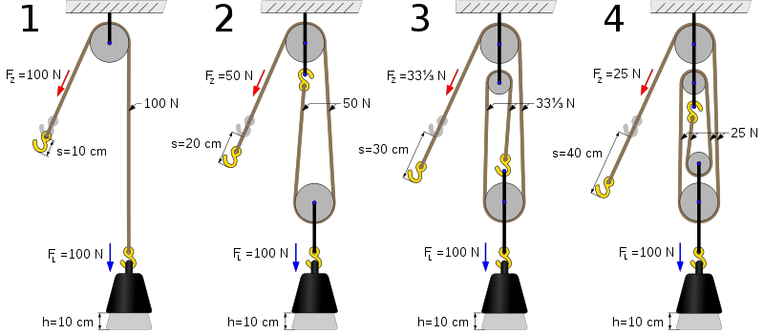
Fig. 1 Fig. 2 Fig. 3 Fig. 4
Image courtesy of Wikipedia Commons:
http://upload.wikimedia.org/wikipedia/commons/thumb/e/e9/Four_pulleys.svg/500px-Four_pulleys.svg.png&imgrefurl

Data Tables for Stop Pulling My Bot Around Lab

Type | Resistance Distance (cm) | Resistance Force (N) | Effort Force (N) | Effort Distance (cm)
Single Fixed (fig. 1)
Single Fixed, Single Movable (fig. 2)
Single fixed, Single movable (fig. 3)
Double fixed, Double movable (fig.4)

Type of System | Work  (W = F x d) | Efficiency  (W_{output}/W_{input}) | Mechanical Advantage
Single Fixed (fig. 1)
Single Fixed, Single Movable (fig. 2)
Single fixed, Single movable (fig. 3)
Double fixed, Double movable (fig.4)

