SPIRIT 2.0 Lesson:
Stop Pulling My Bot Around!!
==========================Lesson Header ==========================
Lesson Title: Stop Pulling My Bot Around!!
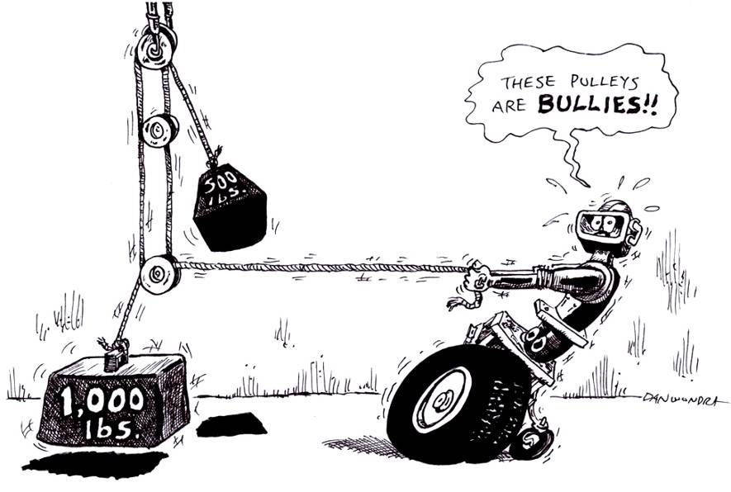
Draft Date: June 23, 2009
1st Author (Writer): Mark Wemhoff
Instructional Component Used: Simple Machines (Pulleys)
Grade Level: 9-12 Science

Content (what is taught):
- Scientific Method
- What is Work?
- What is Efficiency?
- Mechanical Advantage of simple machine
- Relationship between work and mechanical advantage

Context (how it is taught):
- Students will investigate how to find the mechanical advantage of a simple machine.
- Students will investigate the amount of work that a CEENBoT can do on a pulley system.
- Students calculate the efficiency of a simple machine (input vs. output).
- Students will create an analogy between work and mechanical advantage of simple machines (chart and graphs)
- Students must be able to list and understand the parts of the scientific method.
Activity Description: A simple machine, such as a pulley, changes the direction of a force and increases either the size of the effort force or the distance the resistance moves. If you have ever raised or lowered a flag or a slatted window blind, you have used a pulley. A single fixed pulley is one that cannot move up or down. A series of pulleys is called a block and tackle. You may have seen a block and tackle in an auto repair shop, where it is used to lift car engines.
Standards: (At least one standard each for Math, Science, Engineering and Technology - use standards provided)

Math
MD2, ME1, ME2, ME3
Science
SB1, SE2

Technology
TA4, TC4, TD3

Engineering
EB1, ED1, ED3

Materials List:
Ring to mount above the ground, String (about 1.3meters), 0.5 kg mass, 4 Single Pulleys, Newton Spring Scale, 2 wire ties one 10 and 30 cm long, meter stick, masking tape, paperclip, CEENBoT-with controller.
Asking Questions (Stop Pulling My Bot Around!!)

Summary: Provide students with pulleys, ropes and weights and allow them to experiment with a pulley system. The student will begin to understand concepts like mechanical advantage, work, and efficiency of work. Finally, pulley systems will be classified.

Outline:
- Understand how to set up a pulley system.
- Look at pulley system and see how they provide mechanical advantage.
- Classification of pulley systems

Activity:
Allow the students to recall when the last time they used a pulley system. Then allow them time to work with the pulley systems in class. Ask them how the pulley system that they used made their work easier. Then give them (or ask them) a few examples of pulley systems and ask them to determine how it can make work easier. Then ask them to answer the following questions and fill in the answers. Finally, students will classify/explain the types of pulley systems in the images given.

Questions | Answers
What is the equation used to find work? | Work = Force x distance
How do you determine the mechanical advantage of each pulley system? | The number of ropes that are supporting the mass being moved.
How do you calculate efficiency? | Efficiency = work output/work input
How can the CEENBoT make this lab more efficient? | It allows the mass on the pulley to be pulled with a more uniform rate and force.

Images of pulleys (single fixed, single fixed/single movable, double fixed/single movable, double fixed/double movable) can be found at http://images.google.com

Exploring Concepts (Stop Pulling My Bot Around!!)

Summary: Students will look for pulley systems that are used in the real world on a day-to-day basis. They will calculate the mechanical advantage and determine how this system makes our lives easier.

Outline:
- Find every day objects and determine the mechanical advantage of each and determine how it makes our lives easier.
- What are some places in which pulleys could be used to make our work easier?

Activity:
Determine the pulley systems that are encountered on a day-to-day basis. Then determine which category the pulley system falls under and what the mechanical advantage is of each pulley system and how does it make the job easier. Brainstorm with your neighbor and determine what could have a pulley system added to it to make the work easier?

Location | Type of Pulley | Mechanical Advantage | How does it make the Job Easier?
Flag Pole | Single Fixed | 1 | Changes direction of force
Engine Hoist | Double Fixed | 2 | Change direction & multiply force

New Idea Pulley System | How can it make the job easier?
Door | Pull the door shut without pushing on it.
Track system for books | Pull books to third floor so they don’t have to be carried.

Additional images of pulleys can be found at http://images.google.com
Mechanical Advantage

Putting “Mechanical Advantage” in Recognizable terms: Mechanical Advantage is a measure of how much a machine or mechanism will change the applied force. If a person applies a 10 newton force to one side of a lever, but the opposite side then lifts an object applying a 20 newton force, the lever has a mechanical advantage of 2 since the lifting force is doubled.

Putting “Mechanical Advantage” in Conceptual terms: Actual Mechanical Advantage (AMA) is the ratio of the output force (F_{o}) to the input force (F_{i}) for a machine or mechanism which may include friction. Sometimes the output force is called resistance force (F_{r}) and the input force is called the applied force (F_{a}). Ideal Mechanical Advantage (IMA) is the mechanical advantage without friction. Friction increases the amount of work needed when using the machine or mechanism. Friction causes the AMA to be less than the IMA reducing the effectiveness of the machine to less than 100% as energy often is lost in the form of heat. Measuring this reduction is called efficiency. The efficiency of a machine or mechanism is dependent on how close the AMA is to the IMA, or the how close the actual is to the ideal.

Putting “Mechanical Advantage” in Mathematical terms: To calculate the actual mechanical advantage use the formula: AMA = Force Output / Force Input. This formula is derived from the work formula. Assuming there is no friction, the work relationship for the ideal is: Work Input = Work Output. Work can be expanded to its formula of force multiplied by displacement (W=Fd) when the force applied is in the same direction as the displacement or distance.
W_{i} = W_{o} Work input (i) equals work output (o) in the ideal case
F_{i} x d_{i} = F_{o} x d_{o} Force input x displacement input = force output x displacement output
d_{i} / d_{o} = F_{o} / F_{i} Rearrange to solve for actual mechanical advantage which is F_{o} / F_{i}
The proof above also solves for the ideal mechanical advantage: IMA = distance input/ distance output (d_{i}/d_{o}), which should be the same regardless of friction. In the MKS system the unit for measuring work is the joule (J); force is the newton (N); and distance is the meter (m).
The efficiency (E) is defined as: E = Useful Work Output / Total Work Input. It can, also, be calculated using: E = AMA / IMA, the proof is shown below:
E = W_{o} / W_{i} Efficiency is the ratio of work output (o) to work input (i)
E = ( F_{o} x d_{o} ) / ( F_{i} x d_{i} ) Replace work with force times distance
E = ( F_{o} / F_{i} ) / ( d_{i} / d_{o} ) Divide numerator and denominator by ( F_{i} x d_{o} )
E = AMA / IMA Replace using the formulas for AMA and IMA

Putting “Mechanical Advantage” in Process terms: All machines are a combination of six simple machines: lever, inclined plane, pulley, wedge, screw, and wheel-n-axle. Each one’s ideal mechanical advantage can be measured by taking the distance input/distance output the only difference is the locations measured will vary on each simple machine.

Putting “Mechanical Advantage” in Applicable terms: All machines and mechanisms can be analyzed in terms of mechanical advantage and efficiency. Designers of equipment are constantly trying to get a machine’s AMA closer to its IMA, or 100% efficiency as this will increase the work output and decrease the amount of energy lost.

Organizing Learning (Stop Pulling My Bot Around!!)

Summary: Students are asked to determine the amount of work the CEENBoT can do on each pulley system and determine the mechanical advantage and efficiency of each pulley system.

Outline:
- Collect data as the CEENBoT lifts the mass with different pulley systems.
- Vary the mass or the type of pulley system.
- Calculate Work, Efficiency, and Mechanical Advantage.
- Create Graphs using collected data and calculations

Activity: The teams will need to make predictions of how much force the CEENBoT will apply on the effort arm of the pulley system to move the mass. The teams will then calculate the amount of work and efficiency of each type of pulley system. The CEENBoT will be pulling a mass that is attached to a string and force scale that will be run through a specific pulley system. Each team must turn in a lab report with the calculated values for work and efficiency. These values can be compared to a list of accepted values. Any values off by more than 15% or more must be accompanied by an explanation of what happened. The team will then need to create graphs for comparing effort and resistance forces, effort and resistance distances, effort force vs. work, and mechanical advantage vs. efficiency.

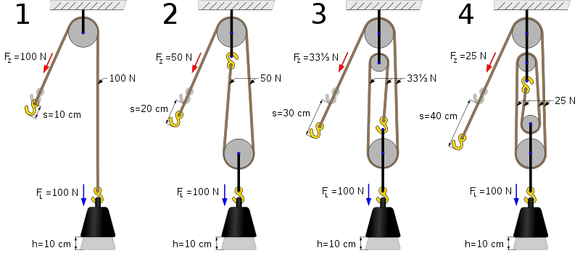
Fig. 1 Fig. 2 Fig. 3 Fig. 4

Image courtesy of Wikipedia Commons: Four Pulleys

Worksheets: Lab Exercise and Lab Questions
Understanding Learning (Stop Pulling My Bot Around!!)

Summary: Students will be assessed on their writing prompts and their abilities to correctly create graphs based on the data collected.

Outline:
- Formative assessment of Work with Simple Machines.
- Summative assessment of Work with Simple Machines.

Activity:
Formative Assessment
As students are engaged in learning activities, ask yourself or your students these questions:
- Were the students able to understand what work is and that pulley systems can help reduce the amount of work?
- Can the students explain the difference between work and force?
- Can the students explain how mechanical advantage can make work easier?

Summative Assessment
Students can answer the following writing prompts:
- How does adding a pulley change the amount of work required by the CEENBoT to lift a weight? Be sure to justify your answer with mathematical reasoning.
- State 3 examples where pulleys are used in the world and how pulleys in each situation make the work load easier?
- Would it be possible for a 5 year old to pick up 500 pounds? Why or why not. You must justify your answer with sound reasoning.

